​
​
UNITED STATES
SECURITIES AND EXCHANGE COMMISSION
Washington, D.C. 20549
FORM 8-K
CURRENT REPORT
Pursuant to Section 13 OR 15(d)
of The Securities Exchange Act of 1934
​
Date of Report (Date of earliest event reported): July 23, 2026
DIGITAL REALTY TRUST, INC.
(Exact name of registrant as specified in its charter)
​

​ | ​ | ​
Maryland | 001-32336 | 26-0081711
(State or other jurisdiction  of incorporation) | (Commission  File Number) | (IRS Employer  Identification No.)
​

​ | ​
601 West 2nd Street, Floor 32  Austin, Texas | 78701
(Address of principal executive offices) | (Zip Code)
​
(737) 281-0101
(Registrant’s telephone number, including area code)
​
2323 Bryan Street, Suite 1800 Dallas, Texas 75201
(Former name or former address, if changed since last report)
Check the appropriate box below if the Form 8-K filing is intended to simultaneously satisfy the filing obligation of the registrant under any of the following provisions:
​
☐ Written communications pursuant to Rule 425 under the Securities Act (17 CFR 230.425)
​
☐ Soliciting material pursuant to Rule 14a-12 under the Exchange Act (17 CFR 240.14a-12)
​
☐ Pre-commencement communications pursuant to Rule 14d-2(b) under the Exchange Act (17 CFR 240.14d-2(b))
​
☐ Pre-commencement communications pursuant to Rule 13e-4(c) under the Exchange Act (17 CFR 240.13e-4(c))
​
Securities registered pursuant to Section 12(b) of the Act:
​

​ | ​ | ​
Title of each class | Trading  symbol(s) | Name of each exchange on  which registered
Common Stock | DLR | New York Stock Exchange
Series J Cumulative Redeemable Preferred Stock | DLR Pr J | New York Stock Exchange
Series K Cumulative Redeemable Preferred Stock | DLR Pr K | New York Stock Exchange
Series L Cumulative Redeemable Preferred Stock | DLR Pr L | New York Stock Exchange
​
Indicate by check mark whether the registrant is an emerging growth company as defined in Rule 405 of the Securities Act of 1933 (§230.405 of this chapter) or Rule 12b-2 of the Securities Exchange Act of 1934 (§240.12b-2 of this chapter).
​
​ | ​ | ​
​ | Emerging growth company ☐ | ​
​
If an emerging growth company, indicate by check mark if the registrant has elected not to use the extended transition period for complying with any new or revised financial accounting standards provided pursuant to Section 13(a) of the Exchange Act. ☐
​
​
​
Item 2.02 Results of Operations and Financial Condition.
The information in this Item 2.02 of this Current Report on Form 8-K is also being furnished under Item 7.01 “Regulation FD Disclosure” of Form 8-K. Such information, including the exhibits attached hereto, is furnished pursuant to Item 2.02 and shall not be deemed “filed” for any purpose, including for the purposes of Section 18 of the Securities Exchange Act of 1934, as amended (Exchange Act), or otherwise subject to the liabilities of that Section. The information in this Current Report on Form 8-K shall not be deemed incorporated by reference into any filing under the Securities Act of 1933, as amended (Securities Act), or the Exchange Act regardless of any general incorporation language in such filing.
On July 23, 2026, we issued a press release announcing our financial results for the quarter ended June 30, 2026. The press release referred to certain supplemental information that is available on the Company’s website at www.digitalrealty.com. A copy of the press release and supplemental information is attached hereto as Exhibit 99.1 and incorporated by reference herein.
On July 23, 2026, we also posted presentation materials to our website at www.digitalrealty.com. The presentation materials are attached hereto as Exhibit 99.2 and incorporated by reference herein.
Item 7.01 Regulation FD Disclosure.
The information in this Item 7.01 of this Current Report on Form 8-K is also being furnished under Item 2.02 “Results of Operations and Financial Condition” of Form 8-K. Such information, including the exhibits attached hereto, is furnished pursuant to Item 7.01 and shall not be deemed “filed” for any purpose, including for the purposes of Section 18 of the Exchange Act, or otherwise subject to the liabilities of that Section. The information in this Current Report on Form 8-K shall not be deemed incorporated by reference into any filing under the Securities Act or the Exchange Act regardless of any general incorporation language in such filing.
On July 23, 2026, we issued a press release announcing our financial results for the quarter ended June 30, 2026. The press release referred to certain supplemental information that is available on the Company’s website at www.digitalrealty.com. A copy of the press release and supplemental information is attached hereto as Exhibit 99.1 and incorporated by reference herein.
On July 23, 2026, we also posted presentation materials to our website at www.digitalrealty.com. The presentation materials are attached hereto as Exhibit 99.2 and incorporated by reference herein.
Item 9.01 Financial Statements and Exhibits.
(d) Exhibits.
​
​
​ | ​ | ​
​ | ​ | ​
Exhibit No. | ​ ​ ​ | Description
​ | ​ | ​
99.1 | ​ | Earnings Press Release and Supplemental Information for the Quarter Ended June 30, 2026.
99.2 | ​ | Presentation Materials posted July 23, 2026.
104 | ​ | Cover Page Interactive Data File (embedded within the Inline XBRL document)
​
​
SIGNATURES
Pursuant to the requirements of the Securities Exchange Act of 1934, the registrant has duly caused this report to be signed on its behalf by the undersigned hereunto duly authorized.
​
EANNIE | ​
​ | ​ | Digital Realty Trust, Inc.
​ | By: | /s/ JEANNIE LEE
​ | ​ | Jeannie Lee
​ | ​ | Executive Vice President, General Counsel and Secretary  ​
​
Date: July 23, 2026
​
​
​
​
​
​
Table of Contents
Exhibit 99.1
​
​
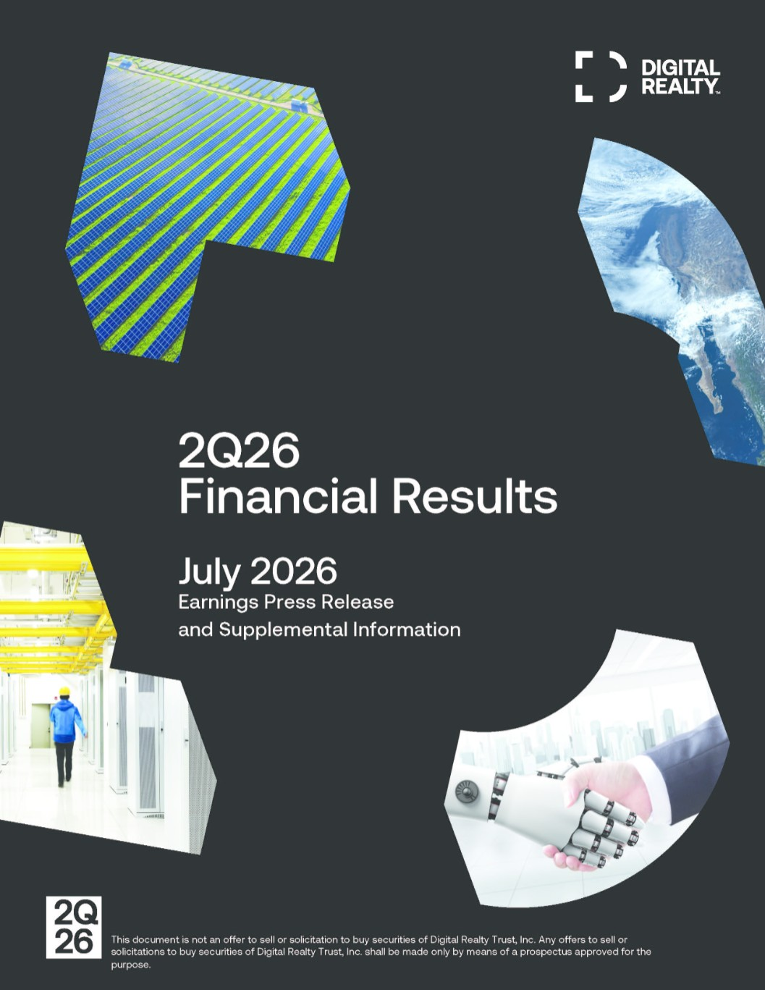
​

Table of Contents
​ |  | Financial Supplement
Table of Contents |  | ​ | Second Quarter 2026
​
​
Overview | PAGE
​ | ​
Corporate Information | 3
​ | ​
Key Quarterly Financial Data | 5
​ | ​
Consolidated Statements of Operations | ​
​ | ​
Earnings Release | 7
​ | ​
2026 Outlook | 10
​ | ​
Consolidated Quarterly Statements of Operations | 12
​ | ​
Funds From Operations and Core Funds From Operations | 13
​ | ​
Adjusted Funds From Operations | 14
​ | ​
Balance Sheet Information | ​
​ | ​
Consolidated Balance Sheets | 15
​ | ​
Components of Net Asset Value | 16
​ | ​
Debt Maturities | 17
​ | ​
Internal Growth | ​
​ | ​
Same-Capital Operating Trend Summary | 18
​ | ​
Summary of Leasing Activity - Signed and Renewed | 19
​ | ​
Lease Expirations - By Size | 20
​ | ​
Top 20 Customers by Annualized Rent | 21
​ | ​
Occupancy Analysis | 22
​ | ​
External Growth | ​
​ | ​
Development Lifecycle | 23
​ | ​
Historical Capital Expenditures and Investments in Real Estate | 24
​ | ​
Acquisitions / Dispositions / Joint Ventures | 25
​ | ​
Unconsolidated Entities | 26
​ | ​
Additional Information | ​
​ | ​
Reconciliation of Earnings Before Interest, Taxes, Depreciation & Amortization and Financial Ratios | 27
​ | ​
Management Statements on Non-GAAP Measures | 28
​ | ​
Forward-Looking Statements | 30
​
​
​
​

Table of Contents
​ |  | Financial Supplement
Corporate Information |  | ​ | Second Quarter 2026
​
Corporate Profile
Digital Realty Trust, Inc. (“Digital Realty” or the “company”) owns, acquires, develops, and operates data centers through its operating partnership subsidiary, Digital Realty Trust, L.P. (the “operating partnership”). The company is focused on providing data center, colocation, and interconnection solutions for domestic and international customers across a variety of industry verticals ranging from cloud and information technology services, communications and social networking to financial services, manufacturing, energy, healthcare, and consumer products. As of June 30, 2026, the company’s 310 data centers, including 89 data centers held as investments in unconsolidated entities, contain applications and operations critical to the day-to-day operations of technology industry and corporate enterprise data center customers. Digital Realty’s portfolio is comprised of approximately 3.1 gigawatts of IT capacity, as well as approximately 8.5 gigawatts of buildable IT capacity under active development and held for future development, located throughout North America, Europe, South America, Asia, Australia, and Africa. For additional information, please visit the company’s website at digitalrealty.com.
​
​ | ​
Corporate Headquarters  601 W 2nd St., 32nd Floor  Austin, TX  (737) 281-0101  digitalrealty.com | Senior Management  President & Chief Executive Officer: Andrew P. Power  Chief Financial Officer: Matthew R. Mercier  Chief Investment Officer: Gregory S. Wright  Chief Technology Officer: Christopher L. Sharp  Chief Revenue Officer: Colin M. McLean
​
Investor Relations
To request more information or to be added to our e-mail distribution list, please visit the Investor Relations section of our website at https://investor.digitalrealty.com.
​
Analyst Coverage
BMO |  |  |  | ​ |  |  |  | ​ |  | ​
​ | ​ ​ ​ | ​ | ​ ​ | BMO Capital | ​ ​ | BNP Paribas | ​ ​ | ​ | ​ ​ | ​ | ​ ​ | ​
Barclays | ​ | Bernstein | ​ | Markets | ​ | Exane | ​ | BofA Securities | ​ | BTIG | ​ | Cantor
Brendan Lynch | ​ | Madison Rezaei | ​ | Ari Klein | ​ | Nate Crossett | ​ | Michael Funk | ​ | Thomas Catherwood | ​ | Brett Knoblauch
​ | ​ | ​ | ​ | ​ | ​ | ​ | ​ | ​ | ​ | ​ | ​ | ​
Citigroup | ​ | Citizens JMP | ​ | Deutsche Bank | ​ | Evercore ISI | ​ | Goldman Sachs | ​ | Green Street Advisors | ​ | Guggenheim
Michael Rollins | ​ | Greg Miller | ​ | Benjamin Soff | ​ | Irvin Liu | ​ | Michael Ng | ​ | David Guarino | ​ | Joseph Osha
​ | ​ | ​ | ​ | ​ | ​ | ​ | ​ | ​ | ​ | ​ | ​ | ​
HSBC | ​ | Jefferies | ​ | J.P. Morgan | ​ | KeyBanc | ​ | Mizuho Group | ​ | MoffettNathanson | ​ | Morgan Stanley
Phani Kanumuri | ​ | Jonathan Petersen | ​ | Richard Choe | ​ | Brandon Nispel | ​ | Vikram Malhotra | ​ | Nick Del Deo | ​ | Cameron McVeigh
​ | ​ | ​ | ​ | ​ | ​ | ​ | ​ | ​ | ​ | ​ | ​ | ​
Oppenheimer | ​ | Raymond James | ​ | RBC Capital Markets | ​ | Scotiabank | ​ | Stifel | ​ | TD Cowen | ​ | Truist Securities
Timothy Horan | ​ | Frank Louthan | ​ | Jonathan Atkin | ​ | Maher Yaghi | ​ | Erik Rasmussen | ​ | Michael Elias | ​ | Matthew Niknam
​ | ​ | ​ | ​ | ​ | ​ | ​ | ​ | ​ | ​ | ​ | ​ | ​
UBS | ​ | Wells Fargo | ​ | Wolfe Research | ​ | ​ | ​ | ​ | ​ | ​ | ​ | ​
John Hodulik | ​ | Eric Luebchow | ​ | Andrew Rosivach | ​ | ​ | ​ | ​ | ​ | ​ | ​ | ​
​ | ​ | ​ | ​ | ​ | ​ | ​ | ​ | ​ | ​ | ​ | ​ | ​
​
This Earnings Press Release and Supplemental Information package supplements the information provided in our quarterly and annual reports filed with the U.S. Securities and Exchange Commission. Additional information about Digital Realty and our business is also available on our website at digitalrealty.com.
Upcoming Conference Schedule
​ | ​ | ​
August 4, 2026 | Deutsche Bank Data Center Summit | New York City, NY
August 11, 2026 | Oppenheimer Annual Technology, Internet & Communications Conference | Virtual
August 18, 2026 | Raymond James Park City Summer Summit | Park City, UT
September 8, 2026 | Citi’s Global TMT Conference | New York City, NY
September 9, 2026 | Bank of America Media, Communications & Entertainment Conference | New York City, NY
September 16, 2026 | Bank of America Global Real Estate Conference | New York City, NY
September 29, 2026 | RBC Global Communications Infrastructure Conference | Chicago, IL
​
Webcasts for these events are available through the Digital Realty Investor Relations website when possible. Please check our website for additional information.
3

Table of Contents
​ |  | Financial Supplement
Corporate Information (Continued) |  | ​ | Second Quarter 2026
​
Stock Listing Information
The stock of Digital Realty Trust, Inc. is traded primarily on the New York Stock Exchange under the following symbols:
Common Stock: | ​ | DLR
Series J Preferred Stock: | ​ | DLRPRJ
Series K Preferred Stock: | ​ | DLRPRK
Series L Preferred Stock: | ​ | DLRPRL
​
Symbols may vary by stock quote provider.
Credit Ratings
Standard & Poor’s | ​ | ​ | ​
Corporate Credit Rating: | ​ | BBB+ | (Stable Outlook)
Preferred Stock: | ​ | BBB- | ​
​ | ​ | ​ | ​
Moody’s | ​ | ​ | ​
Issuer Rating: | ​ | Baa2 | (Positive Outlook)
Preferred Stock: | ​ | Baa3 | ​
​ | ​ | ​ | ​
Fitch | ​ | ​ | ​
Issuer Default Rating: | ​ | BBB | (Stable Outlook)
Preferred Stock: | ​ | BB+ | ​
​
These credit ratings may not reflect the potential impact of risks relating to the structure or trading of the company’s securities and are provided solely for informational purposes. Credit ratings are not recommendations to buy, hold or sell any security, and may be revised or withdrawn at any time by the issuing rating agency at its sole discretion. The company does not undertake any obligation to maintain the ratings or to advise of any change in ratings. Each agency’s rating should be evaluated independently of any other agency’s rating. An explanation of the significance of the ratings may be obtained from each of the rating agencies.
​
Common Stock Price Performance
The following summarizes recent activity of Digital Realty’s common stock (DLR):
​ | ​ | ​ | ​ | ​ | ​ | ​ | ​ | ​ | ​ | ​ | ​ | ​ | ​ | ​ | ​ | ​
​ | ​ | Three Months Ended
​ | ​ | 30-Jun-26 |  | ​ | 31-Mar-26 |  | ​ | 31-Dec-25 |  | ​ | 30-Sep-25 |  | ​ | 30-Jun-25 |  | ​
High price | ​ |  | $208.14 | ​ |  | $184.79 | ​ |  | $182.48 | ​ |  | $182.00 | ​ |  | $178.85
Low price | ​ ​ | ​ | $178.41 | ​ ​ | ​ | $151.50 | ​ ​ | ​ | $146.23 | ​ ​ | ​ | $159.22 | ​ ​ | ​ | $129.95 | ​
Closing price, end of quarter | ​ | ​ | $179.58 | ​ | ​ | $180.21 | ​ | ​ | $154.71 | ​ | ​ | $172.88 | ​ | ​ | $174.33 | ​
Average daily trading volume (1) | ​ | ​ | 2,433 | ​ | ​ | 2,060 | ​ | ​ | 1,826 | ​ | ​ | 1,520 | ​ | ​ | 2,034 | ​
Indicated dividend per common share (2) | ​ | ​ | $4.88 | ​ | ​ | $4.88 | ​ | ​ | $4.88 | ​ | ​ | $4.88 | ​ | ​ | $4.88 | ​
Closing annual dividend yield, end of quarter | ​ | ​ | 2.7% | ​ | ​ | 2.7% | ​ | ​ | 3.2% | ​ | ​ | 2.8% | ​ | ​ | 2.8% | ​
Shares and units outstanding, end of quarter (1) (3) | ​ | ​ | 376,675 | ​ | ​ | 355,217 | ​ | ​ | 349,746 | ​ | ​ | 349,244 | ​ | ​ | 346,644 | ​
Closing market value of shares and units outstanding (4) | ​ | ​ | $67,643,297 | ​ | ​ | $64,013,656 | ​ | ​ | $54,109,204 | ​ | ​ | $60,377,303 | ​ | ​ | $60,430,449 | ​
​
(1) | Shares or shares and units in thousands.
(2) | On an annualized basis.
(3) | As of June 30, 2026, the total number of shares and units includes 370,010 shares of common stock, 4,294 common units held by third parties and 2,371 common units and vested and unvested long-term incentive units held by directors, officers and others and excludes all shares of common stock potentially issuable upon conversion of our series J, series K and series L cumulative redeemable preferred stock upon certain change of control transactions.
(4) | Dollars in thousands as of the end of the quarter.
​
This Earnings Press Release and Supplemental Information package supplements the information provided in our quarterly and annual reports filed with the U.S. Securities and Exchange Commission. Additional information about us and our data centers is also available on our website at digitalrealty.com.
​
​
​
4

Table of Contents
Key Quarterly Financial Data |  | Financial Supplement
Unaudited, Dollars (except per share data) in Thousands |  | ​ | Second Quarter 2026
​
​
​
​
​
​ | ​ | ​ | ​ | ​ | ​ | ​ | ​ | ​ | ​ | ​ | ​ | ​ | ​ | ​ | ​
Shares and Units at End of Quarter (1) | ​ ​ ​ | 30-Jun-26 |  | ​ ​ ​ | 31-Mar-26 |  | ​ ​ ​ | 31-Dec-25 |  | ​ ​ ​ | 30-Sep-25 |  | ​ ​ ​ | 30-Jun-25
Common shares outstanding |  | ​ | 370,010 |  | ​ | 348,924 |  | ​ | 343,557 |  | ​ | 343,041 |  | ​ | 340,372
Common partnership units outstanding |  | ​ | 6,665 |  | ​ | 6,293 |  | ​ | 6,189 |  | ​ | 6,203 |  | ​ | 6,272
Total Shares and Units |  | ​ | 376,675 |  | ​ | 355,217 |  | ​ | 349,746 |  | ​ | 349,244 |  | ​ | 346,644
​ | ​ | ​ | ​ | ​ | ​ | ​ | ​ | ​ | ​ | ​ | ​ | ​ | ​ | ​ | ​
Enterprise Value |  | ​ | ​ |  | ​ | ​ |  | ​ | ​ |  | ​ | ​ |  | ​ | ​
Market value of common equity (1) (2) | ​ | ​ | $67,643,297 | ​ | ​ | $64,013,656 | ​ | ​ | $54,109,204 | ​ | ​ | $60,377,303 | ​ | ​ | $60,430,449
Liquidation value of preferred equity | ​ |  | 755,000 | ​ |  | 755,000 | ​ |  | 755,000 | ​ |  | 755,000 | ​ |  | 755,000
Total debt at balance sheet carrying value | ​ |  | 18,635,349 | ​ |  | 17,996,633 | ​ |  | 18,402,135 | ​ |  | 18,225,434 | ​ |  | 18,452,148
Total Enterprise Value | ​ | ​ | $87,033,646 | ​ | ​ | $82,765,289 | ​ | ​ | $73,266,339 | ​ | ​ | $79,357,737 | ​ | ​ | $79,637,597
Total debt / total enterprise value | ​ |  | 21.4% | ​ |  | 21.7% | ​ |  | 25.1% | ​ |  | 23.0% | ​ |  | 23.2%
Debt-plus-preferred-to-total-enterprise-value | ​ | ​ | 22.3% | ​ | ​ | 22.7% | ​ | ​ | 26.1% | ​ | ​ | 23.9% | ​ | ​ | 24.1%
​ | ​ | ​ | ​ | ​ | ​ | ​ | ​ | ​ | ​ | ​ | ​ | ​ | ​ | ​ | ​
Selected Balance Sheet Data | ​ |  | ​ | ​ |  | ​ | ​ |  | ​ | ​ |  | ​ | ​ |  | ​
Investments in real estate (before depreciation) | ​ | ​ | $47,141,825 | ​ | ​ | $40,751,409 | ​ | ​ | $39,855,116 | ​ | ​ | $39,374,646 | ​ | ​ | $38,613,260
Total Assets | ​ |  | 54,517,914 | ​ |  | 48,859,973 | ​ |  | 49,410,468 | ​ |  | 48,728,634 | ​ |  | 48,714,995
Total Liabilities | ​ |  | 25,652,511 | ​ |  | 23,462,959 | ​ |  | 24,564,494 | ​ |  | 23,739,412 | ​ |  | 23,853,149
​ | ​ | ​ | ​ | ​ | ​ | ​ | ​ | ​ | ​ | ​ | ​ | ​ | ​ | ​ | ​
Selected Operating Data | ​ |  | ​ | ​ |  | ​ | ​ |  | ​ | ​ |  | ​ | ​ |  | ​
Total operating revenues | ​ | ​ | $1,924,040 | ​ | ​ | $1,635,173 | ​ | ​ | $1,634,671 | ​ | ​ | $1,577,234 | ​ | ​ | $1,493,150
Total operating expenses | ​ |  | 1,464,783 | ​ |  | 1,368,240 | ​ |  | 1,522,047 | ​ |  | 1,438,813 | ​ |  | 1,281,453
Net income | ​ |  | 457,607 | ​ |  | 174,804 | ​ |  | 96,111 | ​ |  | 63,713 | ​ |  | 1,046,946
Net income / (loss) available to common stockholders | ​ |  | 443,108 | ​ |  | 169,093 | ​ |  | 88,466 | ​ |  | 57,631 | ​ |  | 1,021,975
​ | ​ | ​ | ​ | ​ | ​ | ​ | ​ | ​ | ​ | ​ | ​ | ​ | ​ | ​ | ​
Financial Ratios | ​ |  | ​ | ​ |  | ​ | ​ |  | ​ | ​ |  | ​ | ​ |  | ​
EBITDA (3) | ​ | ​ | $1,097,832 | ​ | ​ | $805,115 | ​ | ​ | $688,758 | ​ | ​ | $679,912 | ​ | ​ | $1,605,408
Adjusted EBITDA (4) | ​ |  | 977,589 | ​ |  | 920,307 | ​ |  | 856,836 | ​ |  | 867,807 | ​ |  | 823,319
Net Debt-to-Adjusted EBITDA (5) | ​ |  | 4.7x | ​ |  | 4.7x | ​ |  | 4.9x | ​ |  | 4.9x | ​ |  | 5.1x
Interest expense | ​ |  | 113,943 | ​ |  | 116,384 | ​ |  | 116,516 | ​ |  | 113,584 | ​ |  | 109,383
Fixed charges (6) | ​ |  | 161,226 | ​ |  | 162,202 | ​ |  | 161,479 | ​ |  | 156,687 | ​ |  | 148,957
Interest coverage ratio (7) | ​ |  | 5.5x | ​ |  | 5.2x | ​ |  | 4.8x | ​ |  | 4.9x | ​ |  | 5.0x
Fixed charge coverage ratio (8) | ​ |  | 5.2x | ​ |  | 4.9x | ​ |  | 4.5x | ​ |  | 4.6x | ​ |  | 4.7x
​ | ​ | ​ | ​ | ​ | ​ | ​ | ​ | ​ | ​ | ​ | ​ | ​ | ​ | ​ | ​
Profitability Measures | ​ |  | ​ | ​ |  | ​ | ​ |  | ​ | ​ |  | ​ | ​ |  | ​
Net income / (loss) per common share - basic | ​ | ​ | $1.25 | ​ | ​ | $0.49 | ​ | ​ | $0.26 | ​ | ​ | $0.17 | ​ | ​ | $3.03
Net income / (loss) per common share - diluted | ​ | ​ | $1.21 | ​ | ​ | $0.46 | ​ | ​ | $0.24 | ​ | ​ | $0.15 | ​ | ​ | $2.94
Funds from operations (FFO) / diluted share and unit (9) | ​ | ​ | $2.73 | ​ | ​ | $1.99 | ​ | ​ | $1.89 | ​ | ​ | $1.65 | ​ | ​ | $1.75
Core funds from operations (Core FFO) / diluted share and unit (9) | ​ | ​ | $2.65 | ​ | ​ | $2.04 | ​ | ​ | $1.86 | ​ | ​ | $1.89 | ​ | ​ | $1.87
Core FFO (excluding net promote) / diluted share and unit (9) | ​ | ​ | $2.13 | ​ | ​ | $2.04 | ​ | ​ | $1.86 | ​ | ​ | $1.89 | ​ | ​ | $1.87
Adjusted funds from operations (AFFO) / diluted share and unit (10) | ​ | ​ | $2.47 | ​ | ​ | $1.92 | ​ | ​ | $1.34 | ​ | ​ | $1.76 | ​ | ​ | $1.68
Dividends per share and common unit | ​ | ​ | $1.22 | ​ | ​ | $1.22 | ​ | ​ | $1.22 | ​ | ​ | $1.22 | ​ | ​ | $1.22
Diluted FFO payout ratio (9) (11) | ​ |  | 44.8% | ​ |  | 61.2% | ​ |  | 64.5% | ​ |  | 73.8% | ​ |  | 69.6%
Diluted Core FFO payout ratio (9) (11) | ​ |  | 46.0% | ​ |  | 59.9% | ​ |  | 65.6% | ​ |  | 64.7% | ​ |  | 65.2%
Diluted AFFO payout ratio (10) (11) | ​ |  | 49.5% | ​ |  | 63.6% | ​ |  | 90.9% | ​ |  | 69.2% | ​ |  | 72.8%
​ | ​ | ​ | ​ | ​ | ​ | ​ | ​ | ​ | ​ | ​ | ​ | ​ | ​ | ​ | ​
Portfolio Statistics | ​ |  | ​ | ​ |  | ​ | ​ |  | ​ | ​ |  | ​ | ​ |  | ​
Data Centers (12) | ​ |  | 310 | ​ |  | 309 | ​ |  | 310 | ​ |  | 311 | ​ |  | 310
Cross-connects (12) (13) | ​ |  | 235,500 | ​ |  | 234,000 | ​ |  | 232,500 | ​ |  | 231,000 | ​ |  | 229,000
Occupied MWs (12) | ​ |  | 2,799 | ​ |  | 2,725 | ​ |  | 2,663 | ​ |  | 2,602 | ​ |  | 2,565
IT Load Capacity MWs (12) | ​ |  | 3,102 | ​ |  | 3,024 | ​ |  | 2,963 | ​ |  | 2,879 | ​ |  | 2,858
Occupancy at end of quarter (14) | ​ |  | 90.2% | ​ |  | 90.1% | ​ |  | 89.9% | ​ |  | 90.4% | ​ |  | 89.7%
Same-capital occupancy at end of quarter (14) (15) | ​ |  | 92.5% | ​ |  | 91.6% | ​ |  | 91.6% | ​ |  | 91.9% | ​ |  | 91.5%
Weighted average remaining lease term (years) (16) | ​ |  | 4.1 | ​ |  | 4.3 | ​ |  | 3.9 | ​ |  | 4.2 | ​ |  | 4.2
​
​
​
​
5

Table of Contents
Key Quarterly Financial Data |  | Financial Supplement
Unaudited, Dollars (except per share data) in Thousands |  | ​ | Second Quarter 2026
​
(1) | Shares and units are in thousands.
(2) | The market value of common equity is based on the closing stock price at the end of the quarter and assumes 100% redemption of the limited partnership units in our operating partnership, including common units and vested and unvested long-term incentive units, for shares of our common stock on a one-for-one basis. Excludes shares of common stock potentially issuable upon conversion of our series J, series K and series L cumulative redeemable preferred stock upon certain change of control transactions, as applicable.
(3) | EBITDA is calculated as earnings before interest expense, loss on debt extinguishment and modifications, tax expense, and depreciation and amortization. For a discussion of EBITDA, see page 28. For a reconciliation of net income available to common stockholders to EBITDA, see page 27.
(4) | Adjusted EBITDA is EBITDA excluding (i) unconsolidated entities real estate related depreciation & amortization, (ii) unconsolidated entities interest and tax expense, (iii) severance, equity acceleration and legal expenses, (iv) transaction and integration expenses, (v) gain (loss) on sale / deconsolidation, (vi) provision for impairment, (vii) other non-core adjustments, net, (viii) noncontrolling interests, (ix) preferred stock dividends, (x) gain on / issuance costs associated with redeemed preferred stock and (xi) net promote. For a discussion of Adjusted EBITDA, see page 28. For a reconciliation of net income available to common stockholders to Adjusted EBITDA, see page 27.
(5) | Net Debt to Adjusted EBITDA is calculated as total debt at balance sheet carrying value (see page 5), plus finance lease obligations, plus our share of unconsolidated entities debt at carrying value, less cash and cash equivalents (including our share of unconsolidated entities cash), divided by the product of Adjusted EBITDA (including our pro rata share of unconsolidated entities EBITDA), multiplied by four.
(6) | Fixed charges consist of GAAP interest expense, capitalized interest, scheduled debt principal payments and preferred stock dividends.
(7) | Interest coverage ratio is Adjusted EBITDA (including our pro rata share of unconsolidated entities EBITDA), divided by GAAP interest expense plus capitalized interest (including our share of unconsolidated entities interest expense).
(8) | Fixed charge coverage ratio is Adjusted EBITDA (including our pro rata share of unconsolidated entities EBITDA), divided by fixed charges (including our share of unconsolidated entities fixed charges).
(9) | For definitions and discussion of FFO, Core FFO and Core FFO (excluding net promote), see page 28. For reconciliations of net income available to common stockholders to FFO, Core FFO and Core FFO (excluding net promote), see page 13.
(10) | For a definition and discussion of AFFO, see page 28. For a reconciliation of Core FFO to AFFO, see page 14.
(11) | Diluted payout ratios for FFO, Core FFO and AFFO are calculated as dividends declared per common share and unit divided by the corresponding diluted FFO, diluted Core FFO and diluted AFFO per share and unit, respectively.
(12) | Includes data centers held as investments in unconsolidated entities. Excludes data centers held for sale and contribution.
(13) | Represents approximate amounts.
(14) | Occupancy and same-capital occupancy exclude capacity under active development and capacity held for development. Occupancy represents our consolidated portfolio in addition to our managed portfolio of unconsolidated entities and non-managed unconsolidated entities. For some of our data centers, we calculate occupancy based on factors including available power, required support capacity and common area. Excludes data centers held for sale and contribution.
(15) | Represents data centers owned as of December 31, 2024, with less than 5% of total rentable square feet under development. Excludes data centers that were undergoing, or were expected to undergo, development activities in 2025-2026, data centers classified as held for sale and contribution, and data centers sold or contributed to joint ventures for all periods presented. Prior period results have been adjusted to reflect current same-capital pool.
(16) | Weighted average remaining lease term excludes renewal options and is weighted by annualized recurring revenue.
​
​
​
​
​
​
​
6

Table of Contents
Digital Realty Trust |  | Financial Supplement
Earnings Release |  | ​ | Second Quarter 2026
​
Digital Realty Reports Second Quarter 2026 Results
Austin, TX — July 23, 2026 — Digital Realty (NYSE: DLR), the world’s largest cloud- and carrier-neutral data center platform, announced today financial results for the second quarter of 2026. All per share results are presented on a fully diluted basis.
Highlights
 | ◾ | Reported net income available to common stockholders of $1.21 per share in 2Q26, compared to $2.94 in 2Q25
 | ◾ | Reported FFO per share of $2.73 in 2Q26, compared to $1.75 in 2Q25
 | ◾ | Reported Core FFO per share of $2.65 in 2Q26, compared to $1.87 in 2Q25; reported Core FFO per share (excluding net promote) of $2.13 in 2Q26
 | ◾ | Signed total bookings during 2Q26 that are expected to generate $307 million of annualized GAAP base rent at 100% share; at Digital Realty’s share, bookings were $208 million, including a $108 million contribution from the 0-1 megawatt plus interconnection category
 | ◾ | In July, signed two hyperscale leases, representing $410 million of annualized GAAP base rent at 100% share, or $205 million at Digital Realty’s share
 | ◾ | Reported rental rate increases on renewal leases of 25.4% on a cash basis in 2Q26
 | ◾ | Reported a record total backlog of $1.9 billion of annualized GAAP base rent at 100% share, at the end of 2Q26; at Digital Realty’s share, the backlog was $1.4 billion
 | ◾ | Raised 2026 Core FFO per share (excluding net promote) outlook to $8.15 - $8.20 and 2026 Constant-Currency Core FFO per share (excluding net promote) outlook to $8.10 - $8.15
Financial Results
Digital Realty reported total revenues of $1.9 billion in the second quarter of 2026, an 18% increase from the previous quarter and a 29% increase from the same quarter last year.
During the second quarter, Digital Realty recognized $188 million of net promote income in Core FFO related to the successful development and leasing of three data centers in its development joint venture. The company also recognized a $94 million insurance settlement, net of income tax, related to a previously disclosed 2024 matter, of which approximately $27 million was recognized in Core FFO as business interruption recovery; the remainder related to property damage recoveries, was excluded from Core FFO.
The company delivered net income of $458 million in the second quarter of 2026, as well as net income available to common stockholders of $443 million and $1.21 per share, compared to $0.46 per share in the previous quarter and $2.94 per share in the same quarter last year.
Digital Realty generated Adjusted EBITDA of $978 million in the second quarter of 2026, a 6% increase from the previous quarter and a 19% increase over the same quarter last year.
The company reported Funds From Operations (FFO) of $982 million in the second quarter of 2026, or $2.73 per share, compared to $1.99 per share in the previous quarter and $1.75 per share in the same quarter last year.
Digital Realty delivered Core FFO per share (excluding net promote) of $2.13 in the second quarter of 2026, compared to $2.04 per share in the previous quarter and $1.87 per share in the same quarter last year. Digital Realty delivered Constant-Currency Core FFO per share (excluding net promote) of $2.11 in the second quarter of 2026 and $4.07 per share for the six-month period ended June 30, 2026.
“Digital Realty delivered record Core FFO per share in the quarter, reflecting robust customer demand and strong execution across our core pillars of growth,” said President and Chief Executive Officer Andy Power. “We signed more than $100 million of 0-1 MW plus Interconnection bookings for the first time, demonstrating the strength of our connectivity-rich portfolio and boosting near-term growth. We also continued to make strides in our hyperscale and strategic private capital verticals, as we added powered land in the Kansas City metro, accretively purchased interests in three hyperscale data centers in Northern Virginia, and announced the deal to acquire Columbia Capital, a leading investment firm in the digital infrastructure space. Together, these growth vectors are driving double-digit bottom line growth, and we are focused on extending this runway for years to come.”
Leasing Activity
In the second quarter, Digital Realty signed total bookings that are expected to generate $307 million of annualized GAAP rental revenue, at 100% share; at Digital Realty’s share, total bookings were $208 million, including an $88 million contribution from the 0-1 MW category and a $20 million contribution from interconnection.
The weighted-average lag between new leases signed during the second quarter of 2026 and the contractual commencement date was nine months. The backlog of signed-but-not-commenced leases at quarter-end was $1.9 billion of annualized GAAP base rent at 100% share, and $1.4 billion at Digital Realty’s share. In addition, Digital Realty also signed renewal leases representing $262 million of annualized cash rental revenue during the quarter. Rental rates on renewal leases signed during the second quarter of 2026 increased 25.4% on a cash basis and 32.0% on a GAAP basis.
7

Table of Contents
Digital Realty Trust |  | Financial Supplement
Earnings Release |  | ​ | Second Quarter 2026
​
New leases signed during the second quarter of 2026, at Digital Realty’s share, are summarized by region and product as follows:
​
​ | ​ | ​ | ​ | ​ | ​ | ​ | ​ | ​
​ | ​ ​ ​ | Annualized GAAP |  | ​ ​ ​ | ​ ​ ​ | ​ ​ ​ | ​ | ​
​ | ​ | Base Rent |  | ​ | ​ | ​ | GAAP Base Rent
Americas | ​ | (in thousands) |  | ​ | Megawatts | ​ | per Kilowatt
0-1 MW | ​ | ​ | $37,131 |  | 10.6 | ​ | ​ | $293
> 1 MW | ​ | ​ | 82,706 |  | 44.2 | ​ | ​ | 156
Other (1) | ​ | ​ | 142 |  | — | ​ | ​ | —
Total | ​ | ​ | $119,980 |  | 54.8 | ​ | ​ | $182
​ | ​ | ​ | ​ | ​ | ​ | ​ | ​ | ​
EMEA (2) | ​ | ​ | ​ |  | ​ | ​ | ​ | ​
0-1 MW | ​ | ​ | $42,149 |  | 13.0 | ​ | ​ | $269
> 1 MW | ​ | ​ | 4,999 |  | 2.5 | ​ | ​ | 167
Other (1) | ​ | ​ | 21 |  | — | ​ | ​ | —
Total | ​ | ​ | $47,168 |  | 15.5 | ​ | ​ | $253
​ | ​ | ​ | ​ | ​ | ​ | ​ | ​ | ​
Asia Pacific (2) | ​ | ​ | ​ |  | ​ | ​ | ​ | ​
0-1 MW | ​ | ​ | $8,541 |  | 2.5 | ​ | ​ | $286
> 1 MW | ​ | ​ | 12,141 |  | 6.2 | ​ | ​ | 165
Other (1) | ​ | ​ | 170 |  | — | ​ | ​ | —
Total | ​ | ​ | $20,851 |  | 8.6 | ​ | ​ | $199
​ | ​ | ​ | ​ | ​ | ​ | ​ | ​ | ​
All Regions (2) | ​ | ​ | ​ |  | ​ | ​ | ​ | ​
0-1 MW | ​ | ​ | $87,821 |  | 26.1 | ​ | ​ | $280
> 1 MW | ​ | ​ | 99,846 |  | 52.9 | ​ | ​ | 157
Other (1) | ​ | ​ | 332 |  | — | ​ | ​ | —
Total | ​ | ​ | $187,999 |  | 79.0 | ​ | ​ | $198
​ | ​ | ​ | ​ | ​ | ​ | ​ | ​ | ​
Interconnection | ​ | ​ | $20,497 |  | N/A | ​ | ​ | N/A
​ | ​ | ​ | ​ | ​ | ​ | ​ | ​ | ​
Grand Total at DLR Share | ​ | ​ | $208,495 |  | 79.0 | ​ | ​ | $198
​ | ​ | ​ | ​ | ​ | ​ | ​ | ​ | ​
Grand Total at 100% Share | ​ | ​ | $306,944 |  | 129.8 | ​ | ​ | $183
​
Note: Totals may not foot due to rounding differences.
(1) | Other includes Powered Base Building® shell capacity as well as storage and office space within fully improved data center facilities.
(2) | Based on quarterly average exchange rates during the three months ended June 30, 2026.
Investment Activity
During the second quarter of 2026, Digital Realty acquired:
​
 | ● | Land in Marseille, France for approximately €46.5 million, or $53.1 million, that is expected to support the development of up to 48 megawatts of IT capacity.
 | ● | Land in the Atlanta metro area for approximately $20 million. Together with an adjacent parcel that was acquired in the first quarter, this campus is expected to support over one gigawatt of IT capacity.
​
As previously announced, during the quarter, Digital Realty also acquired:
​
 | ● | Land in the Kansas City metro area for approximately $475 million to support hyperscale data center development for up to two gigawatts of utility power.
 | ● | Two data centers in Malaysia containing 16.5 megawatts of IT capacity, and a land parcel that is expected to support the development of up to 14 megawatts of IT capacity, for total consideration of approximately $134 million.
 | ● | A 64% stake in three fully leased data centers in Northern Virginia containing 288 megawatts of IT capacity, at a gross value of approximately $7.8 billion, reflecting an expected initial stabilized cap rate of over 6.5%. The newly developed assets are expected to be fully stabilized in the first half of 2027 and first half of 2028. Total consideration for our joint venture partners’ equity interest in the assets was approximately $3.5 billion, including $1.2 billion of cash and 12.3 million shares of Digital Realty common stock.

As previously disclosed, during the quarter, Digital Realty sold a non-core asset in the Atlanta metro area for $24 million.
​
​
​
8

Table of Contents
Digital Realty Trust |  | Financial Supplement
Earnings Release |  | ​ | Second Quarter 2026
​
Balance Sheet
​
Digital Realty had approximately $18.6 billion of total debt outstanding as of June 30, 2026, comprised of $17.0 billion of unsecured debt and approximately $1.6 billion of secured debt and other debt. At the end of the second quarter of 2026, net debt-to-Adjusted EBITDA was 4.7x, debt-plus-preferred-to-total enterprise value was 22.3% and fixed charge coverage was 5.2x.
​
From our first quarter earnings report on April 23, 2026 through June 30, 2026, the company sold approximately 6.2 million shares of common stock under its At-The-Market (ATM) equity issuance program at a weighted average price of $191.63 per share, for net proceeds of approximately $1.2 billion. Year-to-date, the company has sold approximately 13.5 million shares under its ATM equity issuance program at a weighted average price of $184.94 per share, for net proceeds of approximately $2.5 billion.
​
​
​
​
​
​
​
​
​
​
​
​
9

Table of Contents
Digital Realty Trust |  | Financial Supplement
Earnings Release |  | ​ | Second Quarter 2026
​
​
2026 Outlook
Digital Realty raised its 2026 Core FFO per share (excluding net promote) outlook to $8.15 - $8.20 and its 2026 Constant-Currency Core FFO per share (excluding net promote) outlook to $8.10 - $8.15. The assumptions underlying the outlook are summarized in the following table.
​ | ​ | ​ | ​ | ​ | ​ | ​ | ​
​ | ​ ​ | As of | ​ ​ | As of | ​ ​ | As of
Top-Line and Cost Structure | ​ | February 5, 2026 | ​ | April 23, 2026 | ​ | July 23, 2026 | ​
Total revenue (excluding promote income) | ​ | $6.600 - $6.700 billion | ​ | $6.650 - $6.750 billion | ​ | $6.850 - $6.950 billion
Net non-cash rent adjustments (1) | ​ | ($90 - $95 million) | ​ | ($90 - $95 million) | ​ | ($145 - $150 million) | ​
Adjusted EBITDA | ​ | $3.600 - $3.700 billion | ​ | $3.650 - $3.750 billion | ​ | $3.750 - $3.850 billion | ​
G&A | ​ | $610 - $620 million | ​ | $615 - $625 million | ​ | $620 - $630 million | ​
​ | ​ | ​ | ​ | ​ | ​ | ​ | ​
Internal Growth | ​ | ​ | ​ | ​ | ​ | ​ | ​
Rental rates on renewal leases | ​ | ​ | ​ | ​ | ​ | ​ | ​
Cash basis | ​ | 6.0% - 8.0% | ​ | 6.5% - 8.5% | ​ | 9.0% - 11.0% | ​
GAAP basis | ​ | 8.5% - 10.5% | ​ | 9.5% - 11.5% | ​ | 12.0% - 14.0% | ​
Year-end portfolio occupancy (2) | ​ | +50 - 100 bps | ​ | +50 - 100 bps | ​ | +75 - 125 bps | ​
"Same-Capital" cash NOI growth (3) | ​ | 4.0% - 5.0% | ​ | 4.0% - 5.0% | ​ | 4.25% - 5.25% | ​
​ | ​ | ​ | ​ | ​ | ​ | ​ | ​
Foreign Exchange Rates | ​ | ​ | ​ | ​ | ​ | ​ | ​
U.S. Dollar / Pound Sterling | ​ | $1.30 - $1.35 | ​ | $1.32 - $1.37 | ​ | $1.32 - $1.37 | ​
U.S. Dollar / Euro | ​ | $1.13 - $1.18 | ​ | $1.15 - $1.20 | ​ | $1.13 - $1.18 | ​
​ | ​ | ​ | ​ | ​ | ​ | ​ | ​
External Growth | ​ | ​ | ​ | ​ | ​ | ​ | ​
Dispositions / Joint Venture Capital | ​ | ​ | ​ | ​ | ​ | ​ | ​
Dollar volume | ​ | $500 - $1,000 million | ​ | $500 - $1,000 million | ​ | $1,000 - $1,500 million | ​
Cap rate | ​ | 0.0% - 10.0% | ​ | 0.0% - 10.0% | ​ | 0.0% - 10.0% | ​
Development | ​ | ​ | ​ | ​ | ​ | ​ | ​
CapEx (Net of Partner Contributions) (4) | ​ | $3,250 - $3,750 million | ​ | $3,500 - $4,000 million | ​ | $4,250 - $4,750 million | ​
Average stabilized yields | ​ | 10.0%+ | ​ | 10.0%+ | ​ | 10.0%+ | ​
Enhancements and other non-recurring CapEx (5) | ​ | $30 - $35 million | ​ | $30 - $35 million | ​ | $30 - $35 million | ​
Recurring CapEx + capitalized leasing costs (6) | ​ | $400 - $425 million | ​ | $400 - $425 million | ​ | $400 - $425 million | ​
​ | ​ | ​ | ​ | ​ | ​ | ​ | ​
Balance Sheet | ​ | ​ | ​ | ​ | ​ | ​ | ​
Long-term debt issuance | ​ | ​ | ​ | ​ | ​ | ​ | ​
Dollar amount | ​ | $1,000 - $1,500 million | ​ | $1,500 - $2,000 million | ​ | $1,500 - $2,000 million | ​
Pricing | ​ | 4.0% - 4.5% | ​ | 4.0% - 4.5% | ​ | 4.5% - 5.5% | ​
Timing | ​ | Mid-Year | ​ | Mid-Year | ​ | 2H-2026 | ​
​ | ​ | ​ | ​ | ​ | ​ | ​ | ​
Net income per diluted share | ​ | $2.55 - $2.65 | ​ | $2.65 - $2.75 | ​ | $3.10 - $3.15 | ​
Real estate depreciation and (gain) / loss on sale | ​ | $4.90 - $4.90 | ​ | $4.95 - $4.95 | ​ | $5.30 - $5.30 | ​
Funds From Operations / share (NAREIT-Defined) | ​ | $7.45 - $7.55 | ​ | $7.60 - $7.70 | ​ | $8.40 - $8.45 | ​
Non-core expenses and revenue streams | ​ | $0.45 - $0.45 | ​ | $0.40 - $0.40 | ​ | $0.25 - $0.25 | ​
Net Promote | ​ | $0.00 - $0.00 | ​ | $0.00 - $0.00 | ​ | ($0.50) - ($0.50) | ​
Core Funds From Operations / share (excluding net promote) | ​ | $7.90 - $8.00 | ​ | $8.00 - $8.10 | ​ | $8.15 - $8.20 | ​
Foreign currency translation adjustments | ​ | $0.00 - $0.00 | ​ | ($0.05) - ($0.05) | ​ | ($0.05) - ($0.05) | ​
Constant-Currency Core FFO / share (excluding net promote) | ​ | $7.90 - $8.00 | ​ | $7.95 - $8.05 | ​ | $8.10 - $8.15 | ​
​
(1) | Net non-cash rent adjustments represent the sum of straight-line rental revenue and straight-line rental expense, as well as the amortization of above- and below-market leases (i.e., ASC 805 adjustments).
(2) | Year-end portfolio occupancy guidance based on IT load (kW).
(3) | The “Same-Capital” pool includes properties owned as of December 31, 2024 with less than 5% of total rentable square feet under development. It excludes properties that were undergoing, or were expected to undergo, development activities in 2025-2026, properties classified as held for sale and contribution, and properties sold or contributed to joint ventures for all periods presented. The 2026 “Same-Capital” cash NOI growth outlook is presented on a constant currency basis.
(4) | Excludes land acquisitions and includes Digital Realty’s share of joint venture and fund contributions. Figure is net of joint venture and fund partners’ share of contributions.
(5) | Other non-recurring CapEx represents costs incurred to enhance the capacity or marketability of operating properties, such as network fiber initiatives and software development costs.
(6) | Recurring CapEx represents non-incremental improvements required to maintain current revenues, including second-generation tenant improvements and leasing commissions.
​
Note: The company does not provide a reconciliation for non-GAAP estimates on a forward-looking basis, where it is unable to provide a meaningful or accurate calculation or estimation of reconciling items, and the information is not available without unreasonable effort. Please see Non-GAAP Financial Measures in this document for further discussion.
10

Table of Contents
Digital Realty Trust |  | Financial Supplement
Earnings Release |  | ​ | Second Quarter 2026
​
​
Non-GAAP Financial Measures
This document contains non-GAAP financial measures, including FFO, Core FFO, Core FFO (excluding net promote), Constant Currency Core FFO (excluding net promote), Adjusted FFO, Net Operating Income (NOI), “Same-Capital” Cash NOI and Adjusted EBITDA. A reconciliation from U.S. GAAP net income available to common stockholders to FFO, a reconciliation from FFO to Core FFO, a reconciliation from Core FFO (excluding net promote) to Constant Currency Core FFO (excluding net promote), a reconciliation from Core FFO to Adjusted FFO, a reconciliation from NOI to Cash NOI, and definitions of FFO, Core FFO, Constant Currency Core FFO, Core FFO (excluding net promote), Adjusted FFO, NOI and “Same-Capital” Cash NOI are included as an attachment to this document. A reconciliation from U.S. GAAP net income available to common stockholders to Adjusted EBITDA, a definition of Adjusted EBITDA and definitions of net debt-to-Adjusted EBITDA, debt-plus-preferred-to-total enterprise value, cash NOI, and fixed charge coverage ratio are included as an attachment to this document.
The company does not provide a reconciliation for non-GAAP estimates on a forward-looking basis, where it is unable to provide a meaningful or accurate calculation or estimation of reconciling items and the information is not available without unreasonable effort. This is due to the inherent difficulty of forecasting the timing and/or amount of various items that would impact net income attributable to common stockholders per diluted share, which is the most directly comparable forward-looking GAAP financial measure. This includes, for example, external growth factors, such as dispositions, and balance sheet items such as debt issuances, that have not yet occurred, are out of the company's control and/or cannot be reasonably predicted. For the same reasons, the company is unable to address the probable significance of the unavailable information. Forward-looking non-GAAP financial measures provided without the most directly comparable GAAP financial measures may vary materially from the corresponding GAAP financial measures.
Investor Conference Call
Prior to Digital Realty’s investor conference call at 5:00 p.m. ET / 4:00 p.m. CT on July 23, 2026, a presentation will be posted to the Investors section of the company’s website at https://investor.digitalrealty.com. The presentation is designed to accompany the discussion of the company’s second quarter 2026 financial results and operating performance. The conference call will feature President & Chief Executive Officer Andy Power and Chief Financial Officer Matt Mercier.
A live webcast of the call will be available on the Investors section of Digital Realty’s website at https://investor.digitalrealty.com. The webcast will be archived for one year and the replay will be available shortly after the conclusion of the live event.
About Digital Realty
Digital Realty brings companies and data together by delivering the full spectrum of data center, colocation and interconnection solutions. PlatformDIGITAL®, the company’s global data center platform, provides customers with a secure data meeting place and a proven Pervasive Datacenter Architecture (PDx®) solution methodology for powering innovation, from cloud and digital transformation to emerging technologies like artificial intelligence (AI), and efficiently managing Data Gravity challenges. Digital Realty gives its customers access to the connected data communities that matter to them with a global data center footprint of 300+ facilities in 55+ metros across 30+ countries on six continents. To learn more about Digital Realty, please visit digitalrealty.com or follow us on LinkedIn and X.
​
Contact Information
Matt Mercier
Chief Financial Officer
Digital Realty
​
Jordan Sadler / Jim Huseby
Investor Relations
Digital Realty
InvestorRelations@digitalrealty.com
​
​
​
​
​
​
​
​
11

Table of Contents
Consolidated Quarterly Statements of Operations |  | Financial Supplement
Unaudited and in Thousands, Except Per Share Data |  | ​ | Second Quarter 2026
​
​
​
​
​
​
​ | ​ | ​ | ​ | ​ | ​ | ​ | ​ | ​ | ​ | ​ | ​ | ​ | ​ | ​ | ​ | ​ | ​ | ​ | ​ | ​ | ​ | ​
​ | ​ | ​ | Three Months Ended |  |  |  |  |  |  |  |  |  |  |  |  | ​ | ​ | Six Months Ended
​ | ​ | ​ | 30-Jun-26 | ​ | ​ | 31-Mar-26 | ​ | ​ | 31-Dec-25 | ​ | ​ | 30-Sep-25 | ​ | ​ | 30-Jun-25 | ​ | ​ | ​ | 30-Jun-26 | ​ ​ ​ | ​ | 30-Jun-25
Rental revenues | ​ | ​ | $1,145,936 | ​ | ​ | $1,103,946 | ​ | ​ | $1,074,703 | ​ | ​ | $1,045,708 | ​ | ​ | $1,003,550 | ​ | ​ | ​ | $2,249,882 | ​ | ​ | $1,964,076
Tenant reimbursements - Utilities | ​ | ​ | 352,897 | ​ | ​ | 333,909 | ​ | ​ | 356,084 | ​ | ​ | 332,681 | ​ | ​ | 294,503 | ​ | ​ | ​ | 686,807 | ​ | ​ | 565,692
Tenant reimbursements - Other | ​ | ​ | 45,391 | ​ | ​ | 38,093 | ​ | ​ | 34,406 | ​ | ​ | 37,302 | ​ | ​ | 37,355 | ​ | ​ | ​ | 83,484 | ​ | ​ | 79,532
Interconnection and other | ​ | ​ | 130,409 | ​ | ​ | 124,278 | ​ | ​ | 123,414 | ​ | ​ | 120,399 | ​ | ​ | 121,952 | ​ | ​ | ​ | 254,687 | ​ | ​ | 234,921
Fee income | ​ | ​ | 248,927 | ​ | ​ | 34,899 | ​ | ​ | 45,692 | ​ | ​ | 36,398 | ​ | ​ | 34,427 | ​ | ​ | ​ | 283,826 | ​ | ​ | 55,070
Other | ​ | ​ | 480 | ​ | ​ | 47 | ​ | ​ | 372 | ​ | ​ | 4,746 | ​ | ​ | 1,363 | ​ | ​ | ​ | 527 | ​ | ​ | 1,496
Total Operating Revenues | ​ | ​ | $1,924,040 | ​ | ​ | $1,635,173 | ​ | ​ | $1,634,671 | ​ | ​ | $1,577,234 | ​ | ​ | $1,493,150 | ​ | ​ | ​ | $3,559,213 | ​ | ​ | $2,900,787
​ | ​ | ​ | ​ | ​ | ​ | ​ | ​ | ​ | ​ | ​ | ​ | ​ | ​ | ​ | ​ | ​ | ​ | ​ | ​ | ​ | ​ | ​
Utilities | ​ | ​ | $396,454 | ​ | ​ | $372,385 | ​ | ​ | $398,185 | ​ | ​ | $375,627 | ​ | ​ | $339,288 | ​ | ​ | ​ | $768,839 | ​ | ​ | $652,673
Rental property operating | ​ | ​ | 291,408 | ​ | ​ | 266,115 | ​ | ​ | 295,948 | ​ | ​ | 278,292 | ​ | ​ | 267,724 | ​ | ​ | ​ | 557,523 | ​ | ​ | 506,324
Property taxes | ​ | ​ | 55,160 | ​ | ​ | 54,964 | ​ | ​ | 50,791 | ​ | ​ | 51,823 | ​ | ​ | 49,570 | ​ | ​ | ​ | 110,124 | ​ | ​ | 98,426
Insurance | ​ | ​ | 4,744 | ​ | ​ | 4,799 | ​ | ​ | 4,711 | ​ | ​ | 4,508 | ​ | ​ | 4,946 | ​ | ​ | ​ | 9,543 | ​ | ​ | 9,429
Depreciation and amortization | ​ | ​ | 507,106 | ​ | ​ | 499,511 | ​ | ​ | 493,458 | ​ | ​ | 497,002 | ​ | ​ | 461,167 | ​ | ​ | ​ | 1,006,617 | ​ | ​ | 904,176
General and administration | ​ | ​ | 153,316 | ​ | ​ | 151,923 | ​ | ​ | 159,283 | ​ | ​ | 139,911 | ​ | ​ | 133,755 | ​ | ​ | ​ | 305,239 | ​ | ​ | 254,867
Severance, equity acceleration and legal expenses | ​ | ​ | 4,384 | ​ | ​ | 2,835 | ​ | ​ | 4,937 | ​ | ​ | 1,794 | ​ | ​ | 2,262 | ​ | ​ | ​ | 7,219 | ​ | ​ | 4,690
Transaction and integration expenses | ​ | ​ | 38,703 | ​ | ​ | 15,685 | ​ | ​ | 36,083 | ​ | ​ | 86,559 | ​ | ​ | 22,546 | ​ | ​ | ​ | 54,388 | ​ | ​ | 62,448
Provision for impairment | ​ | ​ | — | ​ | ​ | — | ​ | ​ | 78,553 | ​ | ​ | — | ​ | ​ | — | ​ | ​ | ​ | — | ​ | ​ | —
Other expenses | ​ | ​ | 13,508 | ​ | ​ | 23 | ​ | ​ | 98 | ​ | ​ | 3,297 | ​ | ​ | 195 | ​ | ​ | ​ | 13,531 | ​ | ​ | 307
Total Operating Expenses | ​ | ​ | $1,464,783 | ​ | ​ | $1,368,240 | ​ | ​ | $1,522,047 | ​ | ​ | $1,438,813 | ​ | ​ | $1,281,453 | ​ | ​ | ​ | $2,833,023 | ​ | ​ | $2,493,340
​ | ​ | ​ | ​ | ​ | ​ | ​ | ​ | ​ | ​ | ​ | ​ | ​ | ​ | ​ | ​ | ​ | ​ | ​ | ​ | ​ | ​ | ​
Operating income before gain (loss) on disposition of properties, net | ​ | ​ | $459,257 | ​ | ​ | $266,933 | ​ | ​ | $112,624 | ​ | ​ | $138,420 | ​ | ​ | $211,698 | ​ | ​ | ​ | $726,190 | ​ | ​ | $407,447
Gain (loss) on disposition of properties, net | ​ | ​ | 7,988 | ​ | ​ | 873 | ​ | ​ | 42,865 | ​ | ​ | 19,780 | ​ | ​ | 931,830 | ​ | ​ | ​ | 8,861 | ​ | ​ | 932,941
Operating Income | ​ | ​ | $467,245 | ​ | ​ | $267,806 | ​ | ​ | $155,489 | ​ | ​ | $158,200 | ​ | ​ | $1,143,527 | ​ | ​ | ​ | $735,051 | ​ | ​ | $1,340,388
​ | ​ | ​ | ​ | ​ | ​ | ​ | ​ | ​ | ​ | ​ | ​ | ​ | ​ | ​ | ​ | ​ | ​ | ​ | ​ | ​ | ​ | ​
Equity in earnings (loss) of unconsolidated entities | ​ | ​ | 36 | ​ | ​ | (1,833) | ​ | ​ | 4,659 | ​ | ​ | (16,944) | ​ | ​ | (12,062) | ​ | ​ | ​ | (1,797) | ​ | ​ | (19,702)
Interest and other income (expense), net | ​ | ​ | 137,944 | ​ | ​ | 45,342 | ​ | ​ | 42,797 | ​ | ​ | 47,735 | ​ | ​ | 37,747 | ​ | ​ | ​ | 183,286 | ​ | ​ | 70,520
Interest (expense) | ​ | ​ | (113,943) | ​ | ​ | (116,384) | ​ | ​ | (116,516) | ​ | ​ | (113,584) | ​ | ​ | (109,383) | ​ | ​ | ​ | (230,327) | ​ | ​ | (207,847)
Income tax benefit (expense) | ​ | ​ | (33,675) | ​ | ​ | (16,008) | ​ | ​ | 9,673 | ​ | ​ | (11,695) | ​ | ​ | (12,883) | ​ | ​ | ​ | (49,683) | ​ | ​ | (30,018)
Gain (loss) on debt extinguishment and modifications | ​ | ​ | — | ​ | ​ | (4,119) | ​ | ​ | 9 | ​ | ​ | — | ​ | ​ | — | ​ | ​ | ​ | (4,119) | ​ | ​ | —
Net Income | ​ | ​ | $457,607 | ​ | ​ | $174,804 | ​ | ​ | $96,111 | ​ | ​ | $63,713 | ​ | ​ | $1,046,946 | ​ | ​ | ​ | $632,411 | ​ | ​ | $1,153,341
​ | ​ | ​ | ​ | ​ | ​ | ​ | ​ | ​ | ​ | ​ | ​ | ​ | ​ | ​ | ​ | ​ | ​ | ​ | ​ | ​ | ​ | ​
Net (income) loss attributable to noncontrolling interests | ​ | ​ | (4,318) | ​ | ​ | 4,470 | ​ | ​ | 2,536 | ​ | ​ | 4,099 | ​ | ​ | (14,790) | ​ | ​ | ​ | 152 | ​ | ​ | (11,211)
Net Income Attributable to Digital Realty Trust, Inc. | ​ | ​ | $453,289 | ​ | ​ | $179,274 | ​ | ​ | $98,647 | ​ | ​ | $67,812 | ​ | ​ | $1,032,156 | ​ | ​ | ​ | $632,563 | ​ | ​ | $1,142,130
​ | ​ | ​ | ​ | ​ | ​ | ​ | ​ | ​ | ​ | ​ | ​ | ​ | ​ | ​ | ​ | ​ | ​ | ​ | ​ | ​ | ​ | ​
Preferred stock dividends | ​ | ​ | (10,181) | ​ | ​ | (10,181) | ​ | ​ | (10,181) | ​ | ​ | (10,181) | ​ | ​ | (10,181) | ​ | ​ | ​ | (20,362) | ​ | ​ | (20,362)
Net Income (Loss) Available to Common Stockholders | ​ | ​ | $443,108 | ​ | ​ | $169,093 | ​ | ​ | $88,466 | ​ | ​ | $57,631 | ​ | ​ | $1,021,975 | ​ | ​ | ​ | $612,201 | ​ | ​ | $1,121,768
​ | ​ | ​ | ​ | ​ | ​ | ​ | ​ | ​ | ​ | ​ | ​ | ​ | ​ | ​ | ​ | ​ | ​ | ​ | ​ | ​ | ​ | ​
Weighted-average shares outstanding - basic | ​ | ​ | 354,118 | ​ | ​ | 345,013 | ​ | ​ | 343,493 | ​ | ​ | 341,370 | ​ | ​ | 337,589 | ​ | ​ | ​ | 349,591 | ​ | ​ | 337,139
Weighted-average shares outstanding - diluted | ​ | ​ | 361,542 | ​ | ​ | 353,255 | ​ | ​ | 351,570 | ​ | ​ | 349,234 | ​ | ​ | 345,734 | ​ | ​ | ​ | 357,355 | ​ | ​ | 345,305
Weighted-average fully diluted shares and units | ​ | ​ | 367,605 | ​ | ​ | 359,300 | ​ | ​ | 357,430 | ​ | ​ | 355,165 | ​ | ​ | 351,691 | ​ | ​ | ​ | 363,462 | ​ | ​ | 351,239
​ | ​ | ​ | ​ | ​ | ​ | ​ | ​ | ​ | ​ | ​ | ​ | ​ | ​ | ​ | ​ | ​ | ​ | ​ | ​ | ​ | ​ | ​
Net income / (loss) per share - basic | ​ | ​ | $1.25 | ​ | ​ | $0.49 | ​ | ​ | $0.26 | ​ | ​ | $0.17 | ​ | ​ | $3.03 | ​ | ​ | ​ | $1.75 | ​ | ​ | $3.33
Net income / (loss) per share - diluted | ​ | ​ | $1.21 | ​ | ​ | $0.46 | ​ | ​ | $0.24 | ​ | ​ | $0.15 | ​ | ​ | $2.94 | ​ | ​ | ​ | $1.68 | ​ | ​ | $3.21
​
​
​
​
12

Table of Contents
Funds From Operations and Core Funds From Operations |  | Financial Supplement
Unaudited and in Thousands, Except Per Share Data |  | ​ | Second Quarter 2026
​
​ | ​ | ​ | ​ | ​ | ​ | ​ | ​ | ​ | ​ | ​ | ​ | ​ | ​ | ​ | ​ | ​ | ​ | ​ | ​ | ​ | ​ | ​
​ | ​ | Three Months Ended |  |  |  |  |  |  |  |  |  |  |  |  |  | ​ | ​ | Six Months Ended
Reconciliation of Net Income to Funds From Operations (FFO) | ​ | ​ | 30-Jun-26 | ​ | ​ | 31-Mar-26 | ​ | ​ | 31-Dec-25 | ​ | ​ | 30-Sep-25 | ​ | ​ | 30-Jun-25 | ​ | ​ | ​ | 30-Jun-26 | ​ | ​ | 30-Jun-25
​ | ​ | ​ | ​ | ​ | ​ | ​ | ​ | ​ | ​ | ​ | ​ | ​ | ​ | ​ | ​ | ​ | ​ | ​ | ​ | ​ | ​ | ​
Net Income (Loss) Available to Common Stockholders | ​ | ​ | $443,108 | ​ | ​ | $169,093 | ​ | ​ | $88,466 | ​ | ​ | $57,631 | ​ | ​ | $1,021,975 | ​ | ​ | ​ | $612,201 | ​ | ​ | $1,121,768
Adjustments: | ​ | ​ | ​ | ​ | ​ | ​ | ​ | ​ | ​ | ​ | ​ | ​ | ​ | ​ | ​ | ​ | ​ | ​ | ​ | ​ | ​ | ​
Noncontrolling interest in operating partnership | ​ | ​ | 9,000 | ​ | ​ | 4,000 | ​ | ​ | 2,000 | ​ | ​ | 2,000 | ​ | ​ | 21,000 | ​ | ​ | ​ | 13,000 | ​ | ​ | 24,000
Real estate related depreciation and amortization (1) | ​ | ​ | 499,106 | ​ | ​ | 490,965 | ​ | ​ | 484,260 | ​ | ​ | 487,182 | ​ | ​ | 451,050 | ​ | ​ | ​ | 990,071 | ​ | ​ | 883,700
Reconciling items related to noncontrolling interests | ​ | ​ | (24,292) | ​ | ​ | (23,726) | ​ | ​ | (22,753) | ​ | ​ | (22,888) | ​ | ​ | (21,038) | ​ | ​ | ​ | (48,018) | ​ | ​ | (40,518)
Unconsolidated entities real estate related depreciation and amortization | ​ | ​ | 62,972 | ​ | ​ | 60,291 | ​ | ​ | 70,260 | ​ | ​ | 65,922 | ​ | ​ | 59,172 | ​ | ​ | ​ | 123,263 | ​ | ​ | 115,033
(Gain) loss on real estate transactions | ​ | ​ | (7,988) | ​ | ​ | (226) | ​ | ​ | (42,865) | ​ | ​ | (19,780) | ​ | ​ | (931,830) | ​ | ​ | ​ | (8,214) | ​ | ​ | (932,941)
Provision for impairment | ​ | ​ | — | ​ | ​ | — | ​ | ​ | 78,553 | ​ | ​ | — | ​ | ​ | — | ​ | ​ | ​ | — | ​ | ​ | —
Funds From Operations | ​ | ​ | $981,906 | ​ | ​ | $700,398 | ​ | ​ | $657,921 | ​ | ​ | $570,067 | ​ | ​ | $600,329 | ​ | ​ | ​ | $1,682,303 | ​ | ​ | $1,171,044
​ | ​ | ​ | ​ | ​ | ​ | ​ | ​ | ​ | ​ | ​ | ​ | ​ | ​ | ​ | ​ | ​ | ​ | ​ | ​ | ​ | ​ | ​
Weighted-average shares and units outstanding - basic | ​ | ​ | 360,181 | ​ | ​ | 351,059 | ​ | ​ | 349,354 | ​ | ​ | 347,301 | ​ | ​ | 343,546 | ​ | ​ | ​ | 355,698 | ​ | ​ | 343,073
Weighted-average shares and units outstanding - diluted (2) (3) | ​ | ​ | 367,605 | ​ | ​ | 359,300 | ​ | ​ | 357,430 | ​ | ​ | 355,165 | ​ | ​ | 351,691 | ​ | ​ | ​ | 363,462 | ​ | ​ | 351,239
​ | ​ | ​ | ​ | ​ | ​ | ​ | ​ | ​ | ​ | ​ | ​ | ​ | ​ | ​ | ​ | ​ | ​ | ​ | ​ | ​ | ​ | ​
Funds From Operations per share - basic | ​ | ​ | $2.73 | ​ | ​ | $2.00 | ​ | ​ | $1.88 | ​ | ​ | $1.64 | ​ | ​ | $1.75 | ​ | ​ | ​ | $4.73 | ​ | ​ | $3.41
​ | ​ | ​ | ​ | ​ | ​ | ​ | ​ | ​ | ​ | ​ | ​ | ​ | ​ | ​ | ​ | ​ | ​ | ​ | ​ | ​ | ​ | ​
Funds From Operations per share - diluted (2) (3) | ​ | ​ | $2.73 | ​ | ​ | $1.99 | ​ | ​ | $1.89 | ​ | ​ | $1.65 | ​ | ​ | $1.75 | ​ | ​ | ​ | $4.73 | ​ | ​ | $3.42
​
s
​
​ | ​ | ​ | ​ | ​ | ​ | ​ | ​ | ​ | ​ | ​ | ​ | ​ | ​ | ​ | ​ | ​ | ​ | ​ | ​ | ​ | ​ | ​
Reconciliation of FFO to Core FFO | ​ | ​ | 30-Jun-26 | ​ | ​ | 31-Mar-26 | ​ | ​ | 31-Dec-25 | ​ | ​ | 30-Sep-25 | ​ | ​ | 30-Jun-25 | ​ | ​ | ​ | 30-Jun-26 | ​ | ​ | 30-Jun-25
​ | ​ | ​ | ​ | ​ | ​ | ​ | ​ | ​ | ​ | ​ | ​ | ​ | ​ | ​ | ​ | ​ | ​ | ​ | ​ | ​ | ​ | ​
Funds From Operations | ​ | ​ | $981,906 | ​ | ​ | $700,398 | ​ | ​ | $657,921 | ​ | ​ | $570,067 | ​ | ​ | $600,329 | ​ | ​ | ​ | $1,682,303 | ​ | ​ | $1,171,044
Other non-core revenue adjustments (4) | ​ | ​ | (80,837) | ​ | ​ | (29) | ​ | ​ | (10,633) | ​ | ​ | (4,746) | ​ | ​ | 4,228 | ​ | ​ | ​ | (80,866) | ​ | ​ | 2,303
Transaction and integration expenses | ​ | ​ | 38,703 | ​ | ​ | 15,685 | ​ | ​ | 36,083 | ​ | ​ | 86,559 | ​ | ​ | 22,546 | ​ | ​ | ​ | 54,388 | ​ | ​ | 62,448
Gain (loss) on debt extinguishment and modifications | ​ | ​ | — | ​ | ​ | 4,119 | ​ | ​ | (9) | ​ | ​ | — | ​ | ​ | — | ​ | ​ | ​ | 4,119 | ​ | ​ | —
Severance, equity acceleration and legal expenses (5) | ​ | ​ | 4,384 | ​ | ​ | 2,835 | ​ | ​ | 4,937 | ​ | ​ | 1,794 | ​ | ​ | 2,262 | ​ | ​ | ​ | 7,219 | ​ | ​ | 4,690
(Gain) loss on FX and derivatives revaluation | ​ | ​ | (1,608) | ​ | ​ | (4,398) | ​ | ​ | (16,295) | ​ | ​ | 252 | ​ | ​ | 8,827 | ​ | ​ | ​ | (6,006) | ​ | ​ | 6,764
Other non-core expense adjustments (6) | ​ | ​ | 13,208 | ​ | ​ | (2,538) | ​ | ​ | (21,794) | ​ | ​ | 2,075 | ​ | ​ | 5,092 | ​ | ​ | ​ | 10,670 | ​ | ​ | 4,390
Core Funds From Operations | ​ | ​ | $955,756 | ​ | ​ | $716,071 | ​ | ​ | $650,210 | ​ | ​ | $656,001 | ​ | ​ | $643,284 | ​ | ​ | ​ | $1,671,827 | ​ | ​ | $1,251,639
​ | ​ | ​ | ​ | ​ | ​ | ​ | ​ | ​ | ​ | ​ | ​ | ​ | ​ | ​ | ​ | ​ | ​ | ​ | ​ | ​ | ​ | ​
Net promote | ​ | ​ | (187,871) | ​ | ​ | — | ​ | ​ | — | ​ | ​ | — | ​ | ​ | — | ​ | ​ | ​ | (187,871) | ​ | ​ | —
​ | ​ | ​ | ​ | ​ | ​ | ​ | ​ | ​ | ​ | ​ | ​ | ​ | ​ | ​ | ​ | ​ | ​ | ​ | ​ | ​ | ​ | ​
Core Funds From Operations (excluding net promote) | ​ | ​ | $767,885 | ​ | ​ | $716,071 | ​ | ​ | $650,210 | ​ | ​ | $656,001 | ​ | ​ | $643,284 | ​ | ​ | ​ | $1,483,956 | ​ | ​ | $1,251,639
​ | ​ | ​ | ​ | ​ | ​ | ​ | ​ | ​ | ​ | ​ | ​ | ​ | ​ | ​ | ​ | ​ | ​ | ​ | ​ | ​ | ​ | ​
Weighted-average shares and units outstanding - diluted (2) (3) | ​ | ​ | 360,648 | ​ | ​ | 351,293 | ​ | ​ | 349,740 | ​ | ​ | 347,700 | ​ | ​ | 343,909 | ​ | ​ | ​ | 356,113 | ​ | ​ | 343,436
​ | ​ | ​ | ​ | ​ | ​ | ​ | ​ | ​ | ​ | ​ | ​ | ​ | ​ | ​ | ​ | ​ | ​ | ​ | ​ | ​ | ​ | ​
Core Funds From Operations per share - diluted (2) | ​ | ​ | $2.65 | ​ | ​ | $2.04 | ​ | ​ | $1.86 | ​ | ​ | $1.89 | ​ | ​ | $1.87 | ​ | ​ | ​ | $4.69 | ​ | ​ | $3.64
​ | ​ | ​ | ​ | ​ | ​ | ​ | ​ | ​ | ​ | ​ | ​ | ​ | ​ | ​ | ​ | ​ | ​ | ​ | ​ | ​ | ​ | ​
Core FFO per share (excluding net promote) - diluted (2) | ​ | ​ | $2.13 | ​ | ​ | $2.04 | ​ | ​ | $1.86 | ​ | ​ | $1.89 | ​ | ​ | $1.87 | ​ | ​ | ​ | $4.17 | ​ | ​ | $3.64
​
​
​ | ​ | ​ | ​ | ​ | ​ | ​ | ​ | ​ | ​ | ​ | ​ | ​ | ​ | ​ | ​ | ​ | ​ | ​ | ​ | ​ | ​ | ​
(1) Real Estate Related Depreciation & Amortization | ​ | ​ | 30-Jun-26 | ​ | ​ | 31-Mar-26 | ​ | ​ | 31-Dec-25 | ​ | ​ | 30-Sep-25 | ​ | ​ | 30-Jun-25 | ​ | ​ | ​ | 30-Jun-26 | ​ | ​ | 30-Jun-25
​ | ​ | ​ | ​ | ​ | ​ | ​ | ​ | ​ | ​ | ​ | ​ | ​ | ​ | ​ | ​ | ​ | ​ | ​ | ​ | ​ | ​ | ​
Depreciation and amortization per income statement | ​ | ​ | $507,106 | ​ | ​ | $499,511 | ​ | ​ | $493,458 | ​ | ​ | $497,002 | ​ | ​ | $461,167 | ​ | ​ | ​ | $1,006,617 | ​ | ​ | $904,175
Non-real estate depreciation | ​ | ​ | (8,000) | ​ | ​ | (8,546) | ​ | ​ | (9,198) | ​ | ​ | (9,820) | ​ | ​ | (10,117) | ​ | ​ | ​ | (16,546) | ​ | ​ | (20,473)
Real Estate Related Depreciation & Amortization | ​ | ​ | $499,106 | ​ | ​ | $490,965 | ​ | ​ | $484,259 | ​ | ​ | $487,182 | ​ | ​ | $451,050 | ​ | ​ | ​ | $990,071 | ​ | ​ | $883,702
​
(2) | Certain of Teraco's minority indirect shareholders have the right to put their shares in an upstream parent company of Teraco to Digital Realty in exchange for cash or the equivalent value of shares of Digital Realty common stock, or a combination thereof. U.S. GAAP requires Digital Realty to assume the put right is settled in shares for purposes of calculating diluted EPS. This same approach was utilized to calculate FFO/share. The potential future dilutive impact associated with this put right will be excluded from Core FFO and AFFO until settlement occurs – causing diluted share count to be higher for FFO than for Core FFO and AFFO. When calculating diluted FFO, Teraco related noncontrolling interest is added back to the FFO numerator as the denominator assumes all shares have been put back to Digital Realty.
​ | ​ | ​ | ​ | ​ | ​ | ​ | ​ | ​ | ​ | ​ | ​ | ​ | ​ | ​ | ​ | ​ | ​ | ​ | ​ | ​ | ​ | ​
​ | ​ | Three Months Ended |  |  |  |  |  |  |  |  |  |  |  |  |  | ​ | ​ | Six Months Ended
​ | ​ | ​ | 30-Jun-26 | ​ | ​ | 31-Mar-26 | ​ | ​ | 31-Dec-25 | ​ | ​ | 30-Sep-25 | ​ | ​ | 30-Jun-25 | ​ | ​ | ​ | 30-Jun-26 | ​ | ​ | 30-Jun-25
Teraco noncontrolling share of FFO | ​ | ​ | $19,979 | ​ | ​ | $15,410 | ​ | ​ | $18,240 | ​ | ​ | $17,018 | ​ | ​ | $15,850 | ​ | ​ | ​ | $35,389 | ​ | ​ | $29,136
Teraco related minority interest | ​ | ​ | $19,979 | ​ | ​ | $15,410 | ​ | ​ | $18,240 | ​ | ​ | $17,018 | ​ | ​ | $15,850 | ​ | ​ | ​ | $35,389 | ​ | ​ | $29,136
​
(3) | For all periods presented, we have excluded the effect of dilutive series J, series K and series L preferred stock, as applicable, that may be converted into common stock upon the occurrence of specified change in control transactions as described in the articles supplementary governing the series J, series K and series L preferred stock, as applicable, which we consider highly improbable. See above for calculations of FFO and the share count detail section that follows the reconciliation of Core FFO to AFFO for calculations of weighted average common stock and units outstanding. For definitions and discussion of FFO, Core FFO and Core FFO (excluding net promote), see the Definitions section.
(4) | Includes development fees included in gains, lease termination fees, gain on sale of equity investment included in other income, insurance proceeds related to property damage and unconsolidated entities non-core adjustments within equity in earnings.
(5) | Relates to severance and other charges related to the departure of company executives and integration-related severance.
(6) | Includes write-offs associated with non-recurring legal and insurance expenses, impact of foreign tax rate changes, non-core adjustments attributable to noncontrolling interests, impact on tax expense due to insurance proceeds related to property damage and adjustments to reflect our proportionate share of transaction costs associated with noncontrolling interests.
​
​
13

Table of Contents
Adjusted Funds From Operations (AFFO) |  | Financial Supplement
Unaudited and in Thousands, Except Per Share Data |  | ​ | Second Quarter 2026
​
​
​
​ | ​ | ​ | ​ | ​ | ​ | ​ | ​ | ​ | ​ | ​ | ​ | ​ | ​ | ​ | ​ | ​ | ​ | ​ | ​ | ​ | ​ | ​
​ | ​ | Three Months Ended |  |  |  |  |  |  |  |  |  |  |  |  |  | ​ | ​ | Six Months Ended
Reconciliation of Core FFO to AFFO | ​ | ​ | 30-Jun-26 | ​ | ​ | 31-Mar-26 | ​ | ​ | 31-Dec-25 | ​ | ​ | 30-Sep-25 | ​ | ​ | 30-Jun-25 | ​ | ​ | ​ | 30-Jun-26 | ​ | ​ | 30-Jun-25
​ | ​ | ​ | ​ | ​ | ​ | ​ | ​ | ​ | ​ | ​ | ​ | ​ | ​ | ​ | ​ | ​ | ​ | ​ | ​ | ​ | ​ | ​
Core Funds From Operations | ​ | ​ | $955,756 | ​ | ​ | $716,071 | ​ | ​ | $650,210 | ​ | ​ | $656,001 | ​ | ​ | $643,284 | ​ | ​ | ​ | $1,671,827 | ​ | ​ | $1,251,638
Adjustments: | ​ | ​ | ​ | ​ | ​ | ​ | ​ | ​ | ​ | ​ | ​ | ​ | ​ | ​ | ​ | ​ | ​ | ​ | ​ | ​ | ​ | ​
Non-real estate depreciation | ​ | ​ | 8,000 | ​ | ​ | 8,546 | ​ | ​ | 9,198 | ​ | ​ | 9,820 | ​ | ​ | 10,117 | ​ | ​ | ​ | 16,546 | ​ | ​ | 20,473
Amortization of deferred financing costs | ​ | ​ | 6,343 | ​ | ​ | 6,443 | ​ | ​ | 6,781 | ​ | ​ | 6,565 | ​ | ​ | 6,451 | ​ | ​ | ​ | 12,786 | ​ | ​ | 12,999
Amortization of debt discount/premium | ​ | ​ | 1,595 | ​ | ​ | 1,581 | ​ | ​ | 1,341 | ​ | ​ | 1,293 | ​ | ​ | 1,251 | ​ | ​ | ​ | 3,176 | ​ | ​ | 2,377
Non-cash stock-based compensation expense | ​ | ​ | 21,379 | ​ | ​ | 20,908 | ​ | ​ | 17,327 | ​ | ​ | 18,174 | ​ | ​ | 18,026 | ​ | ​ | ​ | 42,287 | ​ | ​ | 34,726
Straight-line rental revenue | ​ | ​ | (26,955) | ​ | ​ | (21,741) | ​ | ​ | (34,351) | ​ | ​ | (33,351) | ​ | ​ | (23,698) | ​ | ​ | ​ | (48,696) | ​ | ​ | (33,390)
Straight-line rental expense | ​ | ​ | (602) | ​ | ​ | (1,410) | ​ | ​ | (97) | ​ | ​ | (271) | ​ | ​ | (475) | ​ | ​ | ​ | (2,012) | ​ | ​ | (635)
Above- and below-market rent amortization | ​ | ​ | (962) | ​ | ​ | (1,007) | ​ | ​ | (972) | ​ | ​ | (864) | ​ | ​ | (752) | ​ | ​ | ​ | (1,969) | ​ | ​ | (1,458)
Deferred tax (benefit) / expense | ​ | ​ | (12,681) | ​ | ​ | (10,919) | ​ | ​ | (26,184) | ​ | ​ | 18,187 | ​ | ​ | (30,714) | ​ | ​ | ​ | (23,600) | ​ | ​ | (31,232)
Leasing compensation and internal lease commissions | ​ | ​ | 13,857 | ​ | ​ | 15,476 | ​ | ​ | 14,644 | ​ | ​ | 15,013 | ​ | ​ | 14,721 | ​ | ​ | ​ | 29,333 | ​ | ​ | 28,126
Recurring capital expenditures (1) | ​ | ​ | (76,674) | ​ | ​ | (59,665) | ​ | ​ | (168,539) | ​ | ​ | (77,998) | ​ | ​ | (62,083) | ​ | ​ | ​ | (136,339) | ​ | ​ | (97,388)
​ | ​ | ​ | ​ | ​ | ​ | ​ | ​ | ​ | ​ | ​ | ​ | ​ | ​ | ​ | ​ | ​ | ​ | ​ | ​ | ​ | ​ | ​
Adjusted Funds From Operations (2) | ​ | ​ | $889,056 | ​ | ​ | $674,283 | ​ | ​ | $469,358 | ​ | ​ | $612,569 | ​ | ​ | $576,127 | ​ | ​ | ​ | $1,563,339 | ​ | ​ | $1,186,235
​ | ​ | ​ | ​ | ​ | ​ | ​ | ​ | ​ | ​ | ​ | ​ | ​ | ​ | ​ | ​ | ​ | ​ | ​ | ​ | ​ | ​ | ​
Weighted-average shares and units outstanding - basic | ​ | ​ | 360,181 | ​ | ​ | 351,059 | ​ | ​ | 349,354 | ​ | ​ | 347,301 | ​ | ​ | 343,546 | ​ | ​ | ​ | 355,698 | ​ | ​ | 343,073
Weighted-average shares and units outstanding - diluted (3) | ​ | ​ | 360,648 | ​ | ​ | 351,293 | ​ | ​ | 349,740 | ​ | ​ | 347,700 | ​ | ​ | 343,909 | ​ | ​ | ​ | 356,113 | ​ | ​ | 343,436
​ | ​ | ​ | ​ | ​ | ​ | ​ | ​ | ​ | ​ | ​ | ​ | ​ | ​ | ​ | ​ | ​ | ​ | ​ | ​ | ​ | ​ | ​
AFFO per share - diluted (3) | ​ | ​ | $2.47 | ​ | ​ | $1.92 | ​ | ​ | $1.34 | ​ | ​ | $1.76 | ​ | ​ | $1.68 | ​ | ​ | ​ | $4.39 | ​ | ​ | $3.45
​ | ​ | ​ | ​ | ​ | ​ | ​ | ​ | ​ | ​ | ​ | ​ | ​ | ​ | ​ | ​ | ​ | ​ | ​ | ​ | ​ | ​ | ​
Dividends per share and common unit | ​ | ​ | $1.22 | ​ | ​ | $1.22 | ​ | ​ | $1.22 | ​ | ​ | $1.22 | ​ | ​ | $1.22 | ​ | ​ | ​ | $2.44 | ​ | ​ | $2.44
​ | ​ | ​ | ​ | ​ | ​ | ​ | ​ | ​ | ​ | ​ | ​ | ​ | ​ | ​ | ​ | ​ | ​ | ​ | ​ | ​ | ​ | ​
Diluted AFFO Payout Ratio | ​ | ​ | 49.5% | ​ | ​ | 63.6% | ​ | ​ | 90.9% | ​ | ​ | 69.2% | ​ | ​ | 72.8% | ​ | ​ | ​ | 55.6% | ​ | ​ | 70.6%
​
​
​ | ​ | ​ | ​ | ​ | ​ | ​ | ​ | ​ | ​ | ​ | ​ | ​ | ​ | ​ | ​ | ​ | ​ | ​ | ​ | ​ | ​ | ​
​ | ​ | Three Months Ended |  |  |  |  |  |  |  |  |  |  |  |  |  | ​ | ​ | Six Months Ended
Share Count Detail | ​ | ​ | 30-Jun-26 | ​ | ​ | 31-Mar-26 | ​ | ​ | 31-Dec-25 | ​ | ​ | 30-Sep-25 | ​ | ​ | 30-Jun-25 | ​ | ​ | ​ | 30-Jun-26 | ​ | ​ | 30-Jun-25
​ | ​ | ​ | ​ | ​ | ​ | ​ | ​ | ​ | ​ | ​ | ​ | ​ | ​ | ​ | ​ | ​ | ​ | ​ | ​ | ​ | ​ | ​
Weighted Average Common Stock and Units Outstanding | ​ | ​ | 360,181 | ​ | ​ | 351,059 | ​ | ​ | 349,354 | ​ | ​ | 347,301 | ​ | ​ | 343,546 | ​ | ​ | ​ | 355,698 | ​ | ​ | 343,073
Add: Effect of dilutive securities | ​ | ​ | 467 | ​ | ​ | 234 | ​ | ​ | 386 | ​ | ​ | 399 | ​ | ​ | 362 | ​ | ​ | ​ | 415 | ​ | ​ | 363
Weighted Avg. Common Stock and Units Outstanding - diluted | ​ | ​ | 360,648 | ​ | ​ | 351,293 | ​ | ​ | 349,740 | ​ | ​ | 347,700 | ​ | ​ | 343,909 | ​ | ​ | ​ | 356,113 | ​ | ​ | 343,436
​
(1) | Recurring capital expenditures represent non-incremental building improvements required to maintain current revenues, including second-generation tenant improvements and external leasing commissions. Recurring capital expenditures do not include acquisition costs contemplated when underwriting the purchase of a building, costs which are incurred to bring a building up to Digital Realty’s operating standards, or internal leasing commissions.
(2) | For a definition and discussion of AFFO, see the Definitions section. For a reconciliation of net income (loss) available to common stockholders to FFO and Core FFO, see above.
(3) | For all periods presented, we have excluded the effect of dilutive series J, series K and series L preferred stock, as applicable, that may be converted into common stock upon the occurrence of specified change in control transactions as described in the articles supplementary governing the series J, series K and series L preferred stock, as applicable, which we consider highly improbable. See above for calculations of FFO and for calculations of weighted average common stock and units outstanding.
​
​
​
​
​
​
​
14

Table of Contents
Consolidated Balance Sheets |  | Financial Supplement
Unaudited and in Thousands, Except Per Share Data |  | ​ | Second Quarter 2026
​
​
​
​ | ​ | ​ | ​ | ​ | ​ | ​ | ​ | ​ | ​ | ​ | ​ | ​ | ​ | ​ | ​
​ | ​ | 30-Jun-26 |  | ​ | 31-Mar-26 |  | ​ | 31-Dec-25 |  | ​ | 30-Sep-25 |  | ​ | 30-Jun-25
Assets | ​ | ​ | ​ | ​ | ​ | ​ | ​ | ​ | ​ | ​ | ​ | ​ | ​ | ​ | ​
Investments in real estate: |  | ​ | ​ | ​ | ​ | ​ | ​ | ​ | ​ | ​ | ​ | ​ | ​ | ​ | ​
Real estate |  | ​ | $33,700,303 | ​ | ​ | $31,633,899 | ​ | ​ | $31,359,298 | ​ | ​ | $30,194,891 | ​ | ​ | $29,836,218
Construction in progress |  | ​ | 9,770,384 | ​ | ​ | 5,381,071 | ​ | ​ | 4,976,785 | ​ | ​ | 5,422,338 | ​ | ​ | 5,080,701
Land held for future development |  | ​ | 122,841 | ​ | ​ | 199,681 | ​ | ​ | 91,130 | ​ | ​ | 66,668 | ​ | ​ | 73,665
Investments in Real Estate |  | ​ | $43,593,528 | ​ | ​ | $37,214,651 | ​ | ​ | $36,427,213 | ​ | ​ | $35,683,897 | ​ | ​ | $34,990,583
Accumulated depreciation and amortization |  | ​ | (10,736,127) | ​ | ​ | (10,355,181) | ​ | ​ | (9,993,596) | ​ | ​ | (9,665,380) | ​ | ​ | (9,341,719)
Net Investments in Properties |  | ​ | $32,857,401 | ​ | ​ | $26,859,470 | ​ | ​ | $26,433,617 | ​ | ​ | $26,018,517 | ​ | ​ | $25,648,865
Investment in unconsolidated entities |  | ​ | 3,548,297 | ​ | ​ | 3,536,757 | ​ | ​ | 3,427,903 | ​ | ​ | 3,690,749 | ​ | ​ | 3,622,677
Net Investments in Real Estate |  | ​ | $36,405,698 | ​ | ​ | $30,396,227 | ​ | ​ | $29,861,520 | ​ | ​ | $29,709,266 | ​ | ​ | $29,271,542
​ | ​ | ​ | ​ | ​ | ​ | ​ | ​ | ​ | ​ | ​ | ​ | ​ | ​ | ​ | ​
Operating lease right-of-use assets, net |  | ​ | $1,093,015 | ​ | ​ | $1,105,080 | ​ | ​ | $1,135,645 | ​ | ​ | $1,167,398 | ​ | ​ | $1,180,657
Cash and cash equivalents |  | ​ | 1,864,796 | ​ | ​ | 2,426,631 | ​ | ​ | 3,451,647 | ​ | ​ | 3,299,703 | ​ | ​ | 3,554,126
Accounts and other receivables, net (1) |  | ​ | 1,564,955 | ​ | ​ | 1,430,242 | ​ | ​ | 1,358,895 | ​ | ​ | 1,496,105 | ​ | ​ | 1,586,146
Deferred rent, net |  | ​ | 792,045 | ​ | ​ | 765,198 | ​ | ​ | 750,907 | ​ | ​ | 710,624 | ​ | ​ | 681,375
Goodwill |  | ​ | 9,592,127 | ​ | ​ | 9,591,250 | ​ | ​ | 9,711,953 | ​ | ​ | 9,647,754 | ​ | ​ | 9,636,513
Customer relationship value, deferred leasing costs and other intangibles, net |  | ​ | 2,595,046 | ​ | ​ | 2,053,368 | ​ | ​ | 2,134,698 | ​ | ​ | 2,080,898 | ​ | ​ | 2,171,318
Assets held for sale and contribution | ​ | ​ | — | ​ | ​ | 441,064 | ​ | ​ | 349,826 | ​ | ​ | 116,624 | ​ | ​ | 139,993
Other assets |  | ​ | 610,232 | ​ | ​ | 650,913 | ​ | ​ | 655,377 | ​ | ​ | 500,262 | ​ | ​ | 493,325
Total Assets |  | ​ | $54,517,914 | ​ | ​ | $48,859,973 | ​ | ​ | $49,410,468 | ​ | ​ | $48,728,634 | ​ | ​ | $48,714,995
​ |  | ​ | ​ | ​ | ​ | ​ | ​ | ​ | ​ | ​ | ​ | ​ | ​ | ​ | ​
Liabilities and Equity |  | ​ | ​ | ​ | ​ | ​ | ​ | ​ | ​ | ​ | ​ | ​ | ​ | ​ | ​
Global unsecured revolving credit facilities, net |  | ​ | $709,756 | ​ | ​ | $707,961 | ​ | ​ | $899,090 | ​ | ​ | $1,152,042 | ​ | ​ | $567,699
Unsecured term loans, net |  | ​ | 427,681 | ​ | ​ | 432,450 | ​ | ​ | 439,536 | ​ | ​ | 438,933 | ​ | ​ | 440,788
Unsecured senior notes, net of discount |  | ​ | 15,906,794 | ​ | ​ | 16,013,977 | ​ | ​ | 16,194,441 | ​ | ​ | 15,808,565 | ​ | ​ | 16,641,367
Secured and other debt, net of discount |  | ​ | 1,591,118 | ​ | ​ | 842,245 | ​ | ​ | 869,068 | ​ | ​ | 825,894 | ​ | ​ | 802,294
Operating lease liabilities |  | ​ | 1,209,459 | ​ | ​ | 1,218,509 | ​ | ​ | 1,253,217 | ​ | ​ | 1,285,067 | ​ | ​ | 1,298,085
Accounts payable and other accrued liabilities |  | ​ | 3,922,825 | ​ | ​ | 2,419,888 | ​ | ​ | 2,600,979 | ​ | ​ | 2,377,726 | ​ | ​ | 2,310,882
Deferred tax liabilities |  | ​ | 1,124,899 | ​ | ​ | 1,093,955 | ​ | ​ | 1,124,724 | ​ | ​ | 1,151,374 | ​ | ​ | 1,137,305
Accrued dividends and distributions |  | ​ | — | ​ | ​ | — | ​ | ​ | 428,337 | ​ | ​ | — | ​ | ​ | —
Security deposits and prepaid rents |  | ​ | 759,979 | ​ | ​ | 733,974 | ​ | ​ | 754,920 | ​ | ​ | 699,528 | ​ | ​ | 653,640
Obligations associated with assets held for sale and contribution | ​ | ​ | — | ​ | ​ | — | ​ | ​ | 182 | ​ | ​ | 283 | ​ | ​ | 1,089
Total Liabilities |  | ​ | $25,652,511 | ​ | ​ | $23,462,959 | ​ | ​ | $24,564,494 | ​ | ​ | $23,739,412 | ​ | ​ | $23,853,149
​ |  | ​ | ​ | ​ | ​ | ​ | ​ | ​ | ​ | ​ | ​ | ​ | ​ | ​ | ​
Redeemable noncontrolling interests |  | ​ | 886,249 | ​ | ​ | 1,594,718 | ​ | ​ | 1,498,975 | ​ | ​ | 1,535,972 | ​ | ​ | 1,505,889
​ |  | ​ | ​ | ​ | ​ | ​ | ​ | ​ | ​ | ​ | ​ | ​ | ​ | ​ | ​
Equity |  | ​ | ​ | ​ | ​ | ​ | ​ | ​ | ​ | ​ | ​ | ​ | ​ | ​ | ​
Preferred Stock: $0.01 par value per share, 110,000 shares authorized: |  | ​ | ​ | ​ | ​ | ​ | ​ | ​ | ​ | ​ | ​ | ​ | ​ | ​ | ​
Series J Cumulative Redeemable Preferred Stock (2) |  | ​ | $193,540 | ​ | ​ | $193,540 | ​ | ​ | $193,540 | ​ | ​ | $193,540 | ​ | ​ | $193,540
Series K Cumulative Redeemable Preferred Stock (3) |  | ​ | 203,264 | ​ | ​ | 203,264 | ​ | ​ | 203,264 | ​ | ​ | 203,264 | ​ | ​ | 203,264
Series L Cumulative Redeemable Preferred Stock (4) |  | ​ | 334,886 | ​ | ​ | 334,886 | ​ | ​ | 334,886 | ​ | ​ | 334,886 | ​ | ​ | 334,886
Common Stock: $0.01 par value per share, 502,000 shares authorized (5) |  | ​ | 3,669 | ​ | ​ | 3,459 | ​ | ​ | 3,406 | ​ | ​ | 3,400 | ​ | ​ | 3,374
Additional paid-in capital |  | ​ | 34,160,613 | ​ | ​ | 30,093,165 | ​ | ​ | 29,350,487 | ​ | ​ | 29,182,332 | ​ | ​ | 28,720,826
Dividends in excess of earnings |  | ​ | (6,939,476) | ​ | ​ | (6,946,676) | ​ | ​ | (6,690,722) | ​ | ​ | (6,358,501) | ​ | ​ | (5,997,607)
Accumulated other comprehensive loss, net |  | ​ | (522,024) | ​ | ​ | (512,885) | ​ | ​ | (469,198) | ​ | ​ | (533,891) | ​ | ​ | (543,756)
Total Stockholders' Equity |  | ​ | $27,434,472 | ​ | ​ | $23,368,753 | ​ | ​ | $22,925,663 | ​ | ​ | $23,025,030 | ​ | ​ | $22,914,527
​ |  | ​ | ​ | ​ | ​ | ​ | ​ | ​ | ​ | ​ | ​ | ​ | ​ | ​ | ​
Noncontrolling Interests |  | ​ | ​ | ​ | ​ | ​ | ​ | ​ | ​ | ​ | ​ | ​ | ​ | ​ | ​
Noncontrolling interest in operating partnership |  | ​ | $533,620 | ​ | ​ | $426,853 | ​ | ​ | $415,456 | ​ | ​ | $420,280 | ​ | ​ | $431,000
Noncontrolling interest in consolidated entities |  | ​ | 11,062 | ​ | ​ | 6,690 | ​ | ​ | 5,880 | ​ | ​ | 7,940 | ​ | ​ | 10,430
​ |  | ​ | ​ | ​ | ​ | ​ | ​ | ​ | ​ | ​ | ​ | ​ | ​ | ​ | ​
Total Noncontrolling Interests |  | ​ | $544,682 | ​ | ​ | $433,543 | ​ | ​ | $421,336 | ​ | ​ | $428,220 | ​ | ​ | $441,430
​ |  | ​ | ​ | ​ | ​ | ​ | ​ | ​ | ​ | ​ | ​ | ​ | ​ | ​ | ​
Total Equity |  | ​ | $27,979,154 | ​ | ​ | $23,802,296 | ​ | ​ | $23,346,999 | ​ | ​ | $23,453,250 | ​ | ​ | $23,355,957
​ |  | ​ | ​ | ​ | ​ | ​ | ​ | ​ | ​ | ​ | ​ | ​ | ​ | ​ | ​
Total Liabilities and Equity |  | ​ | $54,517,914 | ​ | ​ | $48,859,973 | ​ | ​ | $49,410,468 | ​ | ​ | $48,728,634 | ​ | ​ | $48,714,995
​
(1) | Net of allowance for doubtful accounts of $73,428 and $80,832 as of June 30, 2026 and June 30, 2025, respectively.
(2) | Series J Cumulative Redeemable Preferred Stock, 5.250%, $200,000 liquidation preference ($25.00 per share), 8,000 shares issued and outstanding as of June 30, 2026 and June 30, 2025.
(3) | Series K Cumulative Redeemable Preferred Stock, 5.850%, $210,000 liquidation preference ($25.00 per share), 8,400 shares issued and outstanding as of June 30, 2026 and June 30, 2025.
(4) | Series L Cumulative Redeemable Preferred Stock, 5.200%, $345,000 liquidation preference ($25.00 per share), 13,800 shares issued and outstanding as of June 30, 2026 and June 30, 2025.
(5) | Common Stock: 370,010 and 340,372 shares issued and outstanding as of June 30, 2026 and June 30, 2025, respectively.
​
​
​
​
​
​
​
15

Table of Contents
Components of Net Asset Value (NAV) (1) |  | Financial Supplement
Unaudited and in Thousands |  | ​ | Second Quarter 2026
44
​
​
​ | ​ | ​ | ​
Consolidated Properties Cash Net Operating Income (NOI)(2), Annualized (3) | ​ | ​ | ​
Network-Dense | ​ | ​ | $1,443,042
Campus | ​ | ​ | 2,068,433
Other (4) | ​ | ​ | 81,858
Total Cash NOI, Annualized | ​ | ​ | $3,593,333
less: Partners' share of consolidated JVs | ​ | ​ | (100,654)
Acquisitions / dispositions / expirations | ​ | ​ | 77,280
FY 2026 backlog cash NOI and 2Q26 carry-over (stabilized) (5) | ​ | ​ | 336,841
Total Consolidated Cash NOI, Annualized | ​ | ​ | $3,906,800
​ | ​ | ​ | ​
Digital Realty's Pro Rata Share of Unconsolidated Entities Cash NOI (3) (6) | ​ | ​ | $375,581
​ | ​ | ​ | ​
Other Income | ​ | ​ | ​
Development and Management Fees (net), Annualized (excluding promote income) | ​ | ​ | $190,182
​ | ​ | ​ | ​
Other Assets | ​ | ​ | ​
Pre-stabilized inventory, at cost (7) | ​ | ​ | $917,416
Land held for development | ​ | ​ | 122,841
Development CIP | ​ | ​ | 9,770,384
less: Investment associated with FY26 Backlog NOI (8) | ​ | ​ | (2,152,379)
Cash and cash equivalents | ​ | ​ | 1,864,796
Accounts and other receivables, net | ​ | ​ | 1,564,955
Other assets | ​ | ​ | 610,232
less: Partners' share of consolidated entities assets | ​ | ​ | (166,589)
Total Other Assets | ​ | ​ | $12,531,656
​ | ​ | ​ | ​
Liabilities | ​ | ​ | ​
Global unsecured revolving credit facilities | ​ | ​ | $726,207
Unsecured term loans | ​ | ​ | 428,325
Unsecured senior notes | ​ | ​ | 16,019,337
Secured and other debt | ​ | ​ | 1,593,736
Accounts payable and other accrued liabilities | ​ | ​ | 3,393,133
Deferred tax liabilities | ​ | ​ | 1,124,899
Security deposits and prepaid rents | ​ | ​ | 759,979
Backlog NOI cost to complete (8) | ​ | ​ | 486,827
Preferred stock | ​ | ​ | 755,000
Digital Realty's share of unconsolidated entities debt | ​ | ​ | 1,985,418
less: Partners' share of consolidated entities liabilities | ​ | ​ | (502,009)
Total Liabilities | ​ | ​ | $26,770,852
​ | ​ | ​ | ​
​
(1) | Backlog and associated financial line items include activity related to properties held in unconsolidated entities.
(2) | For definitions and discussion of NOI and cash NOI and a reconciliation of operating income before gain (loss) on disposition of properties, net to NOI and cash NOI, see page 29.
(3) | Annualized cash NOI is calculated by multiplying results for the most recent quarter by four. Annualized results may not be indicative of any four-quarter period and do not take into account scheduled lease expirations, among other things. Annualized data is presented for illustrative purposes only. Reflects annualized 2Q26 Cash NOI of $3.6 billion. NOI is allocated based on management’s estimates derived using contractual ABR and stabilized margins.
(4) | Other includes Powered Base Building® shell capacity as well as storage and office space within fully improved data center facilities.
(5) | Estimated cash NOI related to signed leases that are expected to commence through December 31, 2026. Includes Digital Realty’s share of signed leases at properties held in unconsolidated entities.
(6) | For a reconciliation of Digital Realty’s pro rata share of unconsolidated entities operating income to cash NOI, see page 26.
(7) | Excludes Digital Realty’s share of cost at properties held in unconsolidated entities.
(8) | Includes Digital Realty’s share of construction in progress and expected cost to complete at properties held in unconsolidated entities.
​
​
​
​
​
16

Table of Contents
Debt Maturities |  | Financial Supplement
Unaudited and Dollars in thousands |  | ​ | Second Quarter 2026
66
​
​
​
​ | ​ | ​ | ​ | ​ | ​ | ​ | ​ | ​ | ​ | ​ | ​ | ​ | ​ | ​ | ​ | ​ | ​ | ​
​ | ​ | As of June 30, 2026
​ | ​ | ​ | ​ | Interest Rate | ​ | ​ | ​ | ​ | ​ | ​ | ​ | ​ | ​ | ​ | ​ | ​ | ​ | ​
​ | ​ | Interest | ​ | Including | ​ | ​ | ​ | ​ | ​ | ​ | ​ | ​ | ​ | ​ | ​ | ​ | ​ | ​
​ | ​ | Rate | ​ | Swaps | ​ | 2026 | ​ | 2027 | ​ | 2028 | ​ | 2029 | ​ | 2030 | ​ | Thereafter | ​ | Total
Global Unsecured Revolving Credit Facilities (1) | ​ | ​ | ​ | ​ | ​ | ​ | ​ | ​ | ​ | ​ | ​ | ​ | ​ | ​ | ​ | ​ | ​ | ​
Global unsecured revolving credit facility | ​ | 1.713% | ​ | 1.713% | ​ | — | ​ | — | ​ | — | ​ | — | ​ | $627,160 | ​ | — | ​ | $627,160
Yen revolving credit facility | ​ | 1.597% | ​ | 1.597% | ​ | — | ​ | — | ​ | — | ​ | — | ​ | 99,047 | ​ | — | ​ | 99,047
Deferred financing costs, net | ​ | — | ​ | — | ​ | — | ​ | — | ​ | — | ​ | — | ​ | — | ​ | — | ​ | (16,451)
Total Global Unsecured Revolving Credit Facilities | ​ | 1.697% | ​ | 1.697% | ​ | — | ​ | — | ​ | — | ​ | — | ​ | $726,207 | ​ | — | ​ | $709,756
​ | ​ | ​ | ​ | ​ | ​ | ​ | ​ | ​ | ​ | ​ | ​ | ​ | ​ | ​ | ​ | ​ | ​ | ​
Unsecured Term Loans (1) | ​ | ​ | ​ | ​ |  | ​ | ​ | ​ | ​ | ​ | ​ | ​ | ​ | ​ | ​ | ​ | ​ | ​
Euro term loan facility | ​ | 3.075% | ​ | 3.075% | ​ | — | ​ | $428,325 | ​ | — | ​ | — | ​ | — | ​ | — | ​ | $428,325
Deferred financing costs, net | ​ | — | ​ | — | ​ | — | ​ | — | ​ | — | ​ | — | ​ | — | ​ | — | ​ | (644)
Total Unsecured Term Loans | ​ | 3.075% | ​ | 3.075% | ​ | — | ​ | $428,325 | ​ | — | ​ | — | ​ | — | ​ | — | ​ | $427,681
​ | ​ | ​ | ​ | ​ | ​ | ​ | ​ | ​ | ​ | ​ | ​ | ​ | ​ | ​ | ​ | ​ | ​ | ​
Senior Notes | ​ | ​ | ​ | ​ | ​ | ​ | ​ | ​ | ​ | ​ | ​ | ​ | ​ | ​ | ​ | ​ | ​ | ​
₣275 million 0.200% Notes due 2026 | ​ | 0.200% | ​ | 0.200% | ​ | $340,176 | ​ | — | ​ | — | ​ | — | ​ | — | ​ | — | ​ | $340,176
₣150 million 1.700% Notes due 2027 | ​ | 1.700% | ​ | 1.700% | ​ | — | ​ | $185,550 | ​ | — | ​ | — | ​ | — | ​ | — | ​ | 185,550
$1.00 billion 3.700% Notes due 2027 (2) | ​ | 3.700% | ​ | 2.485% | ​ | — | ​ | 1,000,000 | ​ | — | ​ | — | ​ | — | ​ | — | ​ | 1,000,000
€500 million 1.125% Notes due 2028 | ​ | 1.125% | ​ | 1.125% | ​ | — | ​ | — | ​ | $571,100 | ​ | — | ​ | — | ​ | — | ​ | 571,100
$900 million 5.550% Notes due 2028 (2) | ​ | 5.550% | ​ | 3.996% | ​ | — | ​ | — | ​ | 900,000 | ​ | — | ​ | — | ​ | — | ​ | 900,000
$650 million 4.450% Notes due 2028 | ​ | 4.450% | ​ | 4.450% | ​ | — | ​ | — | ​ | 650,000 | ​ | — | ​ | — | ​ | — | ​ | 650,000
₣270 million 0.550% Notes due 2029 | ​ | 0.550% | ​ | 0.550% | ​ | — | ​ | — | ​ | — | ​ | $333,991 | ​ | — | ​ | — | ​ | 333,991
$900 million 3.600% Notes due 2029 | ​ | 3.600% | ​ | 3.600% | ​ | — | ​ | — | ​ | — | ​ | 900,000 | ​ | — | ​ | — | ​ | 900,000
£350 million 3.300% Notes due 2029 | ​ | 3.300% | ​ | 3.300% | ​ | — | ​ | — | ​ | — | ​ | 464,170 | ​ | — | ​ | — | ​ | 464,170
$1.15 billion 1.875% Exchangeable Notes due 2029 (2) | ​ | 1.875% | ​ | 1.263% | ​ | — | ​ | — | ​ | — | ​ | 1,150,000 | ​ | — | ​ | — | ​ | 1,150,000
€750 million 1.500% Notes due 2030 | ​ | 1.500% | ​ | 1.500% | ​ | — | ​ | — | ​ | — | ​ | — | ​ | $856,650 | ​ | — | ​ | 856,650
£550 million 3.750% Notes due 2030 | ​ | 3.750% | ​ | 3.750% | ​ | — | ​ | — | ​ | — | ​ | — | ​ | 729,410 | ​ | — | ​ | 729,410
€500 million 1.250% Notes due 2031 | ​ | 1.250% | ​ | 1.250% | ​ | — | ​ | — | ​ | — | ​ | — | ​ | — | ​ | $571,100 | ​ | 571,100
€1.00 billion 0.625% Notes due 2031 | ​ | 0.625% | ​ | 0.625% | ​ | — | ​ | — | ​ | — | ​ | — | ​ | — | ​ | 1,142,200 | ​ | 1,142,200
€750 million 1.000% Notes due 2032 | ​ | 1.000% | ​ | 1.000% | ​ | — | ​ | — | ​ | — | ​ | — | ​ | — | ​ | 856,650 | ​ | 856,650
€750 million 1.375% Notes due 2032 | ​ | 1.375% | ​ | 1.375% | ​ | — | ​ | — | ​ | — | ​ | — | ​ | — | ​ | 856,650 | ​ | 856,650
€600 million 3.750% Notes due 2033 | ​ | 3.750% | ​ | 3.750% | ​ | — | ​ | — | ​ | — | ​ | — | ​ | — | ​ | 685,320 | ​ | 685,320
€850 million 3.875% Notes due 2033 | ​ | 3.875% | ​ | 3.875% | ​ | — | ​ | — | ​ | — | ​ | — | ​ | — | ​ | 970,870 | ​ | 970,870
€850 million 3.875% Notes due 2034 | ​ | 3.875% | ​ | 3.875% | ​ | — | ​ | — | ​ | — | ​ | — | ​ | — | ​ | 970,870 | ​ | 970,870
€850 million 3.875% Notes due 2035 | ​ | 3.875% | ​ | 3.875% | ​ | — | ​ | — | ​ | — | ​ | — | ​ | — | ​ | 970,870 | ​ | 970,870
€800 million 4.250% Notes due 2037 | ​ | 4.250% | ​ | 4.250% | ​ | — | ​ | — | ​ | — | ​ | — | ​ | — | ​ | 913,760 | ​ | 913,760
Unamortized discounts, net | ​ | — | ​ | — | ​ | — | ​ | — | ​ | — | ​ | — | ​ | — | ​ | — | ​ | (41,662)
Deferred financing costs, net | ​ | — | ​ | — | ​ | — | ​ | — | ​ | — | ​ | — | ​ | — | ​ | — | ​ | (70,882)
Total Senior Notes | ​ | 2.806% | ​ | 2.599% | ​ | $340,176 | ​ | $1,185,550 | ​ | $2,121,100 | ​ | $2,848,161 | ​ | $1,586,060 | ​ | $7,938,290 | ​ | $15,906,793
​ | ​ | ​ | ​ | ​ | ​ | ​ | ​ | ​ | ​ | ​ | ​ | ​ | ​ | ​ | ​ | ​ | ​ | ​
Secured Debt | ​ | ​ | ​ | ​ | ​ | ​ | ​ | ​ | ​ | ​ | ​ | ​ | ​ | ​ | ​ | ​ | ​ | ​
ICN10 Facilities | ​ | 4.970% | ​ | 3.228% | ​ | — | ​ | — | ​ | — | ​ | — | ​ | $10,753 | ​ | — | ​ | $10,753
Westin | ​ | 3.290% | ​ | 3.290% | ​ | — | ​ | $135,000 | ​ | — | ​ | — | ​ | — | ​ | — | ​ | 135,000
Teraco Loans | ​ | 8.978% | ​ | 10.050% | ​ | $56,668 | ​ | 113,335 | ​ | $406,741 | ​ | $20,135 | ​ | 70,472 | ​ | $34,367 | ​ | 701,719
Telepoint | ​ | 3.918% | ​ | 3.918% | ​ | — | ​ | — | ​ | 811 | ​ | 438 | ​ | — | ​ | — | ​ | 1,249
N. Virginia credit facility | ​ | 5.725% | ​ | 5.725% | ​ | — | ​ | — | ​ | — | ​ | 725,638 | ​ | — | ​ | — | ​ | 725,638
Deferred financing costs, net | ​ | — | ​ | — | ​ | — | ​ | — | ​ | — | ​ | — | ​ | — | ​ | — | ​ | (2,618)
Total Secured Debt | ​ | 6.959% | ​ | 7.426% | ​ | $56,668 | ​ | $248,335 | ​ | $407,552 | ​ | $746,211 | ​ | $81,225 | ​ | $34,367 | ​ | $1,571,741
​ | ​ | ​ | ​ | ​ | ​ | ​ | ​ | ​ | ​ | ​ | ​ | ​ | ​ | ​ | ​ | ​ | ​ | ​
Other Debt | ​ | ​ | ​ | ​ | ​ | ​ | ​ | ​ | ​ | ​ | ​ | ​ | ​ | ​ | ​ | ​ | ​ | ​
Icolo loans | ​ | 12.741% | ​ | 12.741% | ​ | — | ​ | $5,175 | ​ | $1,263 | ​ | $6,133 | ​ | — | ​ | $6,806 | ​ | $19,377
Total Other Debt | ​ | 12.741% | ​ | 12.741% | ​ | — | ​ | $5,175 | ​ | $1,263 | ​ | $6,133 | ​ | — | ​ | $6,806 | ​ | $19,377
​ | ​ | ​ | ​ | ​ | ​ | ​ | ​ | ​ | ​ | ​ | ​ | ​ | ​ | ​ | ​ | ​ | ​ | ​
Total unhedged variable rate debt | ​ | — | ​ | — | ​ | $2,319 | ​ | $432,962 | ​ | $17,145 | ​ | $727,468 | ​ | $736,725 | ​ | $11,193 | ​ | $1,927,812
Total fixed rate / hedged variable rate debt | ​ | — | ​ | — | ​ | 394,525 | ​ | 1,434,423 | ​ | 2,512,770 | ​ | 2,873,037 | ​ | 1,656,767 | ​ | 7,968,270 | ​ | 16,839,794
Total Debt | ​ | 3.128% | ​ | 2.990% | ​ | $396,844 | ​ | $1,867,385 | ​ | $2,529,915 | ​ | $3,600,505 | ​ | $2,393,492 | ​ | $7,979,463 | ​ | $18,767,606
​ | ​ | ​ | ​ | ​ | ​ | ​ | ​ | ​ | ​ | ​ | ​ | ​ | ​ | ​ | ​ | ​ | ​ | ​
Weighted Average Interest Rate | ​ | ​ | ​ | ​ | ​ | 1.607% | ​ | 3.088% | ​ | 4.442% | ​ | 3.012% | ​ | 2.505% | ​ | 2.711% | ​ | 2.990%
​ | ​ | ​ | ​ | ​ | ​ | ​ | ​ | ​ | ​ | ​ | ​ | ​ | ​ | ​ | ​ | ​ | ​ | ​
Summary | ​ | ​ | ​ | ​ | ​ | ​ | ​ | ​ | ​ | ​ | ​ | ​ | ​ | ​ | ​ | ​ | ​ | ​
​ | ​ | ​ | ​ | ​ | ​ | ​ | ​ | ​ | ​ | ​ | ​ | ​ | ​ | ​ | ​ | ​ | ​ | ​
Weighted Average Term to Initial Maturity | ​ | ​ | ​ | ​ | ​ | ​ | ​ | ​ | ​ | ​ | ​ | ​ | ​ | ​ | ​ | ​ | ​ | 4.4 Years
​ | ​ | ​ | ​ | ​ | ​ | ​ | ​ | ​ | ​ | ​ | ​ | ​ | ​ | ​ | ​ | ​ | ​ | ​
Weighted Average Maturity (assuming exercise of extension options) | ​ | ​ | ​ | ​ | ​ | ​ | ​ | ​ | ​ | ​ | ​ | ​ | ​ | ​ | ​ | ​ | ​ | 4.5 Years
​
​
​ | ​ | ​ | ​ | ​ | ​ | ​ | ​ | ​ | ​ | ​ | ​ | ​
Global Unsecured Revolving Credit Facilities Detail As of June 30, 2026 | ​ | ​ | ​ | ​ | ​ | ​ | ​ | ​ | ​ | ​ | ​ | ​
​ | ​ | ​ | ​ | ​ | ​ | ​ | ​ | ​ | ​ | ​ | ​ | ​
​ | ​ | ​ | Maximum Available |  |  | ​ | Existing Capacity (3) |  |  | ​ | Currently Drawn
​ | ​ | ​ | ​ | ​ | ​ | ​ | ​ | ​ | ​ | ​ | ​ | ​
Global Unsecured Revolving Credit Facilities |  |  | $4,452,064 |  |  | ​ | $3,643,855 |  |  | ​ | $726,207
​
(1) | Assumes all extensions will be exercised.
(2) | Subject to cross-currency swaps.
(3) | Net of letters of credit issued of $82.0 million.
​
​
17

Table of Contents
Same-Capital Operating Trend Summary |  | Financial Supplement
Unaudited and Dollars in Thousands |  | ​ | Second Quarter 2026
​
Stabilized (“Same-Capital”) Portfolio (1)
​
​ | ​ | ​ | ​ | ​ | ​ | ​ | ​ | ​ | ​ | ​ | ​ | ​ | ​ | ​ | ​ | ​ | ​ | ​ | ​ | ​ | ​ | ​ | ​ | ​ | ​ | ​
​ | ​ | Three Months Ended |  |  |  |  |  |  |  |  |  |  |  |  |  | ​ | ​ | Six Months Ended |  |  |  |  |  |  |  | ​
​ | ​ | 30-Jun-26 |  | ​ | 30-Jun-25 |  | ​ | % Change |  | ​ | 31-Mar-26 |  | ​ | % Change |  | ​ | ​ | 30-Jun-26 |  | ​ | 30-Jun-25 |  | ​ | % Change |  | ​
Rental revenues | ​ | ​ | $860,191 | ​ | ​ | $798,338 | ​ | ​ | 7.7% | ​ | ​ | $849,758 | ​ | ​ | 1.2% | ​ | ​ | ​ | $1,709,949 | ​ | ​ | $1,581,098 | ​ | ​ | 8.1% | ​
Tenant reimbursements - Utilities | ​ | ​ | 269,255 | ​ | ​ | 250,296 | ​ | ​ | 7.6% | ​ | ​ | 268,277 | ​ | ​ | 0.4% | ​ | ​ | ​ | 537,532 | ​ | ​ | 480,880 | ​ | ​ | 11.8% | ​
Tenant reimbursements - Other | ​ | ​ | 37,983 | ​ | ​ | 31,524 | ​ | ​ | 20.5% | ​ | ​ | 30,553 | ​ | ​ | 24.3% | ​ | ​ | ​ | 68,536 | ​ | ​ | 63,512 | ​ | ​ | 7.9% | ​
Interconnection and other | ​ | ​ | 104,210 | ​ | ​ | 95,640 | ​ | ​ | 9.0% | ​ | ​ | 99,250 | ​ | ​ | 5.0% | ​ | ​ | ​ | 203,460 | ​ | ​ | 184,840 | ​ | ​ | 10.1% | ​
Total Revenue | ​ | ​ | $1,271,639 | ​ | ​ | $1,175,798 | ​ | ​ | 8.2% | ​ | ​ | $1,247,838 | ​ | ​ | 1.9% | ​ | ​ | ​ | $2,519,477 | ​ | ​ | $2,310,329 | ​ | ​ | 9.1% | ​
​ | ​ | ​ | ​ | ​ | ​ | ​ | ​ | ​ | ​ | ​ | ​ | ​ | ​ | ​ | ​ | ​ | ​ | ​ | ​ | ​ | ​ | ​ | ​ | ​ | ​ | ​
Utilities | ​ | ​ | $298,503 | ​ | ​ | $275,249 | ​ | ​ | 8.4% | ​ | ​ | $297,775 | ​ | ​ | 0.2% | ​ | ​ | ​ | $596,279 | ​ | ​ | $538,301 | ​ | ​ | 10.8% | ​
Rental property operating | ​ | ​ | 220,489 | ​ | ​ | 208,364 | ​ | ​ | 5.8% | ​ | ​ | 207,957 | ​ | ​ | 6.0% | ​ | ​ | ​ | 428,446 | ​ | ​ | 394,433 | ​ | ​ | 8.6% | ​
Property taxes | ​ | ​ | 44,400 | ​ | ​ | 39,093 | ​ | ​ | 13.6% | ​ | ​ | 42,551 | ​ | ​ | 4.3% | ​ | ​ | ​ | 86,951 | ​ | ​ | 77,456 | ​ | ​ | 12.3% | ​
Insurance | ​ | ​ | 5,419 | ​ | ​ | 5,339 | ​ | ​ | 1.5% | ​ | ​ | 5,474 | ​ | ​ | (1.0%) | ​ | ​ | ​ | 10,894 | ​ | ​ | 10,259 | ​ | ​ | 6.2% | ​
Total Expenses | ​ | ​ | $568,812 | ​ | ​ | $528,045 | ​ | ​ | 7.7% | ​ | ​ | $553,757 | ​ | ​ | 2.7% | ​ | ​ | ​ | $1,122,570 | ​ | ​ | $1,020,449 | ​ | ​ | 10.0% | ​
​ | ​ | ​ | ​ | ​ | ​ | ​ | ​ | ​ | ​ | ​ | ​ | ​ | ​ | ​ | ​ | ​ | ​ | ​ | ​ | ​ | ​ | ​ | ​ | ​ | ​ | ​
Net Operating Income (2) | ​ | ​ | $702,827 | ​ | ​ | $647,753 | ​ | ​ | 8.5% | ​ | ​ | $694,081 | ​ | ​ | 1.3% | ​ | ​ | ​ | $1,396,907 | ​ | ​ | $1,289,880 | ​ | ​ | 8.3% | ​
Less: | ​ | ​ | ​ | ​ | ​ | ​ | ​ | ​ | ​ | ​ | ​ | ​ | ​ | ​ | ​ | ​ | ​ | ​ | ​ | ​ | ​ | ​ | ​ | ​ | ​ | ​
Stabilized straight-line rent | ​ | ​ | $4,636 | ​ | ​ | $6,988 | ​ | ​ | (33.7%) | ​ | ​ | $1,566 | ​ | ​ | 196.1% | ​ | ​ | ​ | $6,202 | ​ | ​ | $7,039 | ​ | ​ | (11.9%) | ​
Above- and below-market rent | ​ | ​ | 683 | ​ | ​ | 537 | ​ | ​ | 27.3% | ​ | ​ | 637 | ​ | ​ | 7.3% | ​ | ​ | ​ | 1,320 | ​ | ​ | 1,102 | ​ | ​ | 19.8% | ​
Cash Net Operating Income (2) | ​ | ​ | $697,508 | ​ | ​ | $640,228 | ​ | ​ | 8.9% | ​ | ​ | $691,878 | ​ | ​ | 0.8% | ​ | ​ | ​ | $1,389,385 | ​ | ​ | $1,281,739 | ​ | ​ | 8.4% | ​
​ | ​ | ​ | ​ | ​ | ​ | ​ | ​ | ​ | ​ | ​ | ​ | ​ | ​ | ​ | ​ | ​ | ​ | ​ | ​ | ​ | ​ | ​ | ​ | ​ | ​ | ​
Constant Currency Cash Net Operating Income (3) | ​ | ​ | $686,593 | ​ | ​ | $640,228 | ​ | ​ | 7.2% | ​ | ​ | ​ | ​ | ​ | ​ | ​ | ​ | ​ | $1,344,251 | ​ | ​ | $1,281,739 | ​ | ​ | 4.9% | ​
​ | ​ | ​ | ​ | ​ | ​ | ​ | ​ | ​ | ​ | ​ | ​ | ​ | ​ | ​ | ​ | ​ | ​ | ​ | ​ | ​ | ​ | ​ | ​ | ​ | ​ | ​
Stabilized Portfolio Occupancy at period end (4) | ​ | ​ | 92.5% | ​ | ​ | 91.5% | ​ | ​ | 1.1% | ​ | ​ | 91.6% | ​ | ​ | 1.0% | ​ | ​ | ​ | 92.5% | ​ | ​ | 91.5% | ​ | ​ | 1.1% | ​
​
(1) | Represents data centers owned as of December 31, 2024 with less than 5% of total rentable square feet under development. Excludes data centers that were undergoing, or were expected to undergo, development activities in 2025-2026, data centers classified as held for sale and contribution, and data centers sold or contributed to joint ventures for all periods presented. Prior period numbers adjusted to reflect current same-capital pool.
(2) | For definitions and discussion of NOI and cash NOI and a reconciliation of operating income before gain (loss) on disposition of properties, net to NOI and cash NOI, see page 29.
(3) | Adjustment calculated by holding currency translation rates for 2026 constant with average currency translation rates that were applicable to the same periods in 2025.
(4) | Occupancy excludes capacity under active development and capacity held for development.
​
​
​
​
​
​
​
18

Table of Contents
Summary of Leasing Activity |  | Financial Supplement
Leases Signed and Renewed in the Quarter End June 30, 2026 |  | ​ | Second Quarter 2026
​
​
​
​ | ​ | ​ | ​ | ​ | ​ | ​ | ​ | ​ | ​ | ​ | ​ | ​ | ​ | ​ | ​ | ​ | ​ | ​ | ​ | ​ | ​ | ​ | ​ | ​ | ​ | ​ | ​ | ​ | ​ | ​ | ​ | ​ | ​ | ​ | ​ | ​
​ | ​ | 0-1 MW (Based on kW) |  |  |  |  |  |  |  | ​ | > 1 MW (Based on kW) |  |  |  |  |  |  |  | ​ | Data Center Total |  |  |  |  |  |  |  | ​ | Other (Based on NRSF) (3)
Leasing Activity - New (1) (2) | ​ ​ ​ | 2Q26 |  | ​ ​ ​ | ​ | YTD | ​ | ​ | LTM | ​ ​ ​ | 2Q26 |  | ​ ​ ​ | ​ | YTD | ​ | LTM |  | ​ ​ ​ | 2Q26 |  | ​ ​ ​ | ​ | YTD | ​ | LTM |  | ​ ​ ​ | ​ | 2Q26 | ​ ​ ​ | ​ | YTD | ​ | LTM
​ | ​ | ​ | ​ | ​ | ​ | ​ | ​ | ​ | ​ | ​ | ​ | ​ | ​ | ​ | ​ | ​ | ​ | ​ | ​ | ​ | ​ | ​ | ​ | ​ | ​ | ​ | ​ | ​ | ​ | ​ | ​ | ​ | ​ | ​ | ​ | ​
Annualized GAAP Rent at 100% Share (in thousands) |  | ​ | $95,861 | ​ | ​ | $182,528 |  | ​ | $334,616 | ​ | ​ | $188,674 | ​ | ​ | $787,469 | ​ | ​ | $1,190,753 | ​ | ​ | $284,534 | ​ | ​ | $969,997 | ​ | ​ | $1,525,369 | ​ | ​ | $424 | ​ | ​ | $1,368 | ​ | ​ | $3,925
​ | ​ | ​ | ​ | ​ | ​ | ​ | ​ | ​ | ​ | ​ | ​ | ​ | ​ | ​ | ​ | ​ | ​ | ​ | ​ | ​ | ​ | ​ | ​ | ​ | ​ | ​ | ​ | ​ | ​ | ​ | ​ | ​ | ​ | ​ | ​ | ​
At Digital Realty Share | ​ | ​ | ​ | ​ | ​ | ​ | ​ | ​ | ​ | ​ | ​ | ​ | ​ | ​ | ​ | ​ | ​ | ​ | ​ | ​ | ​ | ​ | ​ | ​ | ​ | ​ | ​ | ​ | ​ | ​ | ​ | ​ | ​ | ​ | ​ | ​
​ | ​ | ​ | ​ | ​ | ​ | ​ | ​ | ​ | ​ | ​ | ​ | ​ | ​ | ​ | ​ | ​ | ​ | ​ | ​ | ​ | ​ | ​ | ​ | ​ | ​ | ​ | ​ | ​ | ​ | ​ | ​ | ​ | ​ | ​ | ​ | ​
Annualized GAAP Rent (in thousands) | ​ | ​ | $87,821 |  | ​ | $166,774 |  | ​ | $308,772 |  | ​ | $99,846 | ​ | ​ | $424,327 | ​ | ​ | $578,462 | ​ | ​ | $187,666 | ​ | ​ | $591,102 | ​ | ​ | $887,234 | ​ | ​ | $332 | ​ | ​ | $1,060 | ​ | ​ | $2,909
​ | ​ | ​ | ​ | ​ | ​ | ​ | ​ | ​ | ​ | ​ | ​ | ​ | ​ | ​ | ​ | ​ | ​ | ​ | ​ | ​ | ​ | ​ | ​ | ​ | ​ | ​ | ​ | ​ | ​ | ​ | ​ | ​ | ​ | ​ | ​ | ​
Kilowatt Leased / NRSF (in thousands) | ​ | ​ | 26,117 | ​ | ​ | 52,745 |  | ​ | 93,720 |  | ​ | 52,875 | ​ | ​ | 202,219 | ​ | ​ | 269,684 | ​ | ​ | 78,992 | ​ | ​ | 254,964 | ​ | ​ | 363,404 | ​ | ​ | 9 | ​ | ​ | 22 | ​ | ​ | 51
​ | ​ | ​ | ​ | ​ | ​ | ​ | ​ | ​ | ​ | ​ | ​ | ​ | ​ | ​ | ​ | ​ | ​ | ​ | ​ | ​ | ​ | ​ | ​ | ​ | ​ | ​ | ​ | ​ | ​ | ​ | ​ | ​ | ​ | ​ | ​ | ​
Weighted Average Lease Term (years) | ​ | ​ | 4.1 |  | ​ | 4.2 |  | ​ | 4.3 |  | ​ | 8.8 | ​ | ​ | 12.2 | ​ | ​ | 11.5 | ​ | ​ | 6.6 | ​ | ​ | 10.0 | ​ | ​ | 9.1 | ​ | ​ | 4.4 | ​ | ​ | 4.3 | ​ | ​ | 6.1
​ | ​ | ​ | ​ | ​ | ​ | ​ | ​ | ​ | ​ | ​ | ​ | ​ | ​ | ​ | ​ | ​ | ​ | ​ | ​ | ​ | ​ | ​ | ​ | ​ | ​ | ​ | ​ | ​ | ​ | ​ | ​ | ​ | ​ | ​ | ​ | ​
Initial Stabilized cash rent per Kilowatt / NRSF | ​ | ​ | $278 |  | ​ | $261 |  | ​ | $271 |  | ​ | $147 | ​ | ​ | $151 | ​ | ​ | $156 | ​ | ​ | $190 | ​ | ​ | $174 | ​ | ​ | $185 | ​ | ​ | $35 | ​ | ​ | $45 | ​ | ​ | $54
GAAP Rent per Kilowatt / NRSF | ​ | ​ | $280 |  | ​ | $263 |  | ​ | $275 |  | ​ | $157 | ​ | ​ | $175 | ​ | ​ | $179 | ​ | ​ | $198 | ​ | ​ | $193 | ​ | ​ | $203 | ​ | ​ | $37 | ​ | ​ | $47 | ​ | ​ | $57
Leasing cost per Kilowatt / NRSF | ​ | ​ | $25 |  | ​ | $21 |  | ​ | $32 |  | ​ | — | ​ | ​ | $0 | ​ | ​ | $1 | ​ | ​ | $8 | ​ | ​ | $4 | ​ | ​ | $9 | ​ | ​ | $3 | ​ | ​ | $2 | ​ | ​ | $3
​ | ​ | ​ | ​ | ​ | ​ | ​ | ​ | ​ | ​ | ​ | ​ | ​ | ​ | ​ | ​ | ​ | ​ | ​ | ​ | ​ | ​ | ​ | ​ | ​ | ​ | ​ | ​ | ​ | ​ | ​ | ​ | ​ | ​ | ​ | ​ | ​
​ | ​ | ​ | ​ | ​ | ​ | ​ | ​ | ​ | ​ | ​ | ​ | ​ | ​ | ​ | ​ | ​ | ​ | ​ | ​ | ​ | ​ | ​ | ​ | ​ | ​ | ​ | ​ | ​ | ​ | ​ | ​ | ​ | ​ | ​ | ​ | ​
​ | ​ | ​ | 0-1 MW (Based on kW) |  |  |  |  |  |  | ​ | ​ | > 1 MW (Based on kW) |  |  |  |  |  |  | ​ | ​ | Data Center Total |  |  |  |  |  |  | ​ | ​ | Other (Based on NRSF) (3)
Leasing Activity - Renewals (1) (2) | ​ ​ ​ | 2Q26 |  | ​ ​ ​ | ​ | YTD | ​ | LTM |  | ​ ​ ​ | ​ | 2Q26 | ​ ​ ​ | ​ | YTD | ​ | LTM |  | ​ ​ ​ | ​ | 2Q26 | ​ ​ ​ | ​ | YTD | ​ | LTM |  | ​ ​ ​ | ​ | 2Q26 | ​ ​ ​ | ​ | YTD | ​ | LTM
​ | ​ | ​ | ​ | ​ | ​ | ​ | ​ | ​ | ​ | ​ | ​ | ​ | ​ | ​ | ​ | ​ | ​ | ​ | ​ | ​ | ​ | ​ | ​ | ​ | ​ | ​ | ​ | ​ | ​ | ​ | ​ | ​ | ​ | ​ | ​ | ​
At Digital Realty Share | ​ | ​ | ​ | ​ | ​ | ​ | ​ | ​ | ​ | ​ | ​ | ​ | ​ | ​ | ​ | ​ | ​ | ​ | ​ | ​ | ​ | ​ | ​ | ​ | ​ | ​ | ​ | ​ | ​ | ​ | ​ | ​ | ​ | ​ | ​ | ​
Leases renewed Kilowatt / NRSF (in thousands) | ​ | ​ | 34,788 |  | ​ | 79,367 |  | ​ | 153,323 |  | ​ | 35,835 | ​ | ​ | 50,209 | ​ | ​ | 108,392 | ​ | ​ | 70,623 | ​ | ​ | 129,576 | ​ | ​ | 261,715 | ​ | ​ | 35 | ​ | ​ | 167 | ​ | ​ | 296
Leasing cost per Kilowatt / NRSF | ​ | ​ | $2 |  | ​ | $1 |  | ​ | $1 |  | ​ | — | ​ | ​ | — | ​ | ​ | $3 | ​ | ​ | $1 | ​ | ​ | $1 | ​ | ​ | $2 | ​ | ​ | $1 | ​ | ​ | $1 | ​ | ​ | $1
​ | ​ | ​ | ​ | ​ | ​ | ​ | ​ | ​ | ​ | ​ | ​ | ​ | ​ | ​ | ​ | ​ | ​ | ​ | ​ | ​ | ​ | ​ | ​ | ​ | ​ | ​ | ​ | ​ | ​ | ​ | ​ | ​ | ​ | ​ | ​ | ​
Weighted Average Lease Term (years) | ​ | ​ | 1.4 |  | ​ | 1.4 |  | ​ | 1.5 |  | ​ | 4.6 | ​ | ​ | 4.2 | ​ | ​ | 5.0 | ​ | ​ | 2.8 | ​ | ​ | 2.3 | ​ | ​ | 2.8 | ​ | ​ | 2.9 | ​ | ​ | 4.5 | ​ | ​ | 4.1
​ | ​ | ​ | ​ | ​ | ​ | ​ | ​ | ​ | ​ | ​ | ​ | ​ | ​ | ​ | ​ | ​ | ​ | ​ | ​ | ​ | ​ | ​ | ​ | ​ | ​ | ​ | ​ | ​ | ​ | ​ | ​ | ​ | ​ | ​ | ​ | ​
Cash Rent | ​ | ​ | ​ | ​ | ​ | ​ | ​ | ​ | ​ | ​ | ​ | ​ | ​ | ​ | ​ | ​ | ​ | ​ | ​ | ​ | ​ | ​ | ​ | ​ | ​ | ​ | ​ | ​ | ​ | ​ | ​ | ​ | ​ | ​ | ​ | ​
Expiring cash rent per Kilowatt / NRSF | ​ | ​ | $331 |  | ​ | $303 |  | ​ | $320 |  | ​ | $159 | ​ | ​ | $163 | ​ | ​ | $170 | ​ | ​ | $244 | ​ | ​ | $249 | ​ | ​ | $258 | ​ | ​ | $57 | ​ | ​ | $32 | ​ | ​ | $48
Renewed cash rent per Kilowatt / NRSF | ​ | ​ | $348 |  | ​ | $318 |  | ​ | $334 |  | ​ | $265 | ​ | ​ | $243 | ​ | ​ | $218 | ​ | ​ | $306 | ​ | ​ | $289 | ​ | ​ | $286 | ​ | ​ | $61 | ​ | ​ | $36 | ​ | ​ | $57
​ | ​ | ​ | ​ | ​ | ​ | ​ | ​ | ​ | ​ | ​ | ​ | ​ | ​ | ​ | ​ | ​ | ​ | ​ | ​ | ​ | ​ | ​ | ​ | ​ | ​ | ​ | ​ | ​ | ​ | ​ | ​ | ​ | ​ | ​ | ​ | ​
Cash Rent % Change kW / NRSF | ​ | ​ | 5.2% |  | ​ | 4.7% |  | ​ | 4.5% |  | ​ | 66.7% | ​ | ​ | 48.7% | ​ | ​ | 28.4% | ​ | ​ | 25.6% | ​ | ​ | 15.9% | ​ | ​ | 11.0% | ​ | ​ | 7.6% | ​ | ​ | 13.2% | ​ | ​ | 19.4%
​ | ​ | ​ | ​ | ​ | ​ | ​ | ​ | ​ | ​ | ​ | ​ | ​ | ​ | ​ | ​ | ​ | ​ | ​ | ​ | ​ | ​ | ​ | ​ | ​ | ​ | ​ | ​ | ​ | ​ | ​ | ​ | ​ | ​ | ​ | ​ | ​
GAAP Rent | ​ | ​ | ​ | ​ | ​ | ​ | ​ | ​ | ​ | ​ | ​ | ​ | ​ | ​ | ​ | ​ | ​ | ​ | ​ | ​ | ​ | ​ | ​ | ​ | ​ | ​ | ​ | ​ | ​ | ​ | ​ | ​ | ​ | ​ | ​ | ​
Expiring GAAP rent per Kilowatt / NRSF | ​ | ​ | $330 |  | ​ | $302 |  | ​ | $319 |  | ​ | $142 | ​ | ​ | $150 | ​ | ​ | $153 | ​ | ​ | $235 | ​ | ​ | $243 | ​ | ​ | $250 | ​ | ​ | $55 | ​ | ​ | $31 | ​ | ​ | $45
Renewed GAAP rent per Kilowatt / NRSF | ​ | ​ | $349 |  | ​ | $318 |  | ​ | $335 |  | ​ | $272 | ​ | ​ | $248 | ​ | ​ | $223 | ​ | ​ | $310 | ​ | ​ | $291 | ​ | ​ | $289 | ​ | ​ | $64 | ​ | ​ | $37 | ​ | ​ | $59
​ | ​ | ​ | ​ | ​ | ​ | ​ | ​ | ​ | ​ | ​ | ​ | ​ | ​ | ​ | ​ | ​ | ​ | ​ | ​ | ​ | ​ | ​ | ​ | ​ | ​ | ​ | ​ | ​ | ​ | ​ | ​ | ​ | ​ | ​ | ​ | ​
GAAP Rent % Change kW / NRSF | ​ | ​ | 5.5% |  | ​ | 5.3% |  | ​ | 5.0% |  | ​ | 92.3% | ​ | ​ | 65.6% | ​ | ​ | 46.0% | ​ | ​ | 32.1% | ​ | ​ | 19.7% | ​ | ​ | 15.4% | ​ | ​ | 15.2% | ​ | ​ | 21.9% | ​ | ​ | 30.3%
​ | ​ | ​ | ​ | ​ | ​ | ​ | ​ | ​ | ​ | ​ | ​ | ​ | ​ | ​ | ​ | ​ | ​ | ​ | ​ | ​ | ​ | ​ | ​ | ​ | ​ | ​ | ​ | ​ | ​ | ​ | ​ | ​ | ​ | ​ | ​ | ​
Churn (4) | ​ | ​ | 2.0% |  | ​ | 4.4% |  | ​ | 8.3% |  | ​ | 0.4% | ​ | ​ | 0.9% | ​ | ​ | 3.3% | ​ | ​ | 1.1% | ​ | ​ | 2.4% | ​ | ​ | 5.5% | ​ | ​ | 2.6% | ​ | ​ | 5.6% | ​ | ​ | 6.3%
​
​
​
​
​
​
Note: Data center totals may not foot due to rounding differences.
(1) | Excludes short-term, roof, storage, and garage leases.
(2) | Includes leases for new and re-leased capacity.
(3) | Other includes Powered Base Building® shell capacity as well as storage and office space within fully improved data center facilities.
(4) | Churn is defined as recurring revenue lost during the period due to leases terminated or not renewed, divided by recurring revenue at the beginning of the period.
​
Note: LTM is last twelve months, including current quarter. Weighted average lease term excludes renewal options and is weighted by annualized GAAP rent.
​
​
​
19

Table of Contents
Lease Expirations - By Size |  | Financial Supplement
Dollars in Thousands (except per kW data) |  | ​ | Second Quarter 2026
​
​
​
​ | ​ | ​ | ​ | ​ | ​ | ​ | ​ | ​ | ​ | ​ | ​ | ​ | ​
​ | ​ ​ ​ | ​ | ​ ​ ​ | % of | ​ ​ ​ | ​ | ​ ​ ​ | ​ | ​ ​ ​ | ​ | ​ ​ ​ | Rent Per kW
​ | ​ | Annualized | ​ | Annualized | ​ | Annualized Rent | ​ | kW of Expiring | ​ | Rent per kW | ​ | Per Month at
Year | ​ | Rent (1) | ​ | Rent | ​ | at Expiration | ​ | Leases | ​ | Per Month | ​ | Expiration
0-1 MW |  | ​ |  | ​ |  | ​ |  | ​ |  | ​ |  | ​
Month to Month (2) |  | $70,777 |  | 1.5% |  | $69,153 |  | 12,831 |  | $460 |  | $449 | ​
2026 |  | 422,830 |  | 8.8% |  | 421,602 |  | 92,044 |  | 383 |  | 382 | ​
2027 |  | 553,360 |  | 11.5% |  | 549,945 |  | 139,079 |  | 332 |  | 330 | ​
2028 |  | 183,932 |  | 3.8% |  | 188,815 |  | 51,266 |  | 299 |  | 307 | ​
2029 |  | 140,233 |  | 2.9% |  | 148,541 |  | 40,610 |  | 288 |  | 305 | ​
2030 |  | 88,266 |  | 1.8% |  | 93,449 |  | 26,439 |  | 278 |  | 295 | ​
2031 |  | 61,964 |  | 1.3% |  | 70,506 |  | 21,030 |  | 246 |  | 279 | ​
2032 |  | 33,941 |  | 0.7% |  | 38,120 |  | 9,254 |  | 306 |  | 343 | ​
2033 |  | 13,440 |  | 0.3% |  | 16,339 |  | 4,410 |  | 254 |  | 309 | ​
2034 |  | 2,596 |  | 0.1% |  | 2,629 |  | 814 |  | 266 |  | 269 | ​
2035 |  | 10,025 |  | 0.2% |  | 13,078 |  | 3,779 |  | 221 |  | 288 | ​
Thereafter |  | 5,800 |  | 0.1% |  | 6,847 |  | 2,822 |  | 171 |  | 202 | ​
Total / Wtd. Avg. |  | $1,587,165 |  | 33.0% | ​ | $1,619,023 | ​ | 404,377 | ​ | $327 | ​ | $334 | ​
​ | ​ | ​ | ​ | ​ | ​ | ​ | ​ | ​ | ​ | ​ | ​ | ​ | ​
​
​
​ | ​ | ​ | ​ | ​ | ​ | ​ | ​ | ​ | ​ | ​ | ​ | ​ | ​
> 1 MW |  | ​ |  | Annualized |  | ​ | ​ | ​ | ​ | ​ | ​ | ​
Month to Month (2) |  | $8,105 |  | 0.2% |  | $8,254 |  | 4,730 |  | $143 |  | $145 | ​
2026 |  | 148,258 |  | 3.1% |  | 148,381 |  | 96,545 |  | 128 |  | 128 | ​
2027 |  | 321,151 |  | 6.7% |  | 325,066 |  | 181,301 |  | 148 |  | 149 | ​
2028 |  | 268,868 |  | 5.6% |  | 276,823 |  | 172,279 |  | 130 |  | 134 | ​
2029 |  | 375,859 |  | 7.8% |  | 393,047 |  | 236,980 |  | 132 |  | 138 | ​
2030 |  | 304,121 |  | 6.3% |  | 321,302 |  | 197,116 |  | 129 |  | 136 | ​
2031 |  | 293,350 |  | 6.1% |  | 339,237 |  | 176,891 |  | 138 |  | 160 | ​
2032 |  | 203,067 |  | 4.2% |  | 224,015 |  | 130,540 |  | 130 |  | 143 | ​
2033 |  | 115,123 |  | 2.4% |  | 125,691 |  | 67,144 |  | 143 |  | 156 | ​
2034 |  | 162,763 |  | 3.4% |  | 183,183 |  | 124,019 |  | 109 |  | 123 | ​
2035 |  | 82,186 |  | 1.7% |  | 85,150 |  | 51,814 |  | 132 |  | 137 | ​
Thereafter |  | 721,062 |  | 15.0% |  | 1,052,299 |  | 413,681 |  | 145 |  | 212 | ​
Total / Wtd. Avg. |  | $3,003,914 |  | 62.5% | ​ | $3,482,448 | ​ | 1,853,040 | ​ | $135 | ​ | $157 | ​
​ | ​ | ​ | ​ | ​ | ​ | ​ | ​ | ​ | ​ | ​ | ​ | ​ | ​
​
​
​ | ​ | ​ | ​ | ​ | ​ | ​ | ​ | ​ | ​ | ​ | ​ | ​ | ​
Data Center Total |  | ​ |  | Annualized |  | ​ | ​ | ​ | ​ | ​ | ​ | ​ | ​
Month to Month (2) |  | $78,882 |  | 1.6% |  | $77,407 |  | 17,562 |  | $374 |  | $367 | ​
2026 |  | 571,088 |  | 11.9% |  | 569,983 |  | 188,588 |  | 252 |  | 252 | ​
2027 |  | 874,512 |  | 18.2% |  | 875,011 |  | 320,380 |  | 227 |  | 228 | ​
2028 |  | 452,800 |  | 9.4% |  | 465,638 |  | 223,545 |  | 169 |  | 174 | ​
2029 |  | 516,092 |  | 10.7% |  | 541,588 |  | 277,590 |  | 155 |  | 163 | ​
2030 |  | 392,388 |  | 8.2% |  | 414,752 |  | 223,554 |  | 146 |  | 155 | ​
2031 |  | 355,314 |  | 7.4% |  | 409,743 |  | 197,921 |  | 150 |  | 173 | ​
2032 |  | 237,009 |  | 4.9% |  | 262,135 |  | 139,794 |  | 141 |  | 156 | ​
2033 |  | 128,562 |  | 2.7% |  | 142,029 |  | 71,554 |  | 150 |  | 165 | ​
2034 |  | 165,359 |  | 3.4% |  | 185,812 |  | 124,832 |  | 110 |  | 124 | ​
2035 |  | 92,211 |  | 1.9% |  | 98,228 |  | 55,593 |  | 138 |  | 147 | ​
Thereafter |  | 726,861 |  | 15.1% |  | 1,059,145 |  | 416,503 |  | 145 |  | 212 | ​
Total / Wtd. Avg. |  | $4,591,078 |  | 95.5% | ​ | $5,101,471 | ​ | 2,257,417 | ​ | $169 | ​ | $188 | ​
​ | ​ | ​ | ​ | ​ | ​ | ​ | ​ | ​ | ​ | ​ | ​ | ​ | ​
​
​
​
​
​
​ | ​ | ​ | ​ | ​ | ​ | ​ | ​ | ​ | ​ | ​ | ​ | ​
Other (3) |  | ​ |  | Annualized |  | ​ | ​ | ​ | ​ | ​ | ​ | ​
Total |  | $217,769 |  | 4.5% | ​ | $228,855 | ​ | — | ​ | — | ​ | —
​
​
​ | ​ | ​ | ​ | ​ | ​ | ​ | ​ | ​ | ​ | ​ | ​ | ​
Grand Total |  | ​ |  | Annualized |  | ​ | ​ | ​ | ​ | ​ | ​ | ​
Total |  | $4,808,848 |  | 100.0% | ​ | $5,330,326 | ​ | — | ​ | — | ​ | —
​
​
​
(1) | Annualized rent represents the monthly contractual base rent (defined as cash base rent before abatements) under existing leases as of June 30, 2026, multiplied by 12.
(2) | Includes leases, licenses, and similar agreements that upon expiration have been automatically renewed on a month-to-month basis.
(3) | Other includes unimproved data center shell capacity as well as storage and office space within fully improved data center facilities.
​
Note: Represents consolidated portfolio in addition to our managed and non-managed portfolio of unconsolidated entities based on our ownership percentage.
​
​
20

Table of Contents
Top 20 Customers by Annualized Rent |  | Financial Supplement
Dollars in Thousands |  | ​ | Second Quarter 2026
​
​
​
​
​ | ​ | ​ | ​ | ​ | ​ | ​ | ​ | ​ | ​ | ​ | ​
​ | ​ | ​ | ​ | ​ | ​ ​ ​ | ​ | ​ | ​ ​ ​ | ​ | ​ ​ ​ | Weighted
​ | ​ | ​ | ​ | ​ | ​ | ​ | ​ | ​ | ​ | ​ | Average
​ | ​ | ​ | ​ | ​ | ​ | Annualized |  | ​ | % of Annualized | ​ | Remaining
​ | ​ | ​ | ​ | Number of | ​ | Recurring |  | ​ | Recurring | ​ | Lease Term in
​ | ​ | Customer | ​ | Locations | ​ | Revenue (1) |  | ​ | Revenue | ​ | Years
1 | ​ | Fortune 50 Software Company | ​ | 75 | ​ | ​ | $550,059 | ​ | 10.8% | ​ | 8.4
2 | ​ | Oracle Corporation | ​ | 42 | ​ | ​ | 509,151 | ​ | 10.0% | ​ | 10.8
3 | ​ | Social Content Platform | ​ | 32 | ​ | ​ | 282,065 | ​ | 5.6% | ​ | 2.5
4 | ​ | Global Cloud Provider | ​ | 65 | ​ | ​ | 225,391 | ​ | 4.4% | ​ | 2.7
5 | ​ | Fortune 25 Tech Company | ​ | 61 | ​ | ​ | 128,884 | ​ | 2.5% | ​ | 8.9
6 | ​ | IBM | ​ | 33 | ​ | ​ | 105,623 | ​ | 2.1% | ​ | 2.4
7 | ​ | Meta Platforms, Inc. | ​ | 51 | ​ | ​ | 103,305 | ​ | 2.0% | ​ | 2.9
8 | ​ | Equinix | ​ | 14 | ​ | ​ | 97,616 | ​ | 1.9% | ​ | 2.9
9 | ​ | Leading AI Chip Maker | ​ | 7 | ​ | ​ | 81,255 | ​ | 1.6% | ​ | 13.7
10 | ​ | LinkedIn Corporation | ​ | 7 | ​ | ​ | 71,757 | ​ | 1.4% | ​ | 1.7
11 | ​ | Fortune 25 Investment Grade-Rated Company | ​ | 29 | ​ | ​ | 68,365 | ​ | 1.3% | ​ | 3.1
12 | ​ | Specialized Cloud Provider | ​ | 5 | ​ | ​ | 67,130 | ​ | 1.3% | ​ | 3.3
13 | ​ | Space Technology and Connectivity Provider | ​ | 6 | ​ | ​ | 64,739 | ​ | 1.3% | ​ | 5.0
14 | ​ | Lumen Technologies, Inc. | ​ | 109 | ​ | ​ | 59,073 | ​ | 1.2% | ​ | 2.9
15 | ​ | AT&T | ​ | 70 | ​ | ​ | 50,124 | ​ | 1.0% | ​ | 1.3
16 | ​ | Global Commerce Platform | ​ | 15 | ​ | ​ | 49,528 | ​ | 1.0% | ​ | 5.3
17 | ​ | Zayo | ​ | 112 | ​ | ​ | 48,227 | ​ | 0.9% | ​ | 0.8
18 | ​ | Comcast Corporation | ​ | 41 | ​ | ​ | 47,762 | ​ | 0.9% | ​ | 1.9
19 | ​ | JPMorgan Chase & Co. | ​ | 20 | ​ | ​ | 44,449 | ​ | 0.9% | ​ | 1.3
20 | ​ | Global Technology and Entertainment Platform | ​ | 22 | ​ | ​ | 43,600 | ​ | 0.9% | ​ | 2.3
​ | ​ | Total / Weighted Average | ​ | ​ | ​ | ​ | $2,698,103 | ​ | 53.1% | ​ | 6.3
​
(1) | Annualized recurring revenue represents the monthly contractual base rent (defined as cash base rent before abatements) and interconnection revenue under existing leases as of June 30, 2026, multiplied by 12.
​
Note: Represents consolidated portfolio in addition to our managed portfolio of unconsolidated entities based on ownership percentage. Our direct customers may be the entities named in the table above or their subsidiaries or affiliates.
​
​
​
21

​
Occupancy Analysis |  | Financial Supplement
Dollars in Thousands |  | ​ | Second Quarter 2026
​
​
​
​ | ​ | ​ | ​ | ​ | ​ | ​ | ​ | ​ | ​ | ​ | ​ | ​ | ​ | ​ | ​ | ​ | ​ | ​
​ | ​ | 100% Share |  |  |  |  |  |  | ​ | Digital Realty Share |  |  |  |  |  |  | ​ | ​
​ | ​ | White Space | ​ | Annualized | ​ | Occupancy (3) |  |  | ​ | White Space | ​ | Annualized | ​ | Occupancy (3) |  |  | ​ | Data Center
Metropolitan Area | ​ | IT Load (1) | ​ | Rent (2) | ​ | 30-Jun-26 | ​ | 31-Mar-26 | ​ | IT Load (1) | ​ | Rent (2) | ​ | 30-Jun-26 | ​ | 31-Mar-26 | ​ | Count
Americas |  | ​ |  | ​ |  | ​ |  | ​ |  | ​ |  | ​ |  | ​ |  | ​ |  | ​
​ | ​ | ​ | ​ | ​ | ​ | ​ | ​ | ​ | ​ | ​ | ​ | ​ | ​ | ​ | ​ | ​ | ​ | ​
Northern Virginia |  | 842 |  | $1,299,128 |  | 98.6% | ​ | 98.6% | ​ | 656 | ​ | $1,054,237 |  | 98.8% | ​ | 98.7% | ​ | 32
Chicago |  | 177 |  | 403,447 |  | 97.1% | ​ | 95.9% | ​ | 103 | ​ | 298,307 |  | 95.4% | ​ | 94.2% | ​ | 10
Dallas |  | 123 |  | 238,586 |  | 93.9% | ​ | 93.2% | ​ | 102 | ​ | 205,848 |  | 92.6% | ​ | 91.8% | ​ | 20
New York |  | 67 |  | 214,053 |  | 85.4% | ​ | 84.9% | ​ | 61 | ​ | 197,485 |  | 84.0% | ​ | 83.5% | ​ | 10
Silicon Valley |  | 99 |  | 213,624 |  | 92.4% | ​ | 78.8% | ​ | 95 | ​ | 192,410 |  | 92.1% | ​ | 78.0% | ​ | 15
Other Markets |  | 502 |  | 903,863 |  | 92.7% | ​ | 92.7% | ​ | 405 | ​ | 742,482 |  | 92.3% | ​ | 92.1% | ​ | 69
​ |  | ​ | ​ | ​ | ​ | ​ | ​ | ​ | ​ | ​ | ​ | ​ | ​ | ​ | ​ | ​ | ​ | ​
Americas Total |  | 1,809 |  | $3,272,701 |  | 95.7% | ​ | 94.7% | ​ | 1,421 | ​ | $2,690,768 |  | 95.2% | ​ | 93.8% | ​ | 156
​ | ​ | ​ | ​ | ​ | ​ | ​ | ​ | ​ | ​ | ​ | ​ | ​ | ​ | ​ | ​ | ​ | ​ | ​
EMEA | ​ | ​ |  | ​ |  | ​ |  | ​ |  | ​ | ​ | ​ |  | ​ |  | ​ |  | ​
​ | ​ | ​ | ​ | ​ | ​ | ​ | ​ | ​ | ​ | ​ | ​ | ​ | ​ | ​ | ​ | ​ | ​ | ​
Frankfurt |  | 184 |  | $341,532 |  | 93.3% | ​ | 93.5% | ​ | 154 | ​ | $299,488 |  | 93.4% | ​ | 93.6% | ​ | 29
London |  | 96 |  | 239,500 |  | 71.9% | ​ | 72.0% | ​ | 96 | ​ | 239,500 |  | 71.9% | ​ | 72.0% | ​ | 13
Amsterdam |  | 140 |  | 221,966 |  | 79.7% | ​ | 87.0% | ​ | 140 | ​ | 221,966 |  | 79.7% | ​ | 87.0% | ​ | 13
Paris |  | 153 |  | 243,902 |  | 86.2% | ​ | 83.3% | ​ | 129 | ​ | 202,735 |  | 85.2% | ​ | 83.9% | ​ | 13
Johannesburg |  | 97 |  | 193,357 |  | 80.1% | ​ | 79.9% | ​ | 59 | ​ | 117,948 |  | 80.1% | ​ | 79.9% | ​ | 5
Other Markets |  | 308 |  | 597,127 |  | 78.2% | ​ | 81.2% | ​ | 292 | ​ | 567,375 |  | 79.2% | ​ | 81.8% | ​ | 57
​ |  | ​ | ​ | ​ | ​ | ​ | ​ | ​ | ​ | ​ | ​ | ​ | ​ | ​ | ​ | ​ | ​ | ​
EMEA Total |  | 978 |  | $1,837,384 |  | 82.1% | ​ | 83.6% | ​ | 870 | ​ | $1,649,011 |  | 81.9% | ​ | 83.7% | ​ | 130
​ | ​ | ​ | ​ | ​ | ​ | ​ | ​ | ​ | ​ | ​ | ​ | ​ | ​ | ​ | ​ | ​ | ​ | ​
Asia Pacific |  | ​ |  | ​ |  | ​ |  | ​ |  | ​ | ​ | ​ |  | ​ |  | ​ |  | ​
​ | ​ | ​ | ​ | ​ | ​ | ​ | ​ | ​ | ​ | ​ | ​ | ​ | ​ | ​ | ​ | ​ | ​ | ​
Singapore |  | 72 |  | $276,174 |  | 93.9% | ​ | 93.3% | ​ | 72 | ​ | $276,174 |  | 93.9% | ​ | 93.3% | ​ | 3
Tokyo |  | 89 |  | 116,216 |  | 90.3% | ​ | 90.3% | ​ | 44 | ​ | 58,108 |  | 90.3% | ​ | 90.3% | ​ | 5
Osaka |  | 65 |  | 81,449 |  | 89.3% | ​ | 89.2% | ​ | 32 | ​ | 40,724 |  | 89.3% | ​ | 89.2% | ​ | 4
Sydney |  | 30 |  | 31,203 |  | 81.7% | ​ | 74.8% | ​ | 30 | ​ | 31,000 |  | 81.7% | ​ | 74.8% | ​ | 4
Hong Kong |  | 24 |  | 30,461 |  | 59.6% | ​ | 59.7% | ​ | 19 | ​ | 26,957 |  | 71.4% | ​ | 71.4% | ​ | 2
Other Markets |  | 35 |  | 38,666 |  | 57.7% | ​ | 54.3% | ​ | 27 | ​ | 36,103 |  | 68.3% | ​ | 64.1% | ​ | 6
​ |  | ​ | ​ | ​ | ​ | ​ | ​ | ​ | ​ | ​ | ​ | ​ | ​ | ​ | ​ | ​ | ​ | ​
Asia Pacific Total |  | 315 |  | $574,169 |  | 84.1% | ​ | 83.1% | ​ | 225 | ​ | $469,068 |  | 85.9% | ​ | 84.6% | ​ | 24
​ | ​ | ​ | ​ | ​ | ​ | ​ | ​ | ​ | ​ | ​ | ​ | ​ | ​ | ​ | ​ | ​ | ​ | ​
Portfolio Total/Weighted Average |  | 3,102 |  | $5,684,254 |  | 90.2% | ​ | 90.1% | ​ | 2,515 | ​ | $4,808,848 |  | 89.8% | ​ | 89.4% | ​ | 310
​ | ​ | ​ | ​ | ​ | ​ | ​ | ​ | ​ | ​ | ​ | ​ | ​ | ​ | ​ | ​ | ​ | ​ | ​
Unconsolidated Portfolio Total | ​ | 817 | ​ | $1,168,106 | ​ | 92.9% | ​ | 92.6% | ​ | 282 | ​ | $401,275 | ​ | 91.2% | ​ | 91.1% | ​ | 88
​ | ​ | ​ | ​ | ​ | ​ | ​ | ​ | ​ | ​ | ​ | ​ | ​ | ​ | ​ | ​ | ​ | ​ | ​
Consolidated Portfolio Total | ​ | 2,285 | ​ | $4,516,148 | ​ | 89.3% | ​ | 89.2% | ​ | 2,234 | ​ | $4,407,573 | ​ | 89.6% | ​ | 89.2% | ​ | 222
​
​
​
(1) | White Space IT Load represents UPS-backed utility power in megawatts dedicated to Digital Realty’s operated data center capacity.
(2) | Annualized base rent represents the monthly contractual base rent (defined as cash base rent before abatements) under existing leases as of June 30, 2026, multiplied by 12.
(3) | Occupancy excludes capacity under active development and capacity held for development.
​
Note: Totals may not foot due to rounding differences.
​
s
22

Table of Contents
Development Lifecycle (1) |  | Financial Supplement
Dollars in Thousands |  | ​ | Second Quarter 2026
​
​
​
​
​
​ | ​ | ​ | ​ | ​ | ​ | ​ | ​ | ​ | ​ | ​ | ​ | ​ | ​ | ​ | ​ | ​ | ​ | ​ | ​ | ​ | ​ | ​ | ​ | ​ | ​ | ​ | ​ | ​ | ​ | ​ | ​ | ​ | ​ | ​ | ​ | ​ | ​
​ | ​ | Future Development Capacity |  |  |  |  |  |  |  |  | ​ | Data Center Construction
​ | ​ | ​ | ​ | ​ | ​ | ​ | ​ | ​ | ​ | ​ | ​ | ​ | ​ | ​ | ​ | ​ | ​ | ​ | ​ | ​ | ​ | ​ | ​ | ​ | ​ | ​ | ​ | ​ | ​ | ​ | ​ | ​ | ​ | ​ | ​ | ​ | ​
​ | ​ | IT Capacity (100% Share) (2) |  |  | ​ | Total Investment (3) |  |  |  |  | ​ | Project Summary (4) |  |  |  |  | ​ | 100% Share (4) |  |  |  |  |  |  |  | ​ | DLR Share (5)
​ | ​ | ​ | ​ | ​ | ​ | ​ | ​ | ​ | ​ | ​ | ​ | ​ | ​ | ​ | ​ | ​ | ​ | ​ | ​ | ​ | ​ | ​ | ​ | ​ | ​ | ​ | ​ | ​ | ​ | ​ | ​ | ​ | ​ | ​ | ​ |  | ​
​ | ​ | ​ | ​ | ​ | ​ | ​ |  | ​ | ​ |  | ​ | Under | ​ | ​ | ​ | Average | ​ | Current |  | ​ | Future |  | ​ | Total |  | ​ | Current |  | ​ | Future |  | ​ | Total |  | ​ | ​ | ​
​ | ​ | ​ | ​ | ​ | ​ | 100% Share |  | ​ | DLR Share |  | ​ | Construction | ​ | ​ | ​ | Expected | ​ | Investment |  | ​ | Investment |  | ​ | Investment |  | ​ | Investment |  | ​ | Investment |  | ​ | Investment |  | ​ | ​ | Yields
Region | ​ | Land (MW) | ​ | Shell (MW) | ​ | ​ | (4) (10) |  | (5) (11) |  | ​ | (MW) | ​ | % Leased | ​ | Completion | ​ | ​ | (6)​ | ​ | ​ | (7)​ | ​ | ​ | (8)​ | ​ | (6)​ |  | ​ | (7)​ |  | ​ | ​ | (8)​ | ​ | ​ | (9)​
Northern Virginia | ​ | 780 |  | 30 | ​ | ​ | $1,785,120 | ​ | ​ | $1,590,669 |  | 422 |  | 56% |  | 3Q27 | ​ | ​ | $1,731,109 | ​ | ​ | $3,654,947 | ​ | ​ | $5,386,056 | ​ | ​ | $1,392,496 | ​ | ​ | $2,334,714 | ​ | ​ | $3,727,211 | ​ | ​ | ​
Charlotte | ​ | 200 |  | — | ​ | ​ | 392,436 | ​ | ​ | 392,436 |  | 212 |  | 94% |  | 2Q28 | ​ | ​ | 294,694 | ​ | ​ | 3,076,840 | ​ | ​ | 3,371,534 | ​ | ​ | 177,269 | ​ | ​ | 1,847,784 | ​ | ​ | 2,025,053 | ​ | ​ | ​
Atlanta | ​ | 1,080 |  | — | ​ | ​ | 616,762 | ​ | ​ | 616,762 |  | 192 |  | — |  | 1Q29 | ​ | ​ | 297,128 | ​ | ​ | 2,934,645 | ​ | ​ | 3,231,773 | ​ | ​ | 141,136 | ​ | ​ | 1,393,956 | ​ | ​ | 1,535,092 | ​ | ​ | ​
Other | ​ | 3,360 |  | 150 | ​ | ​ | 2,106,477 | ​ | ​ | 1,630,465 |  | 314 |  | 85% |  | 2Q27 | ​ | ​ | 1,198,324 | ​ | ​ | 2,885,540 | ​ | ​ | 4,083,864 | ​ | ​ | 979,514 | ​ | ​ | 1,913,797 | ​ | ​ | 2,893,311 | ​ | ​ | ​
Americas |  | 5,420 |  | 180 | ​ | ​ | $4,900,795 | ​ | ​ | $4,230,332 |  | 1,140 |  | 62% |  | ​ | ​ | ​ | $3,521,255 | ​ | ​ | $12,551,971 | ​ | ​ | $16,073,227 | ​ | ​ | $2,690,415 | ​ | ​ | $7,490,252 | ​ | ​ | $10,180,667 | ​ | ​ | 11.8%
​ | ​ | ​ | ​ | ​ | ​ | ​ | ​ | ​ | ​ | ​ | ​ | ​ | ​ | ​ | ​ | ​ | ​ | ​ | ​ | ​ | ​ | ​ | ​ | ​ | ​ | ​ | ​ | ​ | ​ | ​ | ​ | ​ | ​ | ​ | ​ | ​ | ​
Marseille |  | — |  | 30 | ​ | ​ | $220,431 | ​ | ​ | $220,431 |  | 36 |  | — |  | 2Q28 | ​ | ​ | $145,943 | ​ | ​ | $476,457 | ​ | ​ | $622,400 | ​ | ​ | $145,943 | ​ | ​ | $476,457 | ​ | ​ | $622,400 | ​ | ​ | ​
Frankfurt |  | 90 |  | 60 | ​ | ​ | 1,155,462 | ​ | ​ | 934,817 |  | 26 |  | 16% |  | 1Q27 | ​ | ​ | 381,558 | ​ | ​ | 214,562 | ​ | ​ | 596,120 | ​ | ​ | 381,558 | ​ | ​ | 214,562 | ​ | ​ | 596,120 | ​ | ​ | ​
Zurich |  | — |  | — | ​ | ​ | — | ​ | ​ | — |  | 15 |  | — |  | 3Q28 | ​ | ​ | 48,167 | ​ | ​ | 347,552 | ​ | ​ | 395,719 | ​ | ​ | 48,167 | ​ | ​ | 347,552 | ​ | ​ | 395,719 | ​ | ​ | ​
Other |  | 810 |  | 150 | ​ | ​ | 1,446,137 | ​ | ​ | 1,225,549 |  | 106 |  | 17% |  | 2Q27 | ​ | ​ | 660,294 | ​ | ​ | 941,647 | ​ | ​ | 1,601,941 | ​ | ​ | 588,347 | ​ | ​ | 678,466 | ​ | ​ | 1,266,813 | ​ | ​ | ​
EMEA |  | 900 |  | 240 | ​ | ​ | $2,822,030 | ​ | ​ | $2,380,797 |  | 183 |  | 12% |  | ​ | ​ | ​ | $1,235,963 | ​ | ​ | $1,980,218 | ​ | ​ | $3,216,181 | ​ | ​ | $1,164,016 | ​ | ​ | $1,717,037 | ​ | ​ | $2,881,053 | ​ | ​ | 10.4%
​ | ​ | ​ | ​ | ​ | ​ | ​ | ​ | ​ | ​ | ​ | ​ | ​ | ​ | ​ | ​ | ​ | ​ | ​ | ​ | ​ | ​ | ​ | ​ | ​ | ​ | ​ | ​ | ​ | ​ | ​ | ​ | ​ | ​ | ​ | ​ | ​ | ​
Tokyo |  | 30 |  | — | ​ | ​ | $32,768 | ​ | ​ | $16,384 |  | 34 |  | 84% |  | 1Q27 | ​ | ​ | $242,585 | ​ | ​ | $130,200 | ​ | ​ | $372,785 | ​ | ​ | $121,292 | ​ | ​ | $65,100 | ​ | ​ | $186,392 | ​ | ​ | ​
Seoul |  | — |  | 50 | ​ | ​ | 365,342 | ​ | ​ | 365,342 |  | 12 |  | — |  | 4Q27 | ​ | ​ | 29,943 | ​ | ​ | 114,259 | ​ | ​ | 144,202 | ​ | ​ | 29,943 | ​ | ​ | 114,259 | ​ | ​ | 144,202 | ​ | ​ | ​
Osaka |  | 20 |  | 10 | ​ | ​ | 200,741 | ​ | ​ | 100,370 |  | 18 |  | 50% |  | 4Q27 | ​ | ​ | 79,995 | ​ | ​ | 152,324 | ​ | ​ | 232,319 | ​ | ​ | 39,998 | ​ | ​ | 76,162 | ​ | ​ | 116,160 | ​ | ​ | ​
Other |  | 190 |  | 70 | ​ | ​ | 388,809 | ​ | ​ | 255,590 |  | 16 |  | — |  | 1Q28 | ​ | ​ | 52,183 | ​ | ​ | 88,745 | ​ | ​ | 140,928 | ​ | ​ | 40,546 | ​ | ​ | 63,409 | ​ | ​ | 103,955 | ​ | ​ | ​
APAC |  | 240 |  | 130 | ​ | ​ | $987,660 | ​ | ​ | $737,686 |  | 80 |  | 47% |  | ​ | ​ | ​ | $404,706 | ​ | ​ | $485,527 | ​ | ​ | $890,233 | ​ | ​ | $231,779 | ​ | ​ | $318,930 | ​ | ​ | $550,709 | ​ | ​ | 11.2%
​ | ​ | ​ | ​ | ​ | ​ | ​ | ​ | ​ | ​ | ​ | ​ | ​ | ​ | ​ | ​ | ​ | ​ | ​ | ​ | ​ | ​ | ​ | ​ | ​ | ​ | ​ | ​ | ​ | ​ | ​ | ​ | ​ | ​ | ​ | ​ | ​ | ​
Total |  | 6,560 |  | 550 | ​ | ​ | $8,710,485 | ​ | ​ | $7,348,816 |  | 1,402 |  | 54% | ​ | ​ | ​ | ​ | $5,161,924 | ​ | ​ | $15,017,717 | ​ | ​ | $20,179,641 | ​ | ​ | $4,086,209 | ​ | ​ | $9,526,219 | ​ | ​ | $13,612,428 | ​ | ​ | 11.5%
​
(1) | Includes development projects in consolidated and unconsolidated entities.
(2) | Represents the expected megawatt capacity to be developed based on our current plans and estimates; actual megawatt capacity developed may differ. Includes land and capacity held or actively under construction in preparation for future data center fit-out.
(3) | Represents cost incurred through June 30, 2026, plus remaining cost to complete on approved phases in preparation for future data center fit-out, including pro-rata share of acquisition, shell and infrastructure costs.
(4) | Includes Digital Realty's and partners' shares in development joint ventures projects.
(5) | Includes only Digital Realty's share in development joint ventures projects.
(6) | Represents cost incurred through June 30, 2026. Excludes $2.3 billion related to the impact of purchase accounting on the acquisition of three joint venture development projects in Northern Virginia acquired on June 30, 2026.
(7) | Represents estimated cost to complete scope of work pursuant to approved development budget.
(8) | Represents total cost to develop a data center, including pro-rata share of acquisition, shell and infrastructure costs, plus the direct investment in the data center fit-out.
(9) | Represents pre-tax estimated stabilized cash yields, which are based on total expected investment amounts and anticipated net operating income from leases signed or other assumptions based on market conditions.
(10) | Includes $4.2 billion of current investment.
(11) | Includes $3.7 billion of current investment.
​
​
​
​
23

Table of Contents
Historical Capital Expenditures and Investments in Real Estate |  | Financial Supplement
Dollars in Thousands |  | ​ | Second Quarter 2026
​
​
​
​ | ​ | ​ | ​ | ​ | ​ | ​ | ​ | ​ | ​ | ​ | ​ | ​ | ​ | ​ | ​ | ​ | ​ | ​ | ​ | ​ | ​ | ​
​ | ​ | Three Months Ended |  |  |  |  |  |  |  |  |  |  |  |  |  | ​ | ​ | Six Months Ended
​ | ​ ​ | 30-Jun-26 |  | ​ | ​ | 31-Mar-26 |  | 31-Dec-25 |  | ​ ​ | 30-Sep-25 |  | ​ ​ | 30-Jun-25 |  | ​ | ​ | 30-Jun-26 |  | ​ ​ | 30-Jun-25
​ | ​ | ​ | ​ | ​ | ​ | ​ | ​ | ​ | ​ | ​ | ​ | ​ | ​ | ​ | ​ | ​ | ​ | ​ | ​ | ​ | ​ | ​
Non-Recurring Capital Expenditures (1) |  |  | ​ |  |  | ​ |  |  | ​ |  |  | ​ |  |  | ​ | ​ |  |  | ​ |  |  | ​
​ | ​ | ​ | ​ | ​ | ​ | ​ | ​ | ​ | ​ | ​ | ​ | ​ | ​ | ​ | ​ | ​ | ​ | ​ | ​ | ​ | ​ | ​
Development (2) | ​ | ​ | $747,113 | ​ | ​ | $729,959 | ​ | ​ | $756,758 | ​ | ​ | $532,590 | ​ | ​ | $565,168 | ​ | ​ | ​ | $1,477,072 | ​ | ​ | $1,251,790
​ | ​ | ​ | ​ | ​ | ​ | ​ | ​ | ​ | ​ | ​ | ​ | ​ | ​ | ​ | ​ | ​ | ​ | ​ | ​ | ​ | ​ | ​
Enhancements and Other Non-Recurring | ​ | ​ | 7,913 | ​ | ​ | 5,760 | ​ | ​ | 4,385 | ​ | ​ | 8,114 | ​ | ​ | 10,234 | ​ | ​ | ​ | 13,673 | ​ | ​ | 15,822
​ | ​ | ​ | ​ | ​ | ​ | ​ | ​ | ​ | ​ | ​ | ​ | ​ | ​ | ​ | ​ | ​ | ​ | ​ | ​ | ​ | ​ | ​
Total Non-Recurring Capital Expenditures | ​ | ​ | $755,026 | ​ | ​ | $735,719 | ​ | ​ | $761,143 | ​ | ​ | $540,704 | ​ | ​ | $575,402 | ​ | ​ | ​ | $1,490,745 | ​ | ​ | $1,267,612
​ | ​ | ​ | ​ | ​ | ​ | ​ | ​ | ​ | ​ | ​ | ​ | ​ | ​ | ​ | ​ | ​ | ​ | ​ | ​ | ​ | ​ | ​
Recurring Capital Expenditures (3) | ​ | ​ | $76,674 | ​ | ​ | $59,665 | ​ | ​ | $168,539 | ​ | ​ | $77,998 | ​ | ​ | $62,083 | ​ | ​ | ​ | $136,339 | ​ | ​ | $97,388
​ | ​ | ​ | ​ | ​ | ​ | ​ | ​ | ​ | ​ | ​ | ​ | ​ | ​ | ​ | ​ | ​ | ​ | ​ | ​ | ​ | ​ | ​
Total Direct Capital Expenditures | ​ | ​ | $831,700 | ​ | ​ | $795,384 | ​ | ​ | $929,682 | ​ | ​ | $618,702 | ​ | ​ | $637,485 | ​ | ​ | ​ | $1,627,084 | ​ | ​ | $1,365,000
​ | ​ | ​ | ​ | ​ | ​ | ​ | ​ | ​ | ​ | ​ | ​ | ​ | ​ | ​ | ​ | ​ | ​ | ​ | ​ | ​ | ​ | ​
Indirect Capital Expenditures | ​ | ​ | ​ | ​ | ​ | ​ | ​ | ​ | ​ | ​ | ​ | ​ | ​ | ​ | ​ | ​ | ​ | ​ | ​ | ​ | ​ | ​
​ | ​ | ​ | ​ | ​ | ​ | ​ | ​ | ​ | ​ | ​ | ​ | ​ | ​ | ​ | ​ | ​ | ​ | ​ | ​ | ​ | ​ | ​
Capitalized Interest | ​ | ​ | $37,102 | ​ | ​ | $35,637 | ​ | ​ | $34,783 | ​ | ​ | $32,923 | ​ | ​ | $29,393 | ​ | ​ | ​ | $72,739 | ​ | ​ | $59,488
​ | ​ | ​ | ​ | ​ | ​ | ​ | ​ | ​ | ​ | ​ | ​ | ​ | ​ | ​ | ​ | ​ | ​ | ​ | ​ | ​ | ​ | ​
Capitalized Overhead | ​ | ​ | 45,389 | ​ | ​ | 39,017 | ​ | ​ | 37,696 | ​ | ​ | 35,767 | ​ | ​ | 37,445 | ​ | ​ | ​ | 84,406 | ​ | ​ | 67,138
​ | ​ | ​ | ​ | ​ | ​ | ​ | ​ | ​ | ​ | ​ | ​ | ​ | ​ | ​ | ​ | ​ | ​ | ​ | ​ | ​ | ​ | ​
Total Indirect Capital Expenditures | ​ | ​ | $82,491 | ​ | ​ | $74,654 | ​ | ​ | $72,479 | ​ | ​ | $68,690 | ​ | ​ | $66,838 | ​ | ​ | ​ | $157,145 | ​ | ​ | $126,626
​ | ​ | ​ | ​ | ​ | ​ | ​ | ​ | ​ | ​ | ​ | ​ | ​ | ​ | ​ | ​ | ​ | ​ | ​ | ​ | ​ | ​ | ​
Total Improvements to and Advances for Investment in Real Estate | ​ | ​ | $914,191 | ​ | ​ | $870,038 | ​ | ​ | $1,002,161 | ​ | ​ | $687,392 | ​ | ​ | $704,323 | ​ | ​ | ​ | $1,784,229 | ​ | ​ | $1,491,626
​ | ​ | ​ | ​ | ​ | ​ | ​ | ​ | ​ | ​ | ​ | ​ | ​ | ​ | ​ | ​ | ​ | ​ | ​ | ​ | ​ | ​ | ​
​
(1) | Non-recurring capital expenditures are primarily for development of land and capacity, excluding acquisition costs.
(2) | Amount reflects the total capital expenditures on consolidated development projects during the quarter. The total includes 100% of spending on projects contributed to joint ventures and fund prior to their contribution.
(3) | Recurring capital expenditures represent non-incremental data center improvements required to maintain current revenues, including second-generation tenant improvements and external leasing commissions. Recurring capital expenditures do not include acquisition costs contemplated when underwriting the purchase of a data center, costs which are incurred to bring a building up to Digital Realty’s operating standards, or internal leasing commissions.
​
​
​
​
​
24

Table of Contents
Acquisitions / Dispositions/ Joint Ventures |  | Financial Supplement
Dollars in Thousands |  | ​ | Second Quarter 2026
​
Closed Acquisitions:
​
​ | ​ | ​ | ​ | ​ | ​ | ​ | ​ | ​ | ​ | ​
​ | ​ | ​ | ​ | ​ | ​ | ​ | ​ | ​ | ​ | ​ ​ ​ ​ ​ ​ ​ ​ ​ ​ ​ ​ ​ ​ ​ ​
​ | ​ | ​ | ​ | ​ | ​ | ​ | ​ | ​ | ​ | ​
​ | ​ | Acquisition | ​ | Metropolitan | ​ | Date | ​ | Purchase | ​ | Cap
Property | ​ | Type | ​ | Area | ​ | Acquired | ​ | Price (1) | ​ | Rate (2)
15 MW Development | ​ | Building | ​ | Malaysia | ​ | 4/2/2026 | ​ | $117,000 | ​ | NA
2 GW Hyperscale Development | ​ | Land | ​ | Kansas City | ​ | 4/30/2026 | ​ | 475,000 | ​ | NA
48 MW Development | ​ | Land | ​ | Marseille | ​ | 5/18/2026 | ​ | 53,112 | ​ | NA
1.5 MW Data Center and 14 MW Development | ​ | Building and Land | ​ | Malaysia | ​ | 6/9/2026 | ​ | 17,040 | ​ | NA
Assemblage for 1 GW+ Campus | ​ | Land | ​ | Atlanta | ​ | 6/11/2026 | ​ | 5,500 | ​ | NA
Assemblage for 1 GW+ Campus | ​ | Land | ​ | Atlanta | ​ | 6/30/2026 | ​ | 15,000 | ​ | NA
Three Hyperscale Assets (3) | ​ | Building | ​ | Northern Virginia | ​ | 6/30/2026 | ​ | 4,127,398 | ​ | > 6.5%
Total | ​ | ​ | ​ | ​ | ​ | ​ | ​ | $4,810,050 |  | —
​
​
Closed Dispositions:
​
​ | ​ | ​ | ​ | ​ | ​ | ​ | ​ | ​ | ​ | ​
​ | ​ | ​ | ​ | ​ | ​ | ​ | ​ | ​ | ​ | ​
​ | ​ | ​ | ​ | ​ | ​ | ​ | ​ | ​ | ​ | ​
​ | ​ | Disposition | ​ | Metropolitan | ​ | Date | ​ | Sale | ​ | Cap
Property | ​ | Type | ​ | Area | ​ | Disposed | ​ | ​ ​ ​Price (1) | ​ | Rate (2)
Non-Core Asset | ​ | Building | ​ | Atlanta, GA | ​ | 4/15/2026 | ​ | $24,000 | ​ | NA
Total | ​ | ​ | ​ | ​ | ​ | ​ | ​ | $24,000 | ​ | —
​
​
Closed Joint Venture / Fund Contributions:
​
​ | ​ | ​ | ​ | ​ | ​ | ​ | ​ | ​
​ | ​ ​ ​ | ​ | ​ ​ ​ | ​ | ​ ​ ​ | ​ | ​ ​ ​ | ​
​ | ​ | ​ | ​ | ​ | ​ | ​ | ​ | ​
​ | ​ | Metropolitan | ​ | ​ | ​ | Contribution | ​ | Cap
Property | ​ | Area | ​ | Date | ​ | Price | ​ | Rate (2)
U.S. Hyperscale Data Center Fund (4) | ​ | Charlotte and Atlanta | ​ | 5/1/2026 | ​ | $436,000 | ​ | NA
Total |  | ​ |  | ​ |  | $436,000 |  | —
​
(1) | Represents the purchase price or sale price, as applicable before contractual price adjustments, transaction expenses, taxes, and potential currency fluctuations. All prices were converted to USD based on FX rate as of June 30, 2026.
(2) | We calculate the cash capitalization rate on acquisitions, dispositions, and joint venture and fund contributions by dividing anticipated annual net operating income by the purchase/sale/contribution price, including assumed debt and related pre-payment penalties. Net operating income represents rental revenue and tenant reimbursement revenue from in-place leases, less rental property operating and maintenance expenses, property taxes and insurance expenses, and is not a financial measure calculated in accordance with GAAP. We caution you not to place undue reliance on our cash capitalization rates because they are based solely on data made available to us in the diligence process in connection with the relevant acquisitions and are calculated on a non-GAAP basis. Our calculation of the cash capitalization rate on acquisitions may change, based on our experience operating the data centers subsequent to closing of the acquisitions. In addition, the actual cash capitalization rates may differ from our expectations based on numerous other factors, including the results of our final purchase price allocation, difficulties collecting anticipated rental revenues, tenant bankruptcies, property tax reassessments and unanticipated expenses at the data centers that we cannot pass on to tenants.
(3) | Reflects Digital Realty’s purchase of its partner's 64% interest in three hyperscale data centers in Northern Virginia including cash, equity and assumed debt; excludes $900 million of remaining capex spend.
(4) | Digital Realty contributed interests in two development sites to the Fund, the value of which are presented at 100% share. Digital Realty received approximately $170 million of proceeds as a result of the contribution.
​
​
​
​
​
​
​
​
25

Table of Contents
Unconsolidated Entities |  | Financial Supplement
Dollars in Thousands |  |  | Second Quarter 2026
​
​
​
​
​ | ​ | ​ | ​ | ​
Summary Balance Sheet - | ​ | As of June 30, 2026
at the JV's 100% Share | ​ | ​ | ​ | Total (1)
​ | ​ | ​ | ​ | ​
Gross cost of operating real estate |  |  |  | $14,762,195
Accumulated depreciation and amortization | ​ | ​ | ​ | (2,121,799)
Net Book Value of Operating Real Estate | ​ | ​ | ​ | $12,640,396
Cash | ​ | ​ | ​ | 1,111,577
Other assets | ​ | ​ | ​ | 2,827,601
Total Assets | ​ | ​ | ​ | $16,579,574
​ | ​ | ​ | ​ | ​
Debt | ​ | ​ | ​ | 5,939,413
Other liabilities | ​ | ​ | ​ | 2,244,218
Equity / (deficit) | ​ | ​ | ​ | 8,395,942
Total Liabilities and Equity | ​ | ​ | ​ | $16,579,574
​ | ​ | ​ | ​ | ​
Digital Realty's Pro Rata Share of Unconsolidated entities Debt | ​ | ​ | ​ | $1,985,418
​
​
​ | ​ | ​ | ​ | ​
Summary Statement of Operations - | ​ | Three Months Ended June 30, 2026
at the JV's 100% Share | ​ | ​ | ​ | Total (1)
​ | ​ | ​ | ​ | ​
Total revenues |  |  |  | $513,779
Operating expenses | ​ | ​ | ​ | (212,210)
Net Operating Income (NOI) | ​ | ​ | ​ | $301,569
​ | ​ | ​ | ​ | ​
Straight-line rent | ​ | ​ | ​ | (20,267)
Above and below market rent | ​ | ​ | ​ | (8,203)
Cash Net Operating Income (NOI) | ​ | ​ | ​ | $273,099
​ | ​ | ​ | ​ | ​
Interest expense | ​ | ​ | ​ | ($91,704)
Depreciation and amortization | ​ | ​ | ​ | (193,084)
Other income / (expense) | ​ | ​ | ​ | (12,251)
FX remeasurement on USD debt | ​ | ​ | ​ | 15,152
Total Other Expenses, net | ​ | ​ | ​ | ($281,888)
​ | ​ | ​ | ​ | ​
Net Income / (Loss) | ​ | ​ | ​ | $19,681
​ | ​ | ​ | ​ | ​
Digital Realty's Pro Rata Share of Unconsolidated entities NOI | ​ | ​ | ​ | $102,776
​ | ​ | ​ | ​ | ​
Digital Realty's Pro Rata Share of Unconsolidated entities Cash NOI | ​ | ​ | ​ | $93,894
​ | ​ | ​ | ​ | ​
Digital Realty's Earnings (loss) from unconsolidated entities | ​ | ​ | ​ | $36
​ | ​ | ​ | ​ | ​
Digital Realty's Pro Rata Share of Core FFO (2) | ​ | ​ | ​ | $58,143
​ | ​ | ​ | ​ | ​
Digital Realty's Fee Income from Unconsolidated entities | ​ | ​ | ​ | $44,821
​
(1) | Includes Ascenty, Blackstone NoVa, Clise, Digital Realty DC Partners NA Fund, GI Partners, Mapletree, Menlo, Mitsubishi, Realty Income, TPG Real Estate, Walsh, Digital Realty Bersama, Digital Connexion, Lumen, MC Digital Realty, Blackstone Frankfurt, Blackstone Paris, Medallion, Mivne and Digital Core REIT.
(2) | For a definition of Core FFO, see page 28.
​
​
​
​
26

Table of Contents
Reconciliation of Earnings Before Interest, Taxes, Depreciation & Amortization and Financial Ratios |  | Financial Supplement
Unaudited and Dollars in Thousands |  | ​ | Second Quarter 2026
​
​
​
​
​
​
​ | ​ | ​ | ​ | ​ | ​ | ​ | ​ | ​ | ​ | ​ | ​ | ​ | ​ | ​ | ​
​ | ​ | Three Months Ended
Reconciliation of Earnings Before Interest, Taxes, Depreciation & Amortization (EBITDA) (1) | ​ | ​ | 30-Jun-26 | ​ | ​ | 31-Mar-26 | ​ | ​ | 31-Dec-25 | ​ | ​ | 30-Sep-25 | ​ | ​ | 30-Jun-25
​ | ​ | ​ | ​ | ​ | ​ | ​ | ​ | ​ | ​ | ​ | ​ | ​ | ​ | ​ | ​
Net Income (Loss) Available to Common Stockholders | ​ | ​ | $443,108 | ​ | ​ | $169,093 | ​ | ​ | $88,466 | ​ | ​ | $57,631 | ​ | ​ | $1,021,975
Interest expense |  |  | 113,943 |  |  | 116,384 |  |  | 116,516 |  |  | 113,584 |  |  | 109,383
(Gain) loss on debt extinguishment and modifications | ​ | ​ | — | ​ | ​ | 4,119 | ​ | ​ | (9) | ​ | ​ | — | ​ | ​ | —
Income tax expense (benefit) | ​ | ​ | 33,675 | ​ | ​ | 16,008 | ​ | ​ | (9,673) | ​ | ​ | 11,695 | ​ | ​ | 12,883
Depreciation and amortization | ​ | ​ | 507,106 | ​ | ​ | 499,511 | ​ | ​ | 493,458 | ​ | ​ | 497,002 | ​ | ​ | 461,167
EBITDA | ​ | ​ | $1,097,832 | ​ | ​ | $805,115 | ​ | ​ | $688,758 | ​ | ​ | $679,912 | ​ | ​ | $1,605,408
Unconsolidated JV real estate related depreciation and amortization | ​ | ​ | 62,972 | ​ | ​ | 60,291 | ​ | ​ | 70,260 | ​ | ​ | 65,922 | ​ | ​ | 59,172
Unconsolidated JV interest expense and tax expense | ​ | ​ | 37,142 | ​ | ​ | 35,814 | ​ | ​ | 38,498 | ​ | ​ | 44,795 | ​ | ​ | 31,243
Severance, equity acceleration and legal expenses | ​ | ​ | 4,384 | ​ | ​ | 2,835 | ​ | ​ | 4,937 | ​ | ​ | 1,794 | ​ | ​ | 2,262
Transaction and integration expenses | ​ | ​ | 38,703 | ​ | ​ | 15,685 | ​ | ​ | 36,083 | ​ | ​ | 86,559 | ​ | ​ | 22,546
(Gain) loss on disposition of properties, net | ​ | ​ | (7,988) | ​ | ​ | (873) | ​ | ​ | (42,865) | ​ | ​ | (19,780) | ​ | ​ | (931,830)
Provision for impairment | ​ | ​ | — | ​ | ​ | — | ​ | ​ | 78,553 | ​ | ​ | — | ​ | ​ | —
Other non-core adjustments, net (2) | ​ | ​ | (82,084) | ​ | ​ | (4,270) | ​ | ​ | (25,033) | ​ | ​ | 2,523 | ​ | ​ | 9,545
Net promote | ​ | ​ | (187,871) | ​ | ​ | — | ​ | ​ | — | ​ | ​ | — | ​ | ​ | —
Noncontrolling interests | ​ | ​ | 4,318 | ​ | ​ | (4,470) | ​ | ​ | (2,536) | ​ | ​ | (4,099) | ​ | ​ | 14,790
Preferred stock dividends | ​ | ​ | 10,181 | ​ | ​ | 10,181 | ​ | ​ | 10,181 | ​ | ​ | 10,181 | ​ | ​ | 10,181
Adjusted EBITDA | ​ | ​ | $977,589 | ​ | ​ | $920,307 | ​ | ​ | $856,836 | ​ | ​ | $867,807 | ​ | ​ | $823,319
​
(1) | For definitions and discussion of EBITDA and Adjusted EBITDA, see the Definitions section.
(2) | Includes foreign exchange remeasurement (gain) loss, net, impact of foreign tax rate changes, non-recurring legal and insurance expenses, lease termination fees, insurance proceeds related to property damage and similar adjustments on unconsolidated entities.
​ | ​ | ​ | ​ | ​ | ​ | ​ | ​ | ​ | ​ | ​ | ​ | ​ | ​ | ​ | ​
​ | ​ | Three Months Ended
Financial Ratios | ​ | ​ | 30-Jun-26 | ​ | ​ | 31-Mar-26 | ​ | ​ | 31-Dec-25 | ​ | ​ | 30-Sep-25 | ​ | ​ | 30-Jun-25
​ | ​ | ​ | ​ | ​ | ​ | ​ | ​ | ​ | ​ | ​ | ​ | ​ | ​ | ​ | ​
Total GAAP interest expense |  |  | $113,943 |  |  | $116,384 |  |  | $116,516 |  |  | $113,584 |  |  | $109,383
Capitalized interest expense | ​ | ​ | 37,102 | ​ | ​ | 35,637 | ​ | ​ | 34,783 | ​ | ​ | 32,923 | ​ | ​ | 29,393
Change in accrued interest and other non-cash amounts | ​ | ​ | (104,924) | ​ | ​ | 30,268 | ​ | ​ | (52,014) | ​ | ​ | 41,265 | ​ | ​ | (92,065)
Cash Interest Expense (3) | ​ | ​ | $46,121 | ​ | ​ | $182,289 | ​ | ​ | $99,285 | ​ | ​ | $187,772 | ​ | ​ | $46,711
​ | ​ | ​ | ​ | ​ | ​ | ​ | ​ | ​ | ​ | ​ | ​ | ​ | ​ | ​ | ​
Preferred stock dividends | ​ | ​ | 10,181 | ​ | ​ | 10,181 | ​ | ​ | 10,181 | ​ | ​ | 10,181 | ​ | ​ | 10,181
Total Fixed Charges (4) | ​ | ​ | $161,226 | ​ | ​ | $162,202 | ​ | ​ | $161,479 | ​ | ​ | $156,687 | ​ | ​ | $148,957
​ | ​ | ​ | ​ | ​ | ​ | ​ | ​ | ​ | ​ | ​ | ​ | ​ | ​ | ​ | ​
​ | ​ | ​ | ​ | ​ | ​ | ​ | ​ | ​ | ​ | ​ | ​ | ​ | ​ | ​ | ​
Coverage | ​ | ​ | ​ | ​ | ​ | ​ | ​ | ​ | ​ | ​ | ​ | ​ | ​ | ​ | ​
Interest coverage ratio (5) | ​ | ​ | 5.5x | ​ | ​ | 5.2x | ​ | ​ | 4.8x | ​ | ​ | 4.9x | ​ | ​ | 5.0x
Cash interest coverage ratio (6) | ​ | ​ | 13.2x | ​ | ​ | 4.4x | ​ | ​ | 6.8x | ​ | ​ | 3.9x | ​ | ​ | 11.2x
Fixed charge coverage ratio (7) | ​ | ​ | 5.2x | ​ | ​ | 4.9x | ​ | ​ | 4.5x | ​ | ​ | 4.6x | ​ | ​ | 4.7x
Cash fixed charge coverage ratio (8) | ​ | ​ | 11.6x | ​ | ​ | 4.2x | ​ | ​ | 6.3x | ​ | ​ | 3.8x | ​ | ​ | 9.9x
​ | ​ | ​ | ​ | ​ | ​ | ​ | ​ | ​ | ​ | ​ | ​ | ​ | ​ | ​ | ​
Leverage | ​ | ​ | ​ | ​ | ​ | ​ | ​ | ​ | ​ | ​ | ​ | ​ | ​ | ​ | ​
Debt to total enterprise value (9)(10) | ​ | ​ | 21.4% | ​ | ​ | 21.7% | ​ | ​ | 25.1% | ​ | ​ | 23.0% | ​ | ​ | 23.2%
Debt-plus-preferred-stock-to-total-enterprise-value (10)(11) | ​ | ​ | 22.3% | ​ | ​ | 22.7% | ​ | ​ | 26.1% | ​ | ​ | 23.9% | ​ | ​ | 24.1%
Pre-tax income to interest expense (12) | ​ | ​ | 5.0x | ​ | ​ | 2.5x | ​ | ​ | 1.8x | ​ | ​ | 1.6x | ​ | ​ | 10.6x
Net Debt-to-Adjusted EBITDA (13) | ​ | ​ | 4.7x | ​ | ​ | 4.7x | ​ | ​ | 4.9x | ​ | ​ | 4.9x | ​ | ​ | 5.1x
​
(3) | Cash interest expense is interest expense less amortization of debt discount and deferred financing fees and includes interest that we capitalized. We consider cash interest expense to be a useful measure of interest as it excludes non-cash-based interest expense.
(4) | Fixed charges consist of GAAP interest expense, capitalized interest, scheduled debt principal payments and preferred stock dividends.
(5) | Adjusted EBITDA (including our pro rata share of unconsolidated entities EBITDA), divided by GAAP interest expense plus capitalized interest (including our pro rata share of unconsolidated entities interest expense).
(6) | Adjusted EBITDA (including our pro rata share of unconsolidated entities EBITDA), divided by cash interest expense (including our pro rata share of unconsolidated entities interest expense).
(7) | Adjusted EBITDA (including our pro rata share of unconsolidated entities EBITDA), divided by fixed charges (including our pro rata share of unconsolidated entities fixed charges).
(8) | Adjusted EBITDA (including our pro rata share of unconsolidated entities EBITDA), divided by the sum of cash interest expense and preferred stock dividends (including our pro rata share of unconsolidated entities cash fixed charges).
(9) | Total debt divided by market value of common equity plus debt plus preferred stock.
(10) | Total enterprise value defined as market value of common equity plus debt plus preferred stock.
(11) | Same as (9), except numerator includes preferred stock.
(12) | Calculated as net income plus interest expense divided by GAAP interest expense.
(13) | Calculated as total debt at balance sheet carrying value, plus finance lease obligations, plus Digital Realty’s pro rata share of unconsolidated entities debt, less cash and cash equivalents (including Digital Realty’s pro rata share of unconsolidated entities cash) divided by the product of Adjusted EBITDA (including Digital Realty’s pro rata share of unconsolidated entities EBITDA), multiplied by four.
​
27

Table of Contents
Management Statements on Non-GAAP Measures |  | Financial Supplement
Unaudited |  | ​ | Second Quarter 2026
​
Definitions
Funds From Operations (FFO):
We calculate funds from operations, or FFO, in accordance with the standards established by the National Association of Real Estate Investment Trusts (Nareit) in the Nareit Funds From Operations White Paper - 2018 Restatement. FFO is a non-GAAP financial measure and represents net income (loss) available to common stockholders (computed in accordance with GAAP), excluding gain (loss) from the disposition of real estate assets, provision for impairment, real estate related depreciation and amortization (excluding amortization of deferred financing costs), our share of unconsolidated JV real estate related depreciation & amortization, net income attributable to noncontrolling interests in operating partnership and reconciling items related to noncontrolling interests. Management uses FFO as a supplemental performance measure because, in excluding real estate related depreciation and amortization and gains and losses from property dispositions and after adjustments for unconsolidated partnerships and joint ventures, it provides a performance measure that, when compared year over year, captures trends in occupancy rates, rental rates and operating costs. We also believe that, as a widely recognized measure of the performance of REITs, FFO will be used by investors as a basis to compare our operating performance with that of other REITs. However, because FFO excludes depreciation and amortization and captures neither the changes in the value of our data centers that result from use or market conditions, nor the level of capital expenditures and capitalized leasing commissions necessary to maintain the operating performance of our data centers, all of which have real economic effect and could materially impact our financial condition and results from operations, the utility of FFO as a measure of our performance is limited. Other REITs may not calculate FFO in accordance with the Nareit definition and, accordingly, our FFO may not be comparable to other REITs’ FFO. FFO should be considered only as a supplement to net income computed in accordance with GAAP as a measure of our performance.
Core Funds from Operations (Core FFO) and Core FFO (excluding net promote):
We present core funds from operations, or Core FFO, as a supplemental operating measure because, in excluding certain items that do not reflect core revenue or expense streams, it provides a performance measure that, when compared year over year, captures trends in our core business operating performance. We calculate Core FFO by adding to or subtracting from FFO (i) other non-core revenue adjustments, (ii) transaction and integration expenses, (iii) gain (loss) on debt extinguishment and modifications, (iv) gain on / issuance costs associated with redeemed preferred stock, (v) severance, equity acceleration and legal expenses, (vi) gain/loss on FX and derivatives revaluation, and (vii) other non-core expense adjustments. We calculate Core FFO (excluding net promote) by adding to Core FFO the net impact of (i) promote income and (ii) promote expense (collectively “net promote”). Because certain of these adjustments have a real economic impact on our financial condition and results from operations, the utility of Core FFO and Core FFO (excluding net promote) as a measure of our performance is limited. Other REITs may calculate Core FFO and Core FFO (excluding net promote) differently than we do and accordingly, our Core FFO and Core FFO (excluding net promote) may not be comparable to other REITs’ Core FFO and Core FFO (excluding net promote). Core FFO and Core FFO (excluding net promote) should be considered only as a supplement to net income computed in accordance with GAAP as a measure of our performance.
Adjusted Funds from Operations (AFFO):
We present adjusted funds from operations, or AFFO, as a supplemental operating measure because, when compared year over year, it assesses our ability to fund dividend and distribution requirements from our operating activities. We also believe that, as a widely recognized measure of the operations of REITs, AFFO will be used by investors as a basis to assess our ability to fund dividend payments in comparison to other REITs, including on a per share and unit basis. We calculate AFFO by adding to or subtracting from Core FFO (i) non-real estate depreciation, (ii) amortization of deferred financing costs, (iii) amortization of debt discount/premium, (iv) non-cash stock-based compensation expense, (v) straight-line rental revenue, (vi) straight-line rental expense, (vii) above- and below-market rent amortization, (viii) deferred tax expense / (benefit), (ix) leasing compensation and internal lease commissions, and (x) recurring capital expenditures. Other REITs may calculate AFFO differently than we do and, accordingly, our AFFO may not be comparable to other REITs’ AFFO. AFFO should be considered only as a supplement to net income computed in accordance with GAAP as a measure of our performance.
EBITDA and Adjusted EBITDA:
We believe that earnings before interest expense, gain (loss) on debt extinguishment and modifications, income tax expense (benefit), and depreciation and amortization, or EBITDA, and Adjusted EBITDA (as defined below), are useful supplemental performance measures because they allow investors to view our performance without the impact of non-cash depreciation and amortization or the cost of debt and, with respect to Adjusted EBITDA, (i) unconsolidated entities real estate related depreciation & amortization, (ii) unconsolidated entities interest expense and tax expense, (iii) severance, equity acceleration and legal expenses, (iv) transaction and integration expenses, (v) gain (loss) on sale / deconsolidation, (vi) provision for impairment, (vii) other non-core adjustments, net, (viii) noncontrolling interests, (ix) preferred stock dividends, (x) gain on / issuance costs associated with redeemed preferred stock and (xi) net promote. In addition, we believe EBITDA and Adjusted EBITDA are frequently used by securities analysts, investors, and other interested parties in the evaluation of REITs. Because EBITDA and Adjusted EBITDA are calculated before recurring cash charges including interest expense and income taxes, exclude capitalized costs, such as leasing commissions, and are not adjusted for capital expenditures or other recurring cash requirements of our business, their utility as a measure of our performance is limited. Other REITs may calculate EBITDA and Adjusted EBITDA differently than we do and, accordingly, our EBITDA and Adjusted EBITDA may not be comparable to other REITs’ EBITDA and Adjusted EBITDA. Accordingly, EBITDA and Adjusted EBITDA should be considered only as supplements to net income computed in accordance with GAAP as a measure of our financial performance.
28

Table of Contents
Management Statements on Non-GAAP Measures |  | Financial Supplement
Unaudited |  | ​ | Second Quarter 2026
​
Net Operating Income (NOI) and Cash NOI:
Net operating income, or NOI, represents rental revenue, tenant reimbursement revenue and interconnection revenue less utilities expense, rental property operating expenses, property taxes and insurance expenses (as reflected in the statement of operations). NOI is commonly used by stockholders, company management and industry analysts as a measurement of operating performance of the company’s rental portfolio. Cash NOI is NOI less straight-line rents and above- and below-market rent amortization. Cash NOI is commonly used by stockholders, company management and industry analysts as a measure of property operating performance on a cash basis. Same-Capital Cash NOI represents data centers owned as of December 31, 2024 with less than 5% of total rentable square feet under development and excludes data centers that were undergoing, or were expected to undergo, development activities in 2025-2026, data centers classified as held for sale and contribution, and data centers sold or contributed to joint ventures for all periods presented (prior period numbers adjusted to reflect current same-capital pool). However, because NOI and cash NOI exclude depreciation and amortization and capture neither the changes in the value of our data centers that result from use or market conditions, nor the level of capital expenditures and capitalized leasing commissions necessary to maintain the operating performance of our data centers, all of which have real economic effect and could materially impact our results from operations, the utility of NOI and cash NOI as measures of our performance is limited. Other REITs may calculate NOI and cash NOI differently than we do and, accordingly, our NOI and cash NOI may not be comparable to other REITs’ NOI and cash NOI. NOI and cash NOI should be considered only as supplements to net income computed in accordance with GAAP as measures of our performance.
Additional Definitions
GAAP refers to United States generally accepted accounting principles.
Net debt-to-Adjusted EBITDA ratio is calculated as total debt at balance sheet carrying value, plus finance lease obligations, plus Digital Realty’s pro rata share of unconsolidated entities debt, less cash and cash equivalents (including Digital Realty’s pro rata share of unconsolidated entities cash) divided by the product of Adjusted EBITDA (including Digital Realty’s pro rata share of unconsolidated entities EBITDA), multiplied by four.
Debt-plus-preferred-to-total enterprise value is total debt plus preferred stock divided by total debt plus the liquidation value of preferred stock and the market value of outstanding Digital Realty Trust, Inc. common stock and Digital Realty Trust, L.P. units, assuming the redemption of Digital Realty Trust, L.P. units for shares of Digital Realty Trust, Inc. common stock.
Fixed charge coverage ratio is Adjusted EBITDA divided by the sum of GAAP interest expense, capitalized interest and preferred stock dividends. For the quarter ended June 30, 2026, GAAP interest expense was $114 million, capitalized interest was $37 million and preferred stock dividends were $10 million.
​ | ​ | ​ | ​ | ​ | ​ | ​ | ​ | ​ | ​ | ​ | ​ | ​ | ​ | ​ | ​ | ​
Reconciliation of Net Operating Income (NOI) | ​ | Three Months Ended |  |  |  |  |  |  |  | ​ | ​ | Six Months Ended
(in thousands) | ​ ​ ​ | 30-Jun-26 |  | ​ ​ ​ | 31-Mar-26 |  | ​ ​ ​ | 30-Jun-25 |  | ​ | ​ | 30-Jun-26 |  | ​ ​ ​ | 30-Jun-25
​ | ​ |  | ​ | ​ |  | ​ | ​ |  | ​ | ​ | ​ |  | ​ | ​ |  | ​
Operating income before gain (loss) on disposition of properties, net | ​ | ​ | $459,257 | ​ | ​ | $266,933 | ​ | ​ | $211,698 | ​ | ​ | ​ | $726,190 | ​ | ​ | $407,447
​ | ​ | ​ | ​ | ​ | ​ | ​ | ​ | ​ | ​ | ​ | ​ | ​ | ​ | ​ | ​ | ​
Fee income | ​ | ​ | (248,927) | ​ | ​ | (34,899) | ​ | ​ | (34,427) | ​ | ​ | ​ | (283,826) | ​ | ​ | (55,070)
Other income | ​ | ​ | (480) | ​ | ​ | (47) | ​ | ​ | (1,363) | ​ | ​ | ​ | (527) | ​ | ​ | (1,496)
Depreciation and amortization | ​ | ​ | 507,106 | ​ | ​ | 499,511 | ​ | ​ | 461,167 | ​ | ​ | ​ | 1,006,617 | ​ | ​ | 904,176
General and administrative | ​ | ​ | 153,316 | ​ | ​ | 151,923 | ​ | ​ | 133,755 | ​ | ​ | ​ | 305,239 | ​ | ​ | 254,867
Severance, equity acceleration and legal expenses | ​ | ​ | 4,384 | ​ | ​ | 2,835 | ​ | ​ | 2,262 | ​ | ​ | ​ | 7,219 | ​ | ​ | 4,690
Transaction and integration expenses | ​ | ​ | 38,703 | ​ | ​ | 15,685 | ​ | ​ | 22,546 | ​ | ​ | ​ | 54,388 | ​ | ​ | 62,448
Provision for impairment | ​ | ​ | — | ​ | ​ | — | ​ | ​ | — | ​ | ​ | ​ | — | ​ | ​ | —
Other expenses | ​ | ​ | 13,508 | ​ | ​ | 23 | ​ | ​ | 195 | ​ | ​ | ​ | 13,531 | ​ | ​ | 307
​ | ​ | ​ | ​ | ​ | ​ | ​ | ​ | ​ | ​ | ​ | ​ | ​ | ​ | ​ | ​ | ​
Net Operating Income | ​ | ​ | $926,867 | ​ | ​ | $901,963 | ​ | ​ | $795,832 | ​ | ​ | ​ | $1,828,831 | ​ | ​ | $1,577,368
​ | ​ | ​ | ​ | ​ | ​ | ​ | ​ | ​ | ​ | ​ | ​ | ​ | ​ | ​ | ​ | ​
​ | ​ | ​ | ​ | ​ | ​ | ​ | ​ | ​ | ​ | ​ | ​ | ​ | ​ | ​ | ​ | ​
Cash Net Operating Income (Cash NOI) | ​ | ​ | ​ | ​ | ​ | ​ | ​ | ​ | ​ | ​ | ​ | ​ | ​ | ​ | ​ | ​
​ | ​ | ​ | ​ | ​ | ​ | ​ | ​ | ​ | ​ | ​ | ​ | ​ | ​ | ​ | ​ | ​
Net Operating Income | ​ | ​ | $926,867 | ​ | ​ | $901,963 | ​ | ​ | $795,832 | ​ | ​ | ​ | $1,828,831 | ​ | ​ | $1,577,368
​ | ​ | ​ | ​ | ​ | ​ | ​ | ​ | ​ | ​ | ​ | ​ | ​ | ​ | ​ | ​ | ​
Straight-line rental revenue | ​ | ​ | (26,955) | ​ | ​ | (21,813) | ​ | ​ | (24,015) | ​ | ​ | ​ | (48,767) | ​ | ​ | (33,708)
Straight-line rental expense | ​ | ​ | (617) | ​ | ​ | (1,423) | ​ | ​ | (469) | ​ | ​ | ​ | (2,040) | ​ | ​ | (445)
Above- and below-market rent amortization | ​ | ​ | (962) | ​ | ​ | (1,007) | ​ | ​ | (752) | ​ | ​ | ​ | (1,969) | ​ | ​ | (1,458)
​ | ​ | ​ | ​ | ​ | ​ | ​ | ​ | ​ | ​ | ​ | ​ | ​ | ​ | ​ | ​ | ​
Cash Net Operating Income | ​ | ​ | $898,333 | ​ | ​ | $877,720 | ​ | ​ | $770,595 | ​ | ​ | ​ | $1,776,055 | ​ | ​ | $1,541,757
​ | ​ | ​ | ​ | ​ | ​ | ​ | ​ | ​ | ​ | ​ | ​ | ​ | ​ | ​ | ​ | ​
​ | ​ | ​ | ​ | ​ | ​ | ​ | ​ | ​ | ​ | ​ | ​ | ​ | ​ | ​ | ​ | ​
​ | ​ | ​ | ​ | ​ | ​ | ​ | ​ | ​ | ​ | ​ | ​ | ​ | ​ | ​ | ​ | ​
Constant Currency Core FFO (Excluding Net Promote) Reconciliation | ​ | Three Months Ended |  |  |  |  |  |  |  | ​ | ​ | Six Months Ended
(in thousands, except per share data) | ​ ​ ​ | 30-Jun-26 |  | ​ ​ ​ | ​ |  | ​ ​ ​ | 30-Jun-25 |  | ​ | ​ | 30-Jun-26 |  | ​ ​ ​ | 30-Jun-25
​ | ​ |  | ​ | ​ |  | ​ | ​ |  | ​ | ​ | ​ |  | ​ | ​ |  | ​
Core FFO (Excluding Net Promote) (1) | ​ | ​ | $767,885 | ​ | ​ | ​ | ​ | ​ | $643,284 | ​ | ​ | ​ | $1,483,956 | ​ | ​ | $1,251,639
Core FFO impact of holding '25 Exchange Rates Constant (2) | ​ | ​ | (7,720) | ​ | ​ | ​ | ​ | ​ | — | ​ | ​ | ​ | (34,138) | ​ | ​ | —
​ | ​ | ​ | ​ | ​ | ​ | ​ | ​ | ​ | ​ | ​ | ​ | ​ | ​ | ​ | ​ | ​
Constant Currency Core FFO (Excluding Net Promote) | ​ | ​ | $760,165 | ​ | ​ | ​ | ​ | ​ | $643,284 | ​ | ​ | ​ | $1,449,818 | ​ | ​ | $1,251,639
Weighted-average shares and units outstanding - diluted | ​ | ​ | 360,648 | ​ | ​ | ​ | ​ | ​ | 343,909 | ​ | ​ | ​ | 356,113 | ​ | ​ | 343,436
Constant Currency Core FFO Per Share (Excluding Net Promote) | ​ | ​ | $2.11 | ​ | ​ | ​ | ​ | ​ | $1.87 | ​ | ​ | ​ | $4.07 | ​ | ​ | $3.64
​
​
1) | As reconciled to net income above.
2) | Adjustment calculated by holding currency translation rates for 2026 constant with average currency translation rates that were applicable to the same periods in 2025.
​
​
29

Table of Contents
Forward-Looking Statements |  | Financial Supplement
​ |  | ​ | Second Quarter 2026
​
​
This document contains forward-looking statements within the meaning of the federal securities laws, which are based on current expectations, forecasts and assumptions that involve risks and uncertainties that could cause actual outcomes and results to differ materially. Such forward-looking statements include statements relating to: our economic outlook, our expected investment and expansion activity, anticipated continued demand for our products and service, our liquidity, our joint ventures, supply and demand for data center and colocation capacity, our acquisition and disposition activity, pricing and net effective leasing economics, market dynamics and data center fundamentals, our strategic priorities, our product offerings, available inventory, rent from leases that have been signed but have not yet commenced and other contracted rent to be received in future periods, rental rates on future leases, lag between signing and commencement, cap rates and yields, investment activity, the company’s FFO, Core FFO, constant currency Core FFO, Core FFO (excluding net promote), Constant Currency Core FFO (excluding net promote), adjusted FFO, adjusted EBITDA, net income, 2026 outlook and underlying assumptions, information related to trends, our strategy and plans, leasing expectations, weighted average lease terms, the exercise of lease extensions, lease expirations, debt maturities, annualized rent at expiration of leases, the effect new leases and increases in rental rates will have on our rental revenue, our credit ratings, construction and development activity and plans, projected construction costs, estimated yields on investment, expected occupancy, expected square footage and IT load capacity upon completion of development projects, backlog NOI, NAV components, and other forward-looking financial data. Such statements are based on management’s beliefs and assumptions made based on information currently available to management. Such statements are subject to risks, uncertainties and assumptions and are not guarantees of future performance and may be affected by known and unknown risks, trends, uncertainties, and factors that are beyond our control. Should one or more of these risks or uncertainties materialize, or should underlying assumptions prove incorrect, actual results may vary materially from those anticipated, estimated, or projected. Some of the risks and uncertainties that may cause our actual results, performance, or achievements to differ materially from those expressed or implied by forward-looking statements include, among others, the following:
 | ● | reduced demand for data centers or decreases in information technology spending;
 | ● | decreased rental rates, increased operating costs or increased vacancy rates;
 | ● | increased competition or available supply of data center capacity;
 | ● | the suitability of our data centers and data center infrastructure, delays or disruptions in connectivity or availability of power, or failures or breaches of our physical and information security infrastructure or services;
 | ● | breaches of our obligations or restrictions under our contracts with our customers;
 | ● | our inability to successfully develop and lease new properties and development capacity, and delays or unexpected costs in development of properties;
 | ● | the impact of current global and local economic, credit and market conditions;
 | ● | increased tariffs, global supply chain or procurement disruptions, or increased supply chain costs;
 | ● | the impact from periods of heightened inflation on our costs, such as operating and general and administrative expenses, interest expense and real estate acquisition and construction costs;
 | ● | the impact on our customers’ and our suppliers’ operations during an epidemic, pandemic, or other global events;
 | ● | our dependence upon significant customers, bankruptcy or insolvency of a major customer or a significant number of smaller customers, or defaults on or non-renewal of leases by customers;
 | ● | changes in political conditions, geopolitical turmoil, political instability, civil disturbances, restrictive governmental actions or nationalization in the countries in which we operate;
 | ● | our inability to retain data center capacity that we lease or sublease from third parties;
 | ● | information security, cyberattacks, security breaches and data privacy breaches;
 | ● | difficulties managing an international business and acquiring or operating properties in foreign jurisdictions and unfamiliar metropolitan areas;
 | ● | our failure to realize the intended benefits from, or disruptions to our plans and operations or unknown or contingent liabilities related to, our recent and future acquisitions;
 | ● | our failure to successfully integrate and operate acquired or developed properties or businesses;
 | ● | difficulties in identifying properties to acquire and completing acquisitions;
 | ● | risks related to joint venture investments, including as a result of our lack of control of such investments;
 | ● | risks associated with using debt to fund our business activities, including re-financing and interest rate risks, our failure to repay debt when due, adverse changes in our credit ratings or our breach of covenants or other terms contained in our loan facilities and agreements;
 | ● | our failure to obtain necessary debt and equity financing, and our dependence on external sources of capital;
 | ● | financial market fluctuations and changes in foreign currency exchange rates;
 | ● | adverse economic or real estate developments in our industry or the industry sectors that we sell to, including risks relating to decreasing real estate valuations and impairment charges and goodwill and other intangible asset impairment charges;
 | ● | our inability to manage our growth effectively;
 | ● | losses in excess of our insurance coverage;
 | ● | our inability to attract and retain talent;
 | ● | environmental liabilities, risks related to natural disasters and our inability to achieve our sustainability goals;
 | ● | the expected operating performance of anticipated near-term acquisitions and descriptions relating to these expectations;
 | ● | our inability to comply with rules and regulations applicable to our company;
 | ● | Digital Realty Trust, Inc.’s failure to maintain its status as a REIT for U.S. federal income tax purposes;
 | ● | Digital Realty Trust, L.P.’s failure to qualify as a partnership for U.S. federal income tax purposes;
 | ● | restrictions on our ability to engage in certain business activities;
 | ● | changes in local, state, federal and international laws and regulations, including related to taxation, real estate and zoning laws, and increases in real property tax rates; and
 | ● | the impact of any financial, accounting, legal or regulatory issues or litigation that may affect us.
The risks included here are not exhaustive, and additional factors could adversely affect our business and financial performance. Several additional material risks are discussed in our annual report on Form 10-K for the year ended December 31, 2025, and other filings with the U.S. Securities and Exchange Commission. Those risks continue to be relevant to our performance and financial condition. Moreover, we operate in a competitive and rapidly changing environment. New risk factors emerge from time to time and it is not possible for management to predict all such risk factors, nor can it assess the impact of all such risk factors on the business or the extent to which any factor, or combination of factors, may cause actual results to differ materially from those contained in any forward-looking statements. We expressly disclaim any responsibility to update forward-looking statements, whether as a result of new information, future events or otherwise. Digital Realty, Digital Realty Trust, the Digital Realty logo, Interxion, Turn-Key Flex, Powered Base Building, ServiceFabric, AnyScale Colo, Pervasive Data Center Architecture, PlatformDIGITAL, PDx, Data Gravity Index and Data Gravity Index DGx are registered trademarks and service marks of Digital Realty Trust, Inc. in the United States and/or other countries. All other names, trademarks and service marks are the property of their respective owners.
30

Exhibit 99.2
 |  | Global. Connected. Sustainable. 2Q26 FINANCIAL RESULTS July 23, 2026 The meeting place for companies, technologies and data
 | 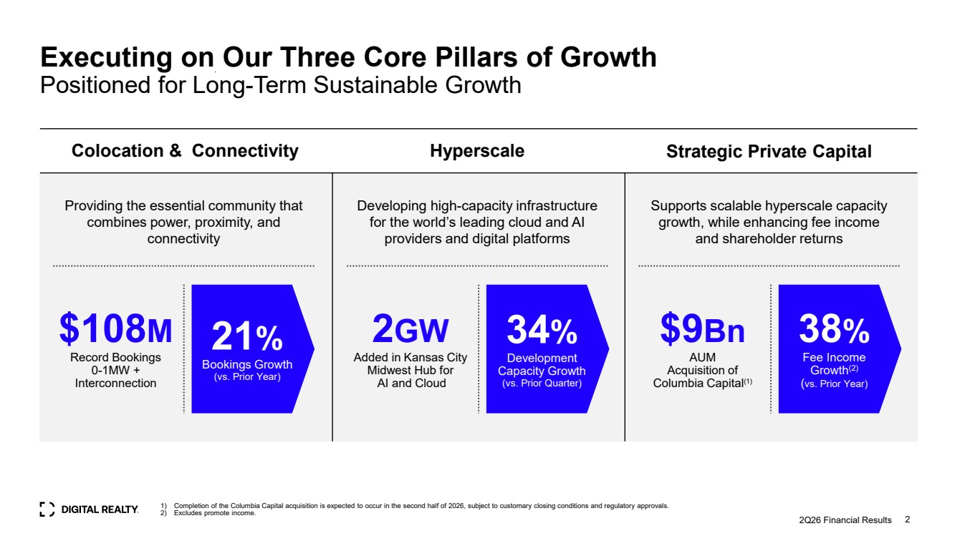 | Providing the essential community that combines power, proximity, and connectivity $108M Record Bookings 0-1MW + Interconnection Developing high-capacity infrastructure for the world’s leading cloud and AI providers and digital platforms Supports scalable hyperscale capacity growth, while enhancing fee income and shareholder returns Colocation & Connectivity Hyperscale Strategic Private Capital 2Q26 Financial Results 2 21% Bookings Growth (vs. Prior Year) Executing on Our Three Core Pillars of Growth Positioned for Long-Term Sustainable Growth 2GW Added in Kansas City Midwest Hub for AI and Cloud 34% Development Capacity Growth (vs. Prior Quarter) $9Bn AUM Acquisition of Columbia Capital(1) 38% Fee Income Growth(2) (vs. Prior Year) 1) Completion of the Columbia Capital acquisition is expected to occur in the second half of 2026, subject to customary closing conditions and regulatory approvals. 2) Excludes promote income.
 | 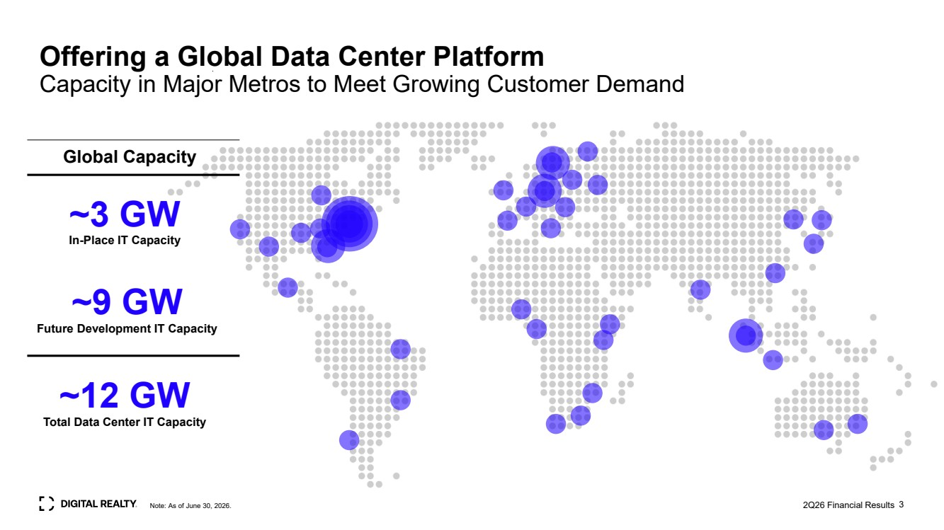 | 3 Offering a Global Data Center Platform Capacity in Major Metros to Meet Growing Customer Demand Global Capacity ~9 GW Future Development IT Capacity 2Q26 Financial Results ~3 GW In-Place IT Capacity Note: As of June 30, 2026. ~12 GW Total Data Center IT Capacity
 | 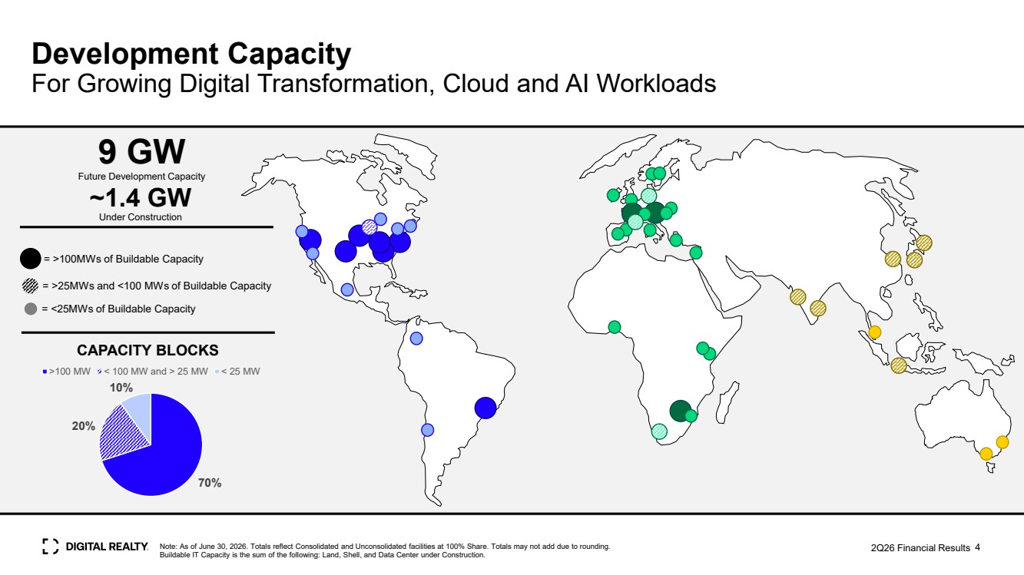 | Note: As of June 30, 2026. Totals reflect Consolidated and Unconsolidated facilities at 100% Share. Totals may not add due to rounding. Buildable IT Capacity is the sum of the following: Land, Shell, and Data Center under Construction. 4 >5 GW Future Development Capacity = >25MWs and <100 MWs of Buildable Capacity = <25MWs of Buildable Capacity = >100MWs of Buildable Capacity Development Capacity For Growing Digital Transformation, Cloud and AI Workloads Future 9 G Development Capacity W 70% 20% 10% >100 MW < 100 MW and > 25 MW < 25 MW CAPACITY BLOCKS 2Q26 Financial Results ~1.4 GW Under Construction
 | 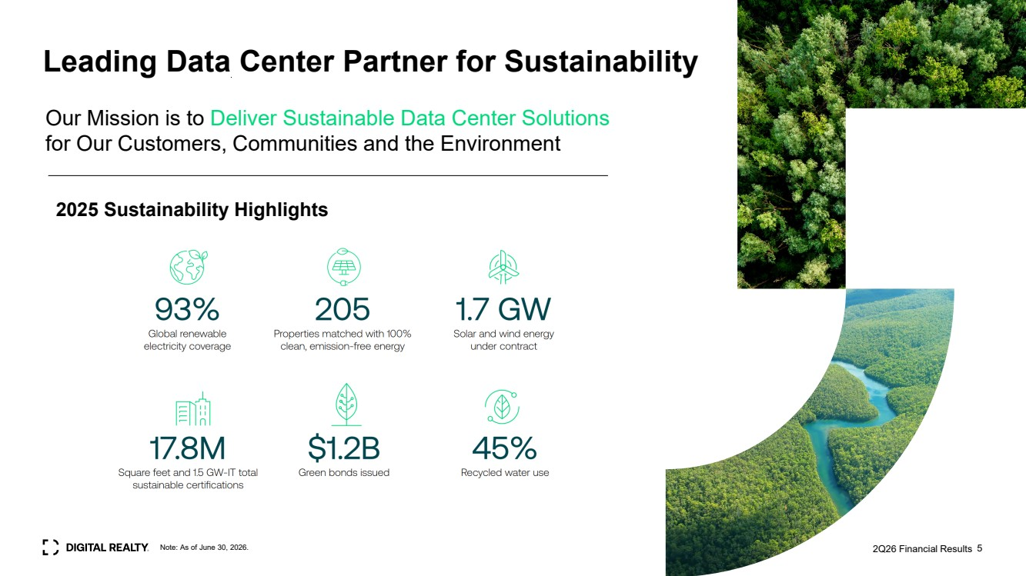 | Leading Data Center Partner for Sustainability Our Mission is to Deliver Sustainable Data Center Solutions for Our Customers, Communities and the Environment 2025 Sustainability Highlights Note: As of June 30, 2026. 2Q26 Financial Results 5
 |  | 2Q26 Financial Results 2Q26 Financial Results 6
 | 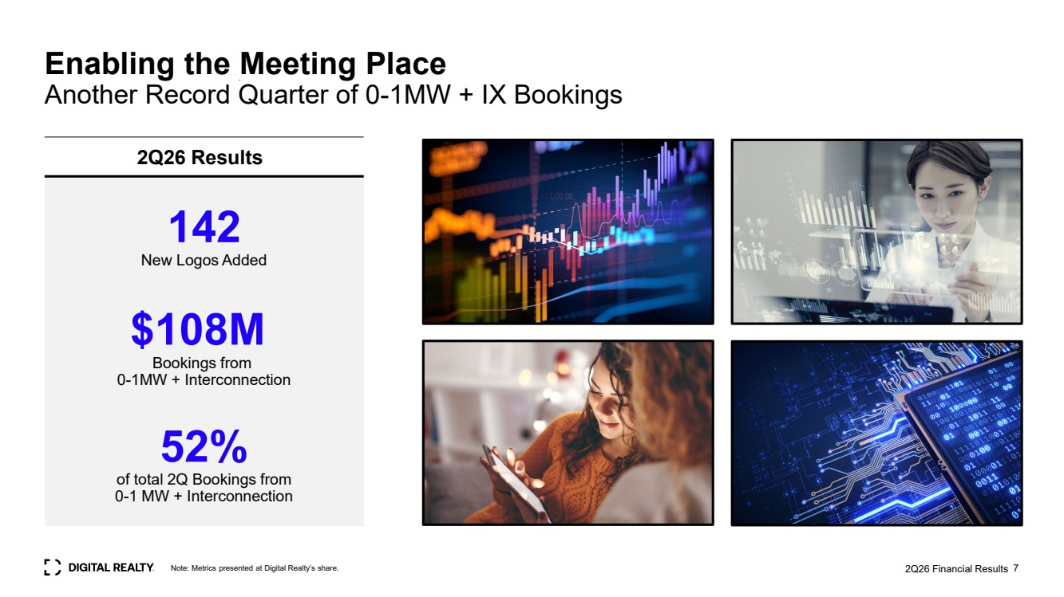 | 2Q26 Financial Results 7 Enabling the Meeting Place Another Record Quarter of 0-1MW + IX Bookings 142 New Logos Added $108M Bookings from 0-1MW + Interconnection 52% of total 2Q Bookings from 0-1 MW + Interconnection 2Q26 Results Note: Metrics presented at Digital Realty’s share.
 | 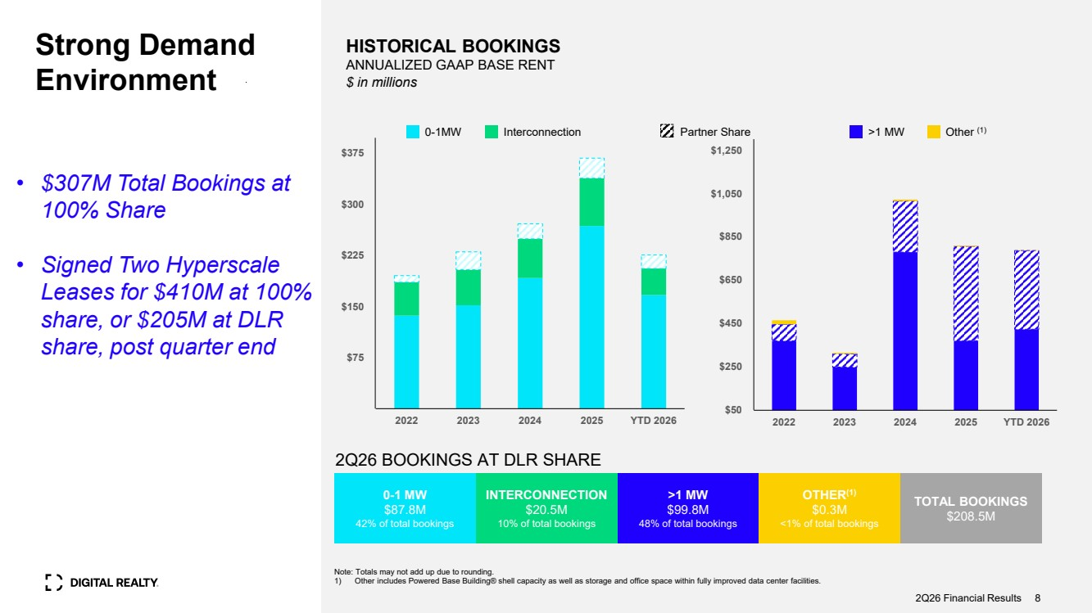 | Note: Totals may not add up due to rounding. 1) Other includes Powered Base Building® shell capacity as well as storage and office space within fully improved data center facilities. 2Q26 BOOKINGS AT DLR SHARE HISTORICAL BOOKINGS ANNUALIZED GAAP BASE RENT $ in millions Strong Demand Environment 0-1 MW $87.8M 42% of total bookings INTERCONNECTION $20.5M 10% of total bookings >1 MW $99.8M 48% of total bookings OTHER(1) $0.3M <1% of total bookings TOTAL BOOKINGS $208.5M 2Q26 Financial Results 8 0-1MW Interconnection >1 MW Other (1) • $307M Total Bookings at 100% Share • Signed Two Hyperscale Leases for $410M at 100% share, or $205M at DLR share, post quarter end $75 $150 $225 $300 $375 2022 2023 2024 2025 YTD 2026 Partner Share $50 $250 $450 $650 $850 $1,050 $1,250 2022 2023 2024 2025 YTD 2026
 | 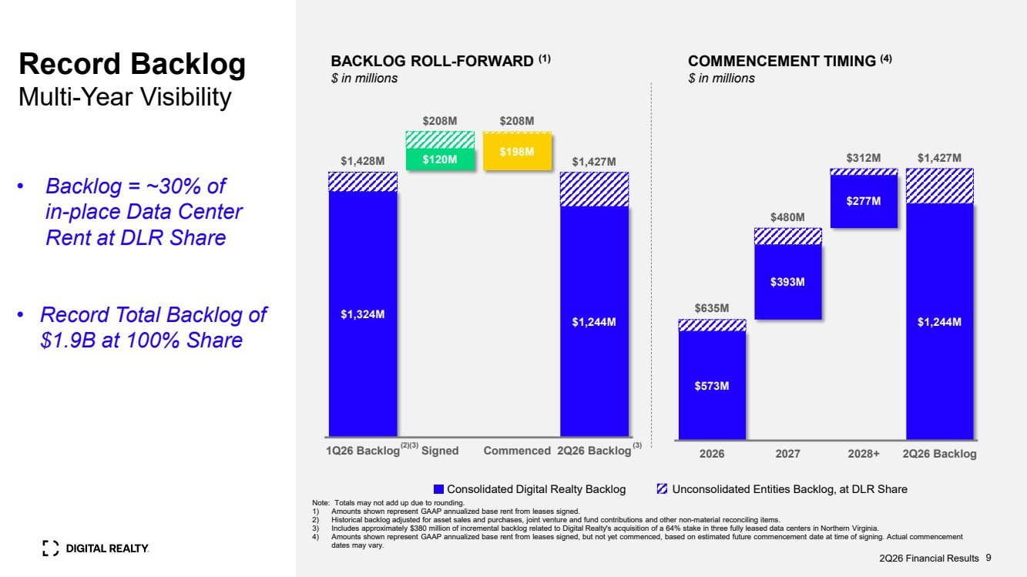 | Note: Totals may not add up due to rounding. 1) Amounts shown represent GAAP annualized base rent from leases signed. 2) Historical backlog adjusted for asset sales and purchases, joint venture and fund contributions and other non-material reconciling items. 3) Includes approximately $380 million of incremental backlog related to Digital Realty's acquisition of a 64% stake in three fully leased data centers in Northern Virginia. 4) Amounts shown represent GAAP annualized base rent from leases signed, but not yet commenced, based on estimated future commencement date at time of signing. Actual commencement dates may vary. BACKLOG ROLL-FORWARD (1) $ in millions Consolidated Digital Realty Backlog Unconsolidated Entities Backlog, at DLR Share COMMENCEMENT TIMING (4) $ in millions 2Q26 Financial Results 9 $1,324M $120M $198M $1,244M $1,428M $208M $208M $1,427M 1Q26 Backlog Signed Commenced 2Q26 Backlog (2) • Backlog = ~30% of in-place Data Center Rent at DLR Share • Record Total Backlog of $1.9B at 100% Share Record Backlog Multi-Year Visibility $573M $393M $277M $1,244M $635M $480M $312M $1,427M 2026 2027 2028+ 2Q26 Backlog (3) (3)
 | 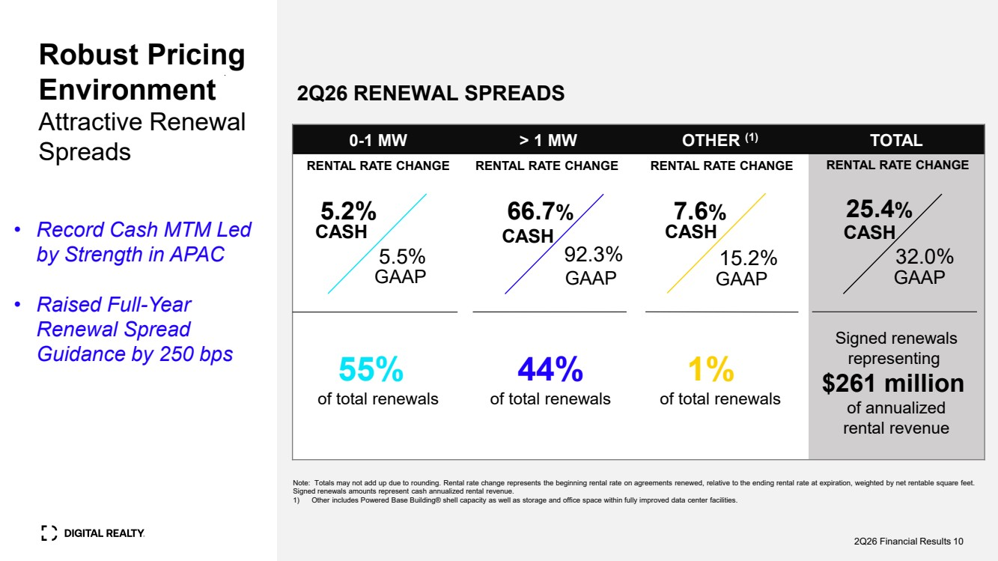 | Robust Pricing Environment Attractive Renewal Spreads 2Q26 RENEWAL SPREADS 0-1 MW > 1 MW OTHER (1) TOTAL 55% of total renewals 44% of total renewals 1% of total renewals Signed renewals representing $261 million of annualized rental revenue RENTAL RATE CHANGE RENTAL RATE CHANGE RENTAL RATE CHANGE RENTAL RATE CHANGE 5.5% 66.7% GAAP Note: Totals may not add up due to rounding. Rental rate change represents the beginning rental rate on agreements renewed, relative to the ending rental rate at expiration, weighted by net rentable square feet. Signed renewals amounts represent cash annualized rental revenue. 1) Other includes Powered Base Building® shell capacity as well as storage and office space within fully improved data center facilities. 5.2% CASH GAAP CASH 92.3% 7.6% CASH 15.2% GAAP 25.4% CASH 32.0% GAAP 2Q26 Financial Results 10 • Record Cash MTM Led by Strength in APAC • Raised Full-Year Renewal Spread Guidance by 250 bps
 | 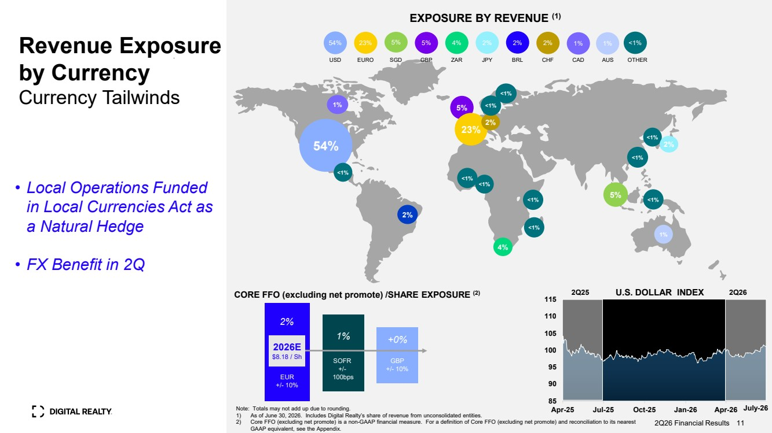 | Revenue Exposure by Currency Currency Tailwinds 1% 5% 23% 5% 54% <1% 2% 4% 2026E $8.18 / Sh 1% SOFR +/- 100bps +0% GBP +/- 10% 2% EUR +/- 10% CORE FFO (excluding net promote) /SHARE EXPOSURE (2) EXPOSURE BY REVENUE (1) Note: Totals may not add up due to rounding. 1) As of June 30, 2026. Includes Digital Realty’s share of revenue from unconsolidated entities. 2) Core FFO (excluding net promote) is a non-GAAP financial measure. For a definition of Core FFO (excluding net promote) and reconciliation to its nearest GAAP equivalent, see the Appendix. 2Q26 Financial Results 11 2% <1% • Local Operations Funded in Local Currencies Act as a Natural Hedge • FX Benefit in 2Q <1% <1% 2Q25 U.S. DOLLAR INDEX 2Q26 ZAR 4% USD EURO SGD GBP 23% 5% 5% OTHER 1% CHF 54% 2% 1% BRL CAD 2% JPY 2% <1% <1% <1% 2% July-26 <1% 1% <1% <1% 85 90 95 100 105 110 115 Apr-25 Jul-25 Oct-25 Jan-26 Apr-26 <1% AUS
 | 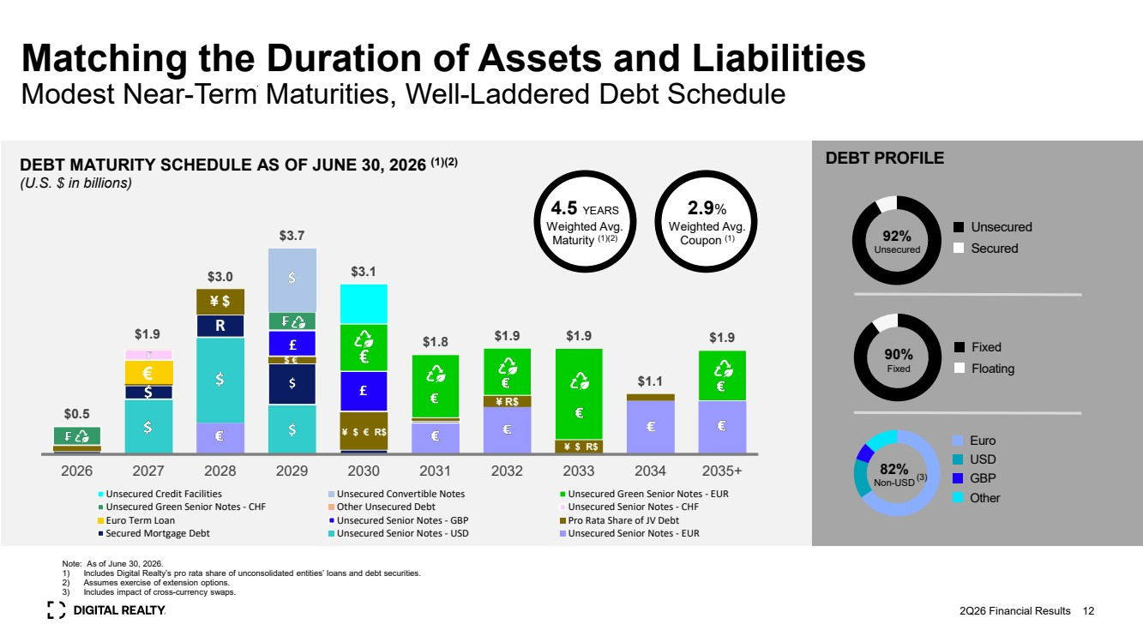 | Matching the Duration of Assets and Liabilities Modest Near-Term Maturities, Well-Laddered Debt Schedule DEBT MATURITY SCHEDULE AS OF JUNE 30, 2026 (1)(2) (U.S. $ in billions) Note: As of June 30, 2026. 1) Includes Digital Realty’s pro rata share of unconsolidated entities’ loans and debt securities. 2) Assumes exercise of extension options. 3) Includes impact of cross-currency swaps. DEBT PROFILE 92% Unsecured Unsecured Secured 82% Non-USD Euro USD GBP Other 90% Fixed Fixed Floating 2Q26 Financial Results (3) 4.5 YEARS Weighted Avg. Maturity (1)(2) 12 2.9% Weighted Avg. Coupon (1) $0.5 $1.9 $3.0 $3.7 $3.1 $1.8 $1.9 $1.9 $1.1 $1.9 2026 2027 2028 2029 2030 2031 2032 2033 2034 2035+ Unsecured Credit Facilities Unsecured Convertible Notes Unsecured Green Senior Notes - EUR Unsecured Green Senior Notes - CHF Other Unsecured Debt Unsecured Senior Notes - CHF Euro Term Loan Unsecured Senior Notes - GBP Pro Rata Share of JV Debt Secured Mortgage Debt Unsecured Senior Notes - USD Unsecured Senior Notes - EUR R € ¥ $ $ € ¥ $ € R$ ¥ R$ ¥ $ R$
 | 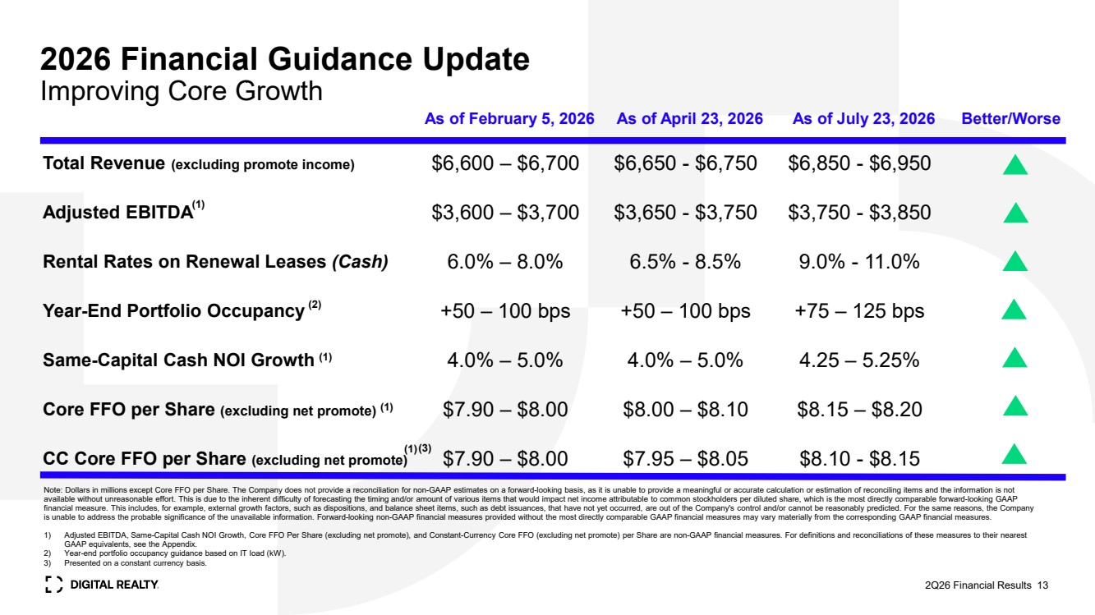 | 2026 Financial Guidance Update Improving Core Growth (1) (1) (2) 2Q26 Financial Results 13 As of February 5, 2026 As of April 23, 2026 As of July 23, 2026 Better/Worse Total Revenue (excluding promote income) $6,600 – $6,700 $6,650 - $6,750 $6,850 - $6,950 Adjusted EBITDA $3,600 – $3,700 $3,650 - $3,750 $3,750 - $3,850 Rental Rates on Renewal Leases (Cash) 6.0% – 8.0% 6.5% - 8.5% 9.0% - 11.0% Year-End Portfolio Occupancy +50 – 100 bps +50 – 100 bps +75 – 125 bps Same-Capital Cash NOI Growth 4.0% – 5.0% 4.0% – 5.0% 4.25 – 5.25% Core FFO per Share (excluding net promote) $7.90 – $8.00 $8.00 – $8.10 $8.15 – $8.20 CC Core FFO per Share (excluding net promote) $7.90 – $8.00 $7.95 – $8.05 $8.10 - $8.15 (1) Note: Dollars in millions except Core FFO per Share. The Company does not provide a reconciliation for non-GAAP estimates on a forward-looking basis, as it is unable to provide a meaningful or accurate calculation or estimation of reconciling items and the information is not available without unreasonable effort. This is due to the inherent difficulty of forecasting the timing and/or amount of various items that would impact net income attributable to common stockholders per diluted share, which is the most directly comparable forward-looking GAAP financial measure. This includes, for example, external growth factors, such as dispositions, and balance sheet items, such as debt issuances, that have not yet occurred, are out of the Company's control and/or cannot be reasonably predicted. For the same reasons, the Company is unable to address the probable significance of the unavailable information. Forward-looking non-GAAP financial measures provided without the most directly comparable GAAP financial measures may vary materially from the corresponding GAAP financial measures. 1) Adjusted EBITDA, Same-Capital Cash NOI Growth, Core FFO Per Share (excluding net promote), and Constant-Currency Core FFO (excluding net promote) per Share are non-GAAP financial measures. For definitions and reconciliations of these measures to their nearest GAAP equivalents, see the Appendix. 2) Year-end portfolio occupancy guidance based on IT load (kW). 3) Presented on a constant currency basis. (1) (3)
 | 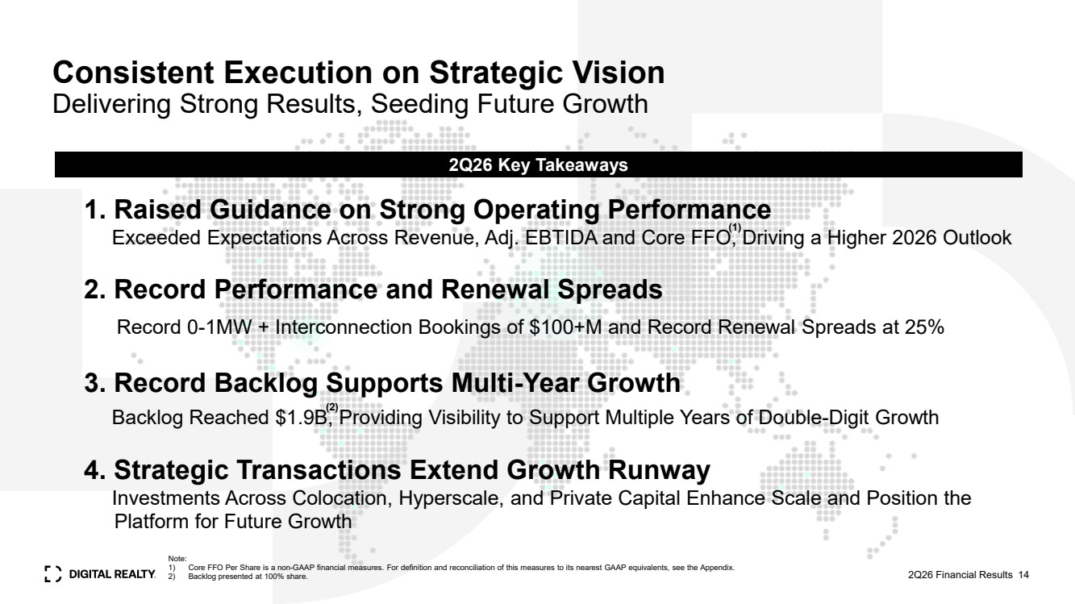 | Consistent Execution on Strategic Vision Delivering Strong Results, Seeding Future Growth 2Q26 Key Takeaways 2Q26 Financial Results 14 1. Raised Guidance on Strong Operating Performance Exceeded Expectations Across Revenue, Adj. EBTIDA and Core FFO, Driving a Higher 2026 Outlook 2. Record Performance and Renewal Spreads 3. Record Backlog Supports Multi-Year Growth Backlog Reached $1.9B, Providing Visibility to Support Multiple Years of Double-Digit Growth 4. Strategic Transactions Extend Growth Runway Investments Across Colocation, Hyperscale, and Private Capital Enhance Scale and Position the kkkPlatform for Future Growth Record 0-1MW + Interconnection Bookings of $100+M and Record Renewal Spreads at 25% (1) Note: 1) Core FFO Per Share is a non-GAAP financial measures. For definition and reconciliation of this measures to its nearest GAAP equivalents, see the Appendix. 2) Backlog presented at 100% share. (2)
 |  | Appendix 2Q26 Financial Results 15
 | 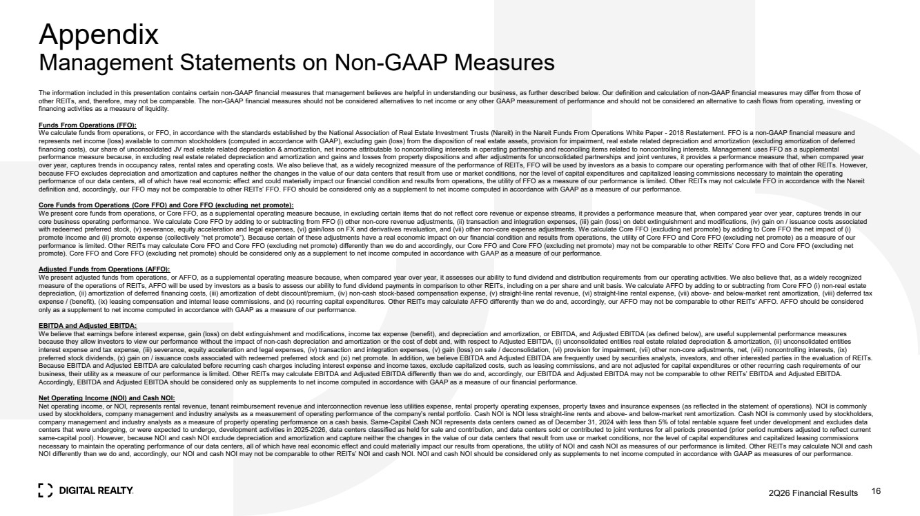 | Appendix Management Statements on Non-GAAP Measures 2Q26 Financial Results 16 The information included in this presentation contains certain non-GAAP financial measures that management believes are helpful in understanding our business, as further described below. Our definition and calculation of non-GAAP financial measures may differ from those of other REITs, and, therefore, may not be comparable. The non-GAAP financial measures should not be considered alternatives to net income or any other GAAP measurement of performance and should not be considered an alternative to cash flows from operating, investing or financing activities as a measure of liquidity. Funds From Operations (FFO): We calculate funds from operations, or FFO, in accordance with the standards established by the National Association of Real Estate Investment Trusts (Nareit) in the Nareit Funds From Operations White Paper - 2018 Restatement. FFO is a non-GAAP financial measure and represents net income (loss) available to common stockholders (computed in accordance with GAAP), excluding gain (loss) from the disposition of real estate assets, provision for impairment, real estate related depreciation and amortization (excluding amortization of deferred financing costs), our share of unconsolidated JV real estate related depreciation & amortization, net income attributable to noncontrolling interests in operating partnership and reconciling items related to noncontrolling interests. Management uses FFO as a supplemental performance measure because, in excluding real estate related depreciation and amortization and gains and losses from property dispositions and after adjustments for unconsolidated partnerships and joint ventures, it provides a performance measure that, when compared year over year, captures trends in occupancy rates, rental rates and operating costs. We also believe that, as a widely recognized measure of the performance of REITs, FFO will be used by investors as a basis to compare our operating performance with that of other REITs. However, because FFO excludes depreciation and amortization and captures neither the changes in the value of our data centers that result from use or market conditions, nor the level of capital expenditures and capitalized leasing commissions necessary to maintain the operating performance of our data centers, all of which have real economic effect and could materially impact our financial condition and results from operations, the utility of FFO as a measure of our performance is limited. Other REITs may not calculate FFO in accordance with the Nareit definition and, accordingly, our FFO may not be comparable to other REITs’ FFO. FFO should be considered only as a supplement to net income computed in accordance with GAAP as a measure of our performance. Core Funds from Operations (Core FFO) and Core FFO (excluding net promote): We present core funds from operations, or Core FFO, as a supplemental operating measure because, in excluding certain items that do not reflect core revenue or expense streams, it provides a performance measure that, when compared year over year, captures trends in our core business operating performance. We calculate Core FFO by adding to or subtracting from FFO (i) other non-core revenue adjustments, (ii) transaction and integration expenses, (iii) gain (loss) on debt extinguishment and modifications, (iv) gain on / issuance costs associated with redeemed preferred stock, (v) severance, equity acceleration and legal expenses, (vi) gain/loss on FX and derivatives revaluation, and (vii) other non-core expense adjustments. We calculate Core FFO (excluding net promote) by adding to Core FFO the net impact of (i) promote income and (ii) promote expense (collectively “net promote”). Because certain of these adjustments have a real economic impact on our financial condition and results from operations, the utility of Core FFO and Core FFO (excluding net promote) as a measure of our performance is limited. Other REITs may calculate Core FFO and Core FFO (excluding net promote) differently than we do and accordingly, our Core FFO and Core FFO (excluding net promote) may not be comparable to other REITs’ Core FFO and Core FFO (excluding net promote). Core FFO and Core FFO (excluding net promote) should be considered only as a supplement to net income computed in accordance with GAAP as a measure of our performance. Adjusted Funds from Operations (AFFO): We present adjusted funds from operations, or AFFO, as a supplemental operating measure because, when compared year over year, it assesses our ability to fund dividend and distribution requirements from our operating activities. We also believe that, as a widely recognized measure of the operations of REITs, AFFO will be used by investors as a basis to assess our ability to fund dividend payments in comparison to other REITs, including on a per share and unit basis. We calculate AFFO by adding to or subtracting from Core FFO (i) non-real estate depreciation, (ii) amortization of deferred financing costs, (iii) amortization of debt discount/premium, (iv) non-cash stock-based compensation expense, (v) straight-line rental revenue, (vi) straight-line rental expense, (vii) above- and below-market rent amortization, (viii) deferred tax expense / (benefit), (ix) leasing compensation and internal lease commissions, and (x) recurring capital expenditures. Other REITs may calculate AFFO differently than we do and, accordingly, our AFFO may not be comparable to other REITs’ AFFO. AFFO should be considered only as a supplement to net income computed in accordance with GAAP as a measure of our performance. EBITDA and Adjusted EBITDA: We believe that earnings before interest expense, gain (loss) on debt extinguishment and modifications, income tax expense (benefit), and depreciation and amortization, or EBITDA, and Adjusted EBITDA (as defined below), are useful supplemental performance measures because they allow investors to view our performance without the impact of non-cash depreciation and amortization or the cost of debt and, with respect to Adjusted EBITDA, (i) unconsolidated entities real estate related depreciation & amortization, (ii) unconsolidated entities interest expense and tax expense, (iii) severance, equity acceleration and legal expenses, (iv) transaction and integration expenses, (v) gain (loss) on sale / deconsolidation, (vi) provision for impairment, (vii) other non-core adjustments, net, (viii) noncontrolling interests, (ix) preferred stock dividends, (x) gain on / issuance costs associated with redeemed preferred stock and (xi) net promote. In addition, we believe EBITDA and Adjusted EBITDA are frequently used by securities analysts, investors, and other interested parties in the evaluation of REITs. Because EBITDA and Adjusted EBITDA are calculated before recurring cash charges including interest expense and income taxes, exclude capitalized costs, such as leasing commissions, and are not adjusted for capital expenditures or other recurring cash requirements of our business, their utility as a measure of our performance is limited. Other REITs may calculate EBITDA and Adjusted EBITDA differently than we do and, accordingly, our EBITDA and Adjusted EBITDA may not be comparable to other REITs’ EBITDA and Adjusted EBITDA. Accordingly, EBITDA and Adjusted EBITDA should be considered only as supplements to net income computed in accordance with GAAP as a measure of our financial performance. Net Operating Income (NOI) and Cash NOI: Net operating income, or NOI, represents rental revenue, tenant reimbursement revenue and interconnection revenue less utilities expense, rental property operating expenses, property taxes and insurance expenses (as reflected in the statement of operations). NOI is commonly used by stockholders, company management and industry analysts as a measurement of operating performance of the company’s rental portfolio. Cash NOI is NOI less straight-line rents and above- and below-market rent amortization. Cash NOI is commonly used by stockholders, company management and industry analysts as a measure of property operating performance on a cash basis. Same-Capital Cash NOI represents data centers owned as of December 31, 2024 with less than 5% of total rentable square feet under development and excludes data centers that were undergoing, or were expected to undergo, development activities in 2025-2026, data centers classified as held for sale and contribution, and data centers sold or contributed to joint ventures for all periods presented (prior period numbers adjusted to reflect current same-capital pool). However, because NOI and cash NOI exclude depreciation and amortization and capture neither the changes in the value of our data centers that result from use or market conditions, nor the level of capital expenditures and capitalized leasing commissions necessary to maintain the operating performance of our data centers, all of which have real economic effect and could materially impact our results from operations, the utility of NOI and cash NOI as measures of our performance is limited. Other REITs may calculate NOI and cash NOI differently than we do and, accordingly, our NOI and cash NOI may not be comparable to other REITs’ NOI and cash NOI. NOI and cash NOI should be considered only as supplements to net income computed in accordance with GAAP as measures of our performance.
 | 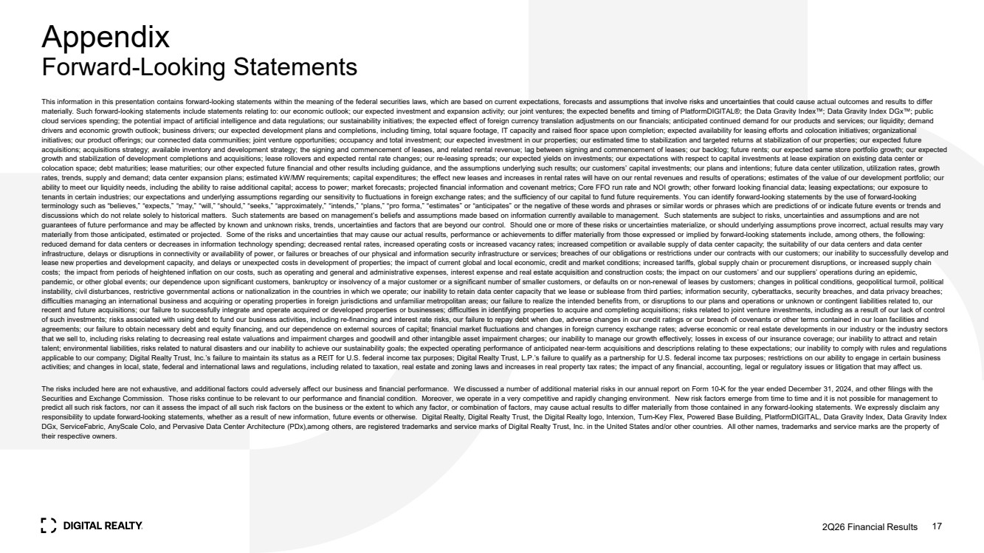 | Appendix Forward-Looking Statements This information in this presentation contains forward-looking statements within the meaning of the federal securities laws, which are based on current expectations, forecasts and assumptions that involve risks and uncertainties that could cause actual outcomes and results to differ materially. Such forward-looking statements include statements relating to: our economic outlook; our expected investment and expansion activity; our joint ventures; the expected benefits and timing of PlatformDIGITAL®; the Data Gravity Index ; Data Gravity Index DGx ; public cloud services spending; the potential impact of artificial intelligence and data regulations; our sustainability initiatives; the expected effect of foreign currency translation adjustments on our financials; anticipated continued demand for our products and services; our liquidity; demand drivers and economic growth outlook; business drivers; our expected development plans and completions, including timing, total square footage, IT capacity and raised floor space upon completion; expected availability for leasing efforts and colocation initiatives; organizational initiatives; our product offerings; our connected data communities; joint venture opportunities; occupancy and total investment; our expected investment in our properties; our estimated time to stabilization and targeted returns at stabilization of our properties; our expected future acquisitions; acquisitions strategy; available inventory and development strategy; the signing and commencement of leases, and related rental revenue; lag between signing and commencement of leases; our backlog; future rents; our expected same store portfolio growth; our expected growth and stabilization of development completions and acquisitions; lease rollovers and expected rental rate changes; our re-leasing spreads; our expected yields on investments; our expectations with respect to capital investments at lease expiration on existing data center or colocation space; debt maturities; lease maturities; our other expected future financial and other results including guidance, and the assumptions underlying such results; our customers’ capital investments; our plans and intentions; future data center utilization, utilization rates, growth rates, trends, supply and demand; data center expansion plans; estimated kW/MW requirements; capital expenditures; the effect new leases and increases in rental rates will have on our rental revenues and results of operations; estimates of the value of our development portfolio; our ability to meet our liquidity needs, including the ability to raise additional capital; access to power; market forecasts; projected financial information and covenant metrics; Core FFO run rate and NOI growth; other forward looking financial data; leasing expectations; our exposure to tenants in certain industries; our expectations and underlying assumptions regarding our sensitivity to fluctuations in foreign exchange rates; and the sufficiency of our capital to fund future requirements. You can identify forward-looking statements by the use of forward-looking terminology such as “believes,” “expects,” “may,” “will,” “should,” “seeks,” “approximately,” “intends,” “plans,” “pro forma,” “estimates” or “anticipates” or the negative of these words and phrases or similar words or phrases which are predictions of or indicate future events or trends and discussions which do not relate solely to historical matters. Such statements are based on management’s beliefs and assumptions made based on information currently available to management. Such statements are subject to risks, uncertainties and assumptions and are not guarantees of future performance and may be affected by known and unknown risks, trends, uncertainties and factors that are beyond our control. Should one or more of these risks or uncertainties materialize, or should underlying assumptions prove incorrect, actual results may vary materially from those anticipated, estimated or projected. Some of the risks and uncertainties that may cause our actual results, performance or achievements to differ materially from those expressed or implied by forward-looking statements include, among others, the following: reduced demand for data centers or decreases in information technology spending; decreased rental rates, increased operating costs or increased vacancy rates; increased competition or available supply of data center capacity; the suitability of our data centers and data center infrastructure, delays or disruptions in connectivity or availability of power, or failures or breaches of our physical and information security infrastructure or services; breaches of our obligations or restrictions under our contracts with our customers; our inability to successfully develop and lease new properties and development capacity, and delays or unexpected costs in development of properties; the impact of current global and local economic, credit and market conditions; increased tariffs, global supply chain or procurement disruptions, or increased supply chain costs; the impact from periods of heightened inflation on our costs, such as operating and general and administrative expenses, interest expense and real estate acquisition and construction costs; the impact on our customers’ and our suppliers’ operations during an epidemic, pandemic, or other global events; our dependence upon significant customers, bankruptcy or insolvency of a major customer or a significant number of smaller customers, or defaults on or non-renewal of leases by customers; changes in political conditions, geopolitical turmoil, political instability, civil disturbances, restrictive governmental actions or nationalization in the countries in which we operate; our inability to retain data center capacity that we lease or sublease from third parties; information security, cyberattacks, security breaches, and data privacy breaches; difficulties managing an international business and acquiring or operating properties in foreign jurisdictions and unfamiliar metropolitan areas; our failure to realize the intended benefits from, or disruptions to our plans and operations or unknown or contingent liabilities related to, our recent and future acquisitions; our failure to successfully integrate and operate acquired or developed properties or businesses; difficulties in identifying properties to acquire and completing acquisitions; risks related to joint venture investments, including as a result of our lack of control of such investments; risks associated with using debt to fund our business activities, including re-financing and interest rate risks, our failure to repay debt when due, adverse changes in our credit ratings or our breach of covenants or other terms contained in our loan facilities and agreements; our failure to obtain necessary debt and equity financing, and our dependence on external sources of capital; financial market fluctuations and changes in foreign currency exchange rates; adverse economic or real estate developments in our industry or the industry sectors that we sell to, including risks relating to decreasing real estate valuations and impairment charges and goodwill and other intangible asset impairment charges; our inability to manage our growth effectively; losses in excess of our insurance coverage; our inability to attract and retain talent; environmental liabilities, risks related to natural disasters and our inability to achieve our sustainability goals; the expected operating performance of anticipated near-term acquisitions and descriptions relating to these expectations; our inability to comply with rules and regulations applicable to our company; Digital Realty Trust, Inc.’s failure to maintain its status as a REIT for U.S. federal income tax purposes; Digital Realty Trust, L.P.’s failure to qualify as a partnership for U.S. federal income tax purposes; restrictions on our ability to engage in certain business activities; and changes in local, state, federal and international laws and regulations, including related to taxation, real estate and zoning laws and increases in real property tax rates; the impact of any financial, accounting, legal or regulatory issues or litigation that may affect us. The risks included here are not exhaustive, and additional factors could adversely affect our business and financial performance. We discussed a number of additional material risks in our annual report on Form 10-K for the year ended December 31, 2024, and other filings with the Securities and Exchange Commission. Those risks continue to be relevant to our performance and financial condition. Moreover, we operate in a very competitive and rapidly changing environment. New risk factors emerge from time to time and it is not possible for management to predict all such risk factors, nor can it assess the impact of all such risk factors on the business or the extent to which any factor, or combination of factors, may cause actual results to differ materially from those contained in any forward-looking statements. We expressly disclaim any responsibility to update forward-looking statements, whether as a result of new information, future events or otherwise. Digital Realty, Digital Realty Trust, the Digital Realty logo, Interxion, Turn-Key Flex, Powered Base Building, PlatformDIGITAL, Data Gravity Index, Data Gravity Index DGx, ServiceFabric, AnyScale Colo, and Pervasive Data Center Architecture (PDx),among others, are registered trademarks and service marks of Digital Realty Trust, Inc. in the United States and/or other countries. All other names, trademarks and service marks are the property of their respective owners. 2Q26 Financial Results 17
 | 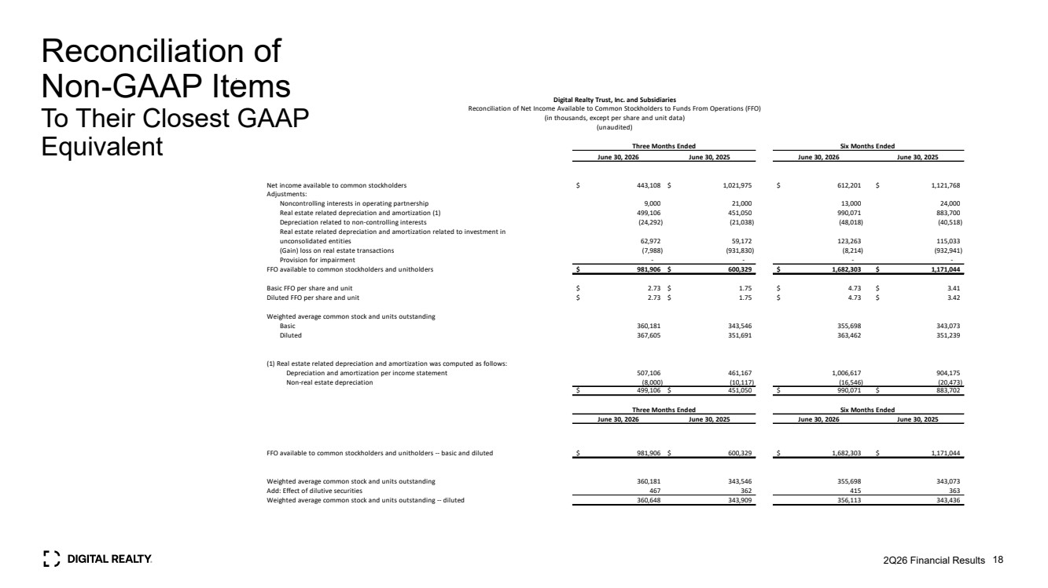 | Reconciliation of Non-GAAP Items To Their Closest GAAP Equivalent 2Q26 Financial Results 18 June 30, 2026 June 30, 2025 June 30, 2026 June 30, 2025 Net income available to common stockholders $ 443,108 $ 1,021,975 $ 612,201 $ 1,121,768 Adjustments: Noncontrolling interests in operating partnership 9,000 21,000 13,000 24,000 Real estate related depreciation and amortization (1) 499,106 451,050 990,071 883,700 Depreciation related to non-controlling interests (24,292) (21,038) (48,018) (40,518) Real estate related depreciation and amortization related to investment in unconsolidated entities 62,972 59,172 123,263 115,033 (Gain) loss on real estate transactions (7,988) (931,830) (8,214) (932,941) Provision for impairment - - - - FFO available to common stockholders and unitholders $ 981,906 $ 600,329 $ 1,682,303 $ 1,171,044 Basic FFO per share and unit $ 2.73 $ 1.75 $ 4.73 $ 3.41 Diluted FFO per share and unit $ 2.73 $ 1.75 $ 4.73 $ 3.42 Weighted average common stock and units outstanding Basic 360,181 343,546 355,698 343,073 Diluted 367,605 351,691 363,462 351,239 (1) Real estate related depreciation and amortization was computed as follows: Depreciation and amortization per income statement 507,106 461,167 1,006,617 904,175 Non-real estate depreciation (8,000) (10,117) (16,546) (20,473) $ 499,106 $ 451,050 $ 990,071 $ 883,702 June 30, 2026 June 30, 2025 June 30, 2026 June 30, 2025 FFO available to common stockholders and unitholders -- basic and diluted $ 981,906 $ 600,329 $ 1,682,303 $ 1,171,044 Weighted average common stock and units outstanding 360,181 343,546 355,698 343,073 Add: Effect of dilutive securities 467 362 415 363 Weighted average common stock and units outstanding -- diluted 360,648 343,909 356,113 343,436 Three Months Ended Six Months Ended Six Months Ended Digital Realty Trust, Inc. and Subsidiaries Reconciliation of Net Income Available to Common Stockholders to Funds From Operations (FFO) (in thousands, except per share and unit data) (unaudited) Three Months Ended
 | 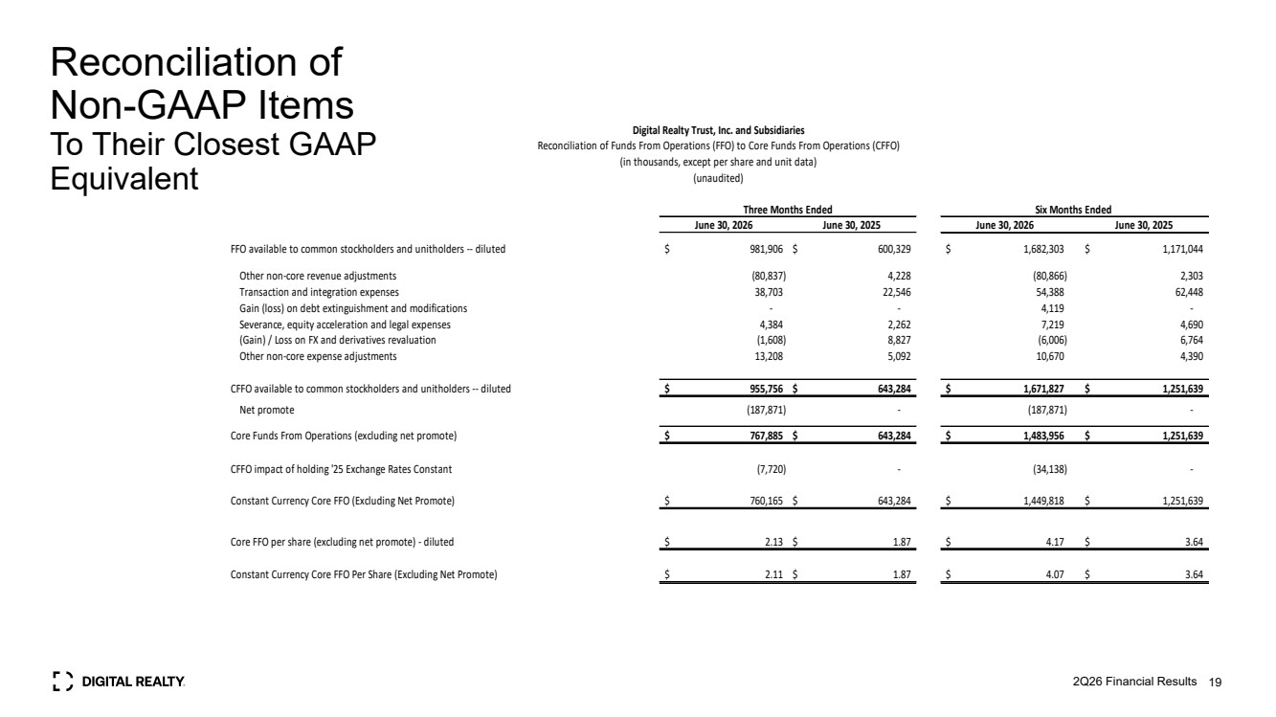 | Reconciliation of Non-GAAP Items To Their Closest GAAP Equivalent 2Q26 Financial Results 19 June 30, 2026 June 30, 2025 June 30, 2026 June 30, 2025 FFO available to common stockholders and unitholders -- diluted $ 981,906 $ 600,329 $ 1,682,303 $ 1,171,044 Other non-core revenue adjustments (80,837) 4,228 (80,866) 2,303 Transaction and integration expenses 38,703 22,546 54,388 62,448 Gain (loss) on debt extinguishment and modifications - - 4,119 - Severance, equity acceleration and legal expenses 4,384 2,262 7,219 4,690 (Gain) / Loss on FX and derivatives revaluation (1,608) 8,827 (6,006) 6,764 Other non-core expense adjustments 13,208 5,092 10,670 4,390 CFFO available to common stockholders and unitholders -- diluted $ 955,756 $ 643,284 $ 1,671,827 $ 1,251,639 Net promote (187,871) - (187,871) - Core Funds From Operations (excluding net promote) $ 767,885 $ 643,284 $ 1,483,956 $ 1,251,639 CFFO impact of holding '25 Exchange Rates Constant (7,720) - (34,138) - Constant Currency Core FFO (Excluding Net Promote) $ 760,165 $ 643,284 $ 1,449,818 $ 1,251,639 Core FFO per share (excluding net promote) - diluted $ 2.13 $ 1.87 $ 4.17 $ 3.64 Constant Currency Core FFO Per Share (Excluding Net Promote) $ 2.11 $ 1.87 $ 4.07 $ 3.64 Digital Realty Trust, Inc. and Subsidiaries Reconciliation of Funds From Operations (FFO) to Core Funds From Operations (CFFO) (in thousands, except per share and unit data) (unaudited) Three Months Ended Six Months Ended
 | 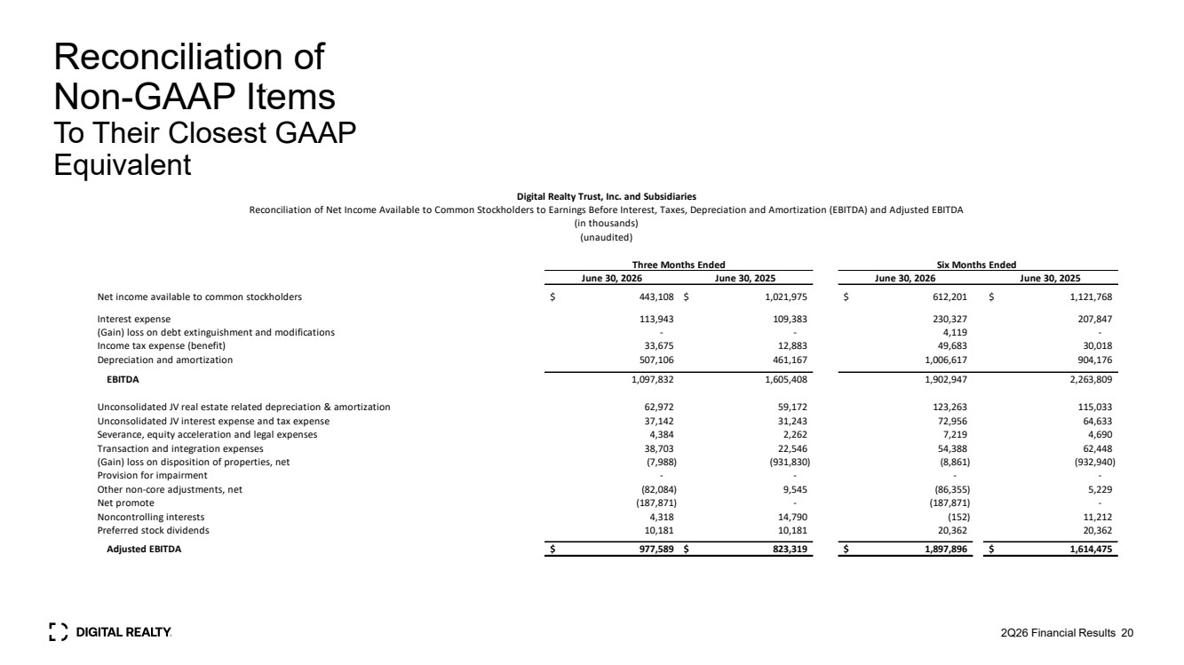 | Reconciliation of Non-GAAP Items To Their Closest GAAP Equivalent 2Q26 Financial Results 20 June 30, 2026 June 30, 2025 June 30, 2026 June 30, 2025 Net income available to common stockholders $ 443,108 $ 1,021,975 $ 612,201 $ 1,121,768 Interest expense 113,943 109,383 230,327 207,847 (Gain) loss on debt extinguishment and modifications - - 4,119 - Income tax expense (benefit) 33,675 12,883 49,683 30,018 Depreciation and amortization 507,106 461,167 1,006,617 904,176 EBITDA 1,097,832 1,605,408 1,902,947 2,263,809 Unconsolidated JV real estate related depreciation & amortization 62,972 59,172 123,263 115,033 Unconsolidated JV interest expense and tax expense 37,142 31,243 72,956 64,633 Severance, equity acceleration and legal expenses 4,384 2,262 7,219 4,690 Transaction and integration expenses 38,703 22,546 54,388 62,448 (Gain) loss on disposition of properties, net (7,988) (931,830) (8,861) (932,940) Provision for impairment - - - - Other non-core adjustments, net (82,084) 9,545 (86,355) 5,229 Net promote (187,871) - (187,871) - Noncontrolling interests 4,318 14,790 (152) 11,212 Preferred stock dividends 10,181 10,181 20,362 20,362 Adjusted EBITDA $ 977,589 $ 823,319 $ 1,897,896 $ 1,614,475 Digital Realty Trust, Inc. and Subsidiaries Reconciliation of Net Income Available to Common Stockholders to Earnings Before Interest, Taxes, Depreciation and Amortization (EBITDA) and Adjusted EBITDA (in thousands) (unaudited) Three Months Ended Six Months Ended
 | 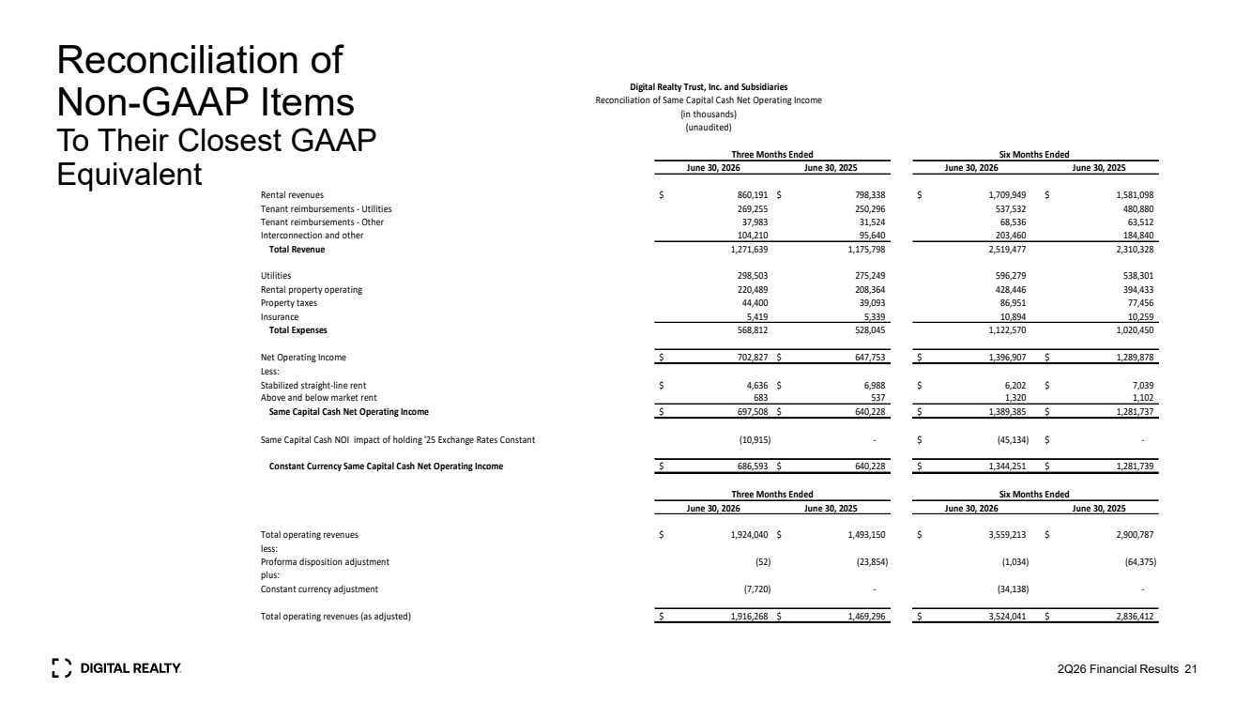 | Reconciliation of Non-GAAP Items To Their Closest GAAP Equivalent 2Q26 Financial Results 21 June 30, 2026 June 30, 2025 June 30, 2026 June 30, 2025 Rental revenues $ 860,191 $ 798,338 $ 1,709,949 $ 1,581,098 Tenant reimbursements - Utilities 269,255 250,296 537,532 480,880 Tenant reimbursements - Other 37,983 31,524 68,536 63,512 Interconnection and other 104,210 95,640 203,460 184,840 Total Revenue 1,271,639 1,175,798 2,519,477 2,310,328 Utilities 298,503 275,249 596,279 538,301 Rental property operating 220,489 208,364 428,446 394,433 Property taxes 44,400 39,093 86,951 77,456 Insurance 5,419 5,339 10,894 10,259 Total Expenses 568,812 528,045 1,122,570 1,020,450 Net Operating Income $ 702,827 $ 647,753 $ 1,396,907 $ 1,289,878 Less: Stabilized straight-line rent $ 4,636 $ 6,988 $ 6,202 $ 7,039 Above and below market rent 683 537 1,320 1,102 Same Capital Cash Net Operating Income $ 697,508 $ 640,228 $ 1,389,385 $ 1,281,737 Same Capital Cash NOI impact of holding '25 Exchange Rates Constant (10,915) - $ (45,134) $ - Constant Currency Same Capital Cash Net Operating Income $ 686,593 $ 640,228 $ 1,344,251 $ 1,281,739 June 30, 2026 June 30, 2025 June 30, 2026 June 30, 2025 Total operating revenues $ 1,924,040 $ 1,493,150 $ 3,559,213 $ 2,900,787 less: Proforma disposition adjustment (52) (23,854) (1,034) (64,375) plus: Constant currency adjustment (7,720) - (34,138) - Total operating revenues (as adjusted) $ 1,916,268 $ 1,469,296 $ 3,524,041 $ 2,836,412 Three Months Ended Six Months Ended Three Months Ended Six Months Ended Digital Realty Trust, Inc. and Subsidiaries Reconciliation of Same Capital Cash Net Operating Income (in thousands) (unaudited)
 | 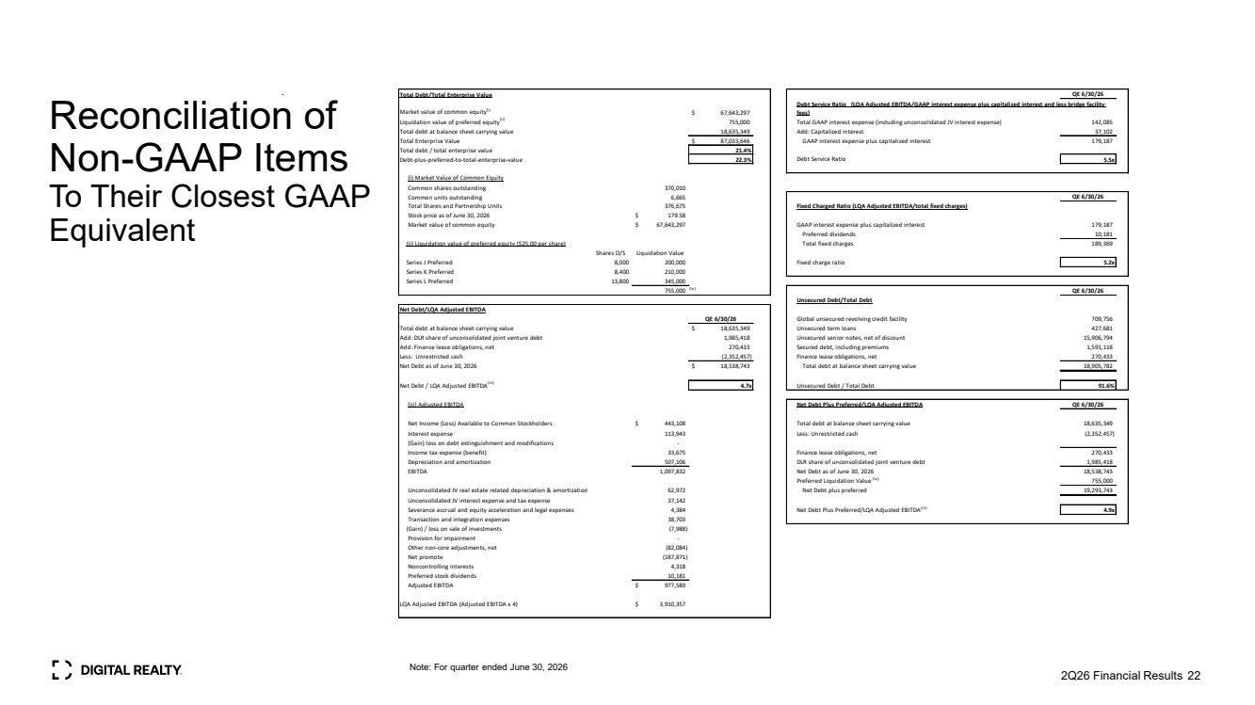 | Reconciliation of Non-GAAP Items To Their Closest GAAP Equivalent 2Q26 Financial Results 22 Note: For quarter ended June 30, 2026 Total Debt/Total Enterprise Value QE 6/30/26 Market value of common equity(i) $ 67,643,297 Liquidation value of preferred equity(ii) 755,000 Total GAAP interest expense (including unconsolidated JV interest expense) 142,085 Total debt at balance sheet carrying value 18,635,349 Add: Capitalized interest 37,102 Total Enterprise Value $ 87,033,646 GAAP interest expense plus capitalized interest 179,187 Total debt / total enterprise value 21.4% Debt-plus-preferred-to-total-enterprise-value 22.3% Debt Service Ratio 5.5x (i) Market Value of Common Equity Common shares outstanding 370,010 Common units outstanding 6,665 QE 6/30/26 Total Shares and Partnership Units 376,675 Fixed Charged Ratio (LQA Adjusted EBITDA/total fixed charges) Stock price as of June 30, 2026 $ 179.58 Market value of common equity $ 67,643,297 GAAP interest expense plus capitalized interest 179,187 Preferred dividends 10,181 (ii) Liquidation value of preferred equity ($25.00 per share) Total fixed charges 189,369 Shares O/S Liquidation Value Series J Preferred 8,000 200,000 Fixed charge ratio 5.2x Series K Preferred 8,400 210,000 Series L Preferred 13,800 345,000 755,000 (iv) QE 6/30/26 Unsecured Debt/Total Debt Net Debt/LQA Adjusted EBITDA QE 6/30/26 Global unsecured revolving credit facility 709,756 Total debt at balance sheet carrying value $ 18,635,349 Unsecured term loans 427,681 Add: DLR share of unconsolidated joint venture debt 1,985,418 Unsecured senior notes, net of discount 15,906,794 Add: Finance lease obligations, net 270,433 Secured debt, including premiums 1,591,118 Less: Unrestricted cash (2,352,457) Finance lease obligations, net 270,433 Net Debt as of June 30, 2026 $ 18,538,743 Total debt at balance sheet carrying value 18,905,782 Net Debt / LQA Adjusted EBITDA(iii) 4.7x Unsecured Debt / Total Debt 91.6% (iii) Adjusted EBITDA Net Debt Plus Preferred/LQA Adjusted EBITDA QE 6/30/26 Net Income (Loss) Available to Common Stockholders $ 443,108 Total debt at balance sheet carrying value 18,635,349 Interest expense 113,943 Less: Unrestricted cash (2,352,457) (Gain) loss on debt extinguishment and modifications - Income tax expense (benefit) 33,675 Finance lease obligations, net 270,433 Depreciation and amortization 507,106 DLR share of unconsolidated joint venture debt 1,985,418 EBITDA 1,097,832 Net Debt as of June 30, 2026 18,538,743 Preferred Liquidation Value (iv) 755,000 Unconsolidated JV real estate related depreciation & amortization 62,972 Net Debt plus preferred 19,293,743 Unconsolidated JV interest expense and tax expense 37,142 Severance accrual and equity acceleration and legal expenses 4,384 Net Debt Plus Preferred/LQA Adjusted EBITDA(iii) 4.9x Transaction and integration expenses 38,703 (Gain) / loss on sale of investments (7,988) Provision for impairment - Other non-core adjustments, net (82,084) Net promote (187,871) Noncontrolling interests 4,318 Preferred stock dividends 10,181 Adjusted EBITDA $ 977,589 LQA Adjusted EBITDA (Adjusted EBITDA x 4) $ 3,910,357 Debt Service Ratio (LQA Adjusted EBITDA/GAAP interest expense plus capitalized interest and less bridge facility fees)
 |  | Thank you

